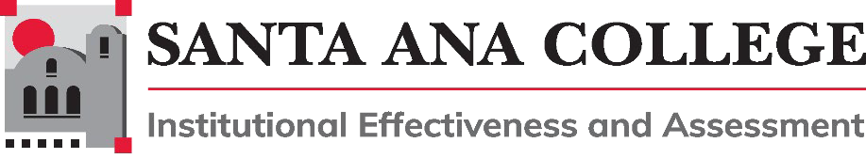

Agenda
September 2, 2026
1:00 – 3:00pm
Zoom: https://rsccd-edu.zoom.us/j/88508650003

Voting Members: Mark Canett, Mike Everett, Dr. Vaniethia Hubbard, Dr. Jim Kennedy, Annie Knight, Dr. Jeff Lamb, Dr. Andrew Manson, Dawn McKenna, Dr. Jesus Miranda, Gizelle Ponzillo, Mark Reynoso, Sarah Salas, Juliana Saldivar, Robert Stucken, Mark Turner
Vacant: Dean (Academic Affairs), Dean (Student Services), Faculty (Student Services), Classified Professional (Academic Affairs), Student Representative

Non-Voting Members: Claire Coyne (co-chair), Dr. Jarek Janio, Paula Kincaid, Program Review Representative, Accreditation Representative

1. Action Items
- Approval of Agenda for September 2, 2026
- Approval of Minutes from May 6, 2026
- Integrated Resource Allocation Process (IRAP) – Second Read (tabled 4/1)
- SAC Participatory Governance Handbook Update – Second Read (tabled 5/6)
- Accreditation Subcommittee Charge and Membership Revisions, Second Read
- Annual Planning Calendar, Second Read
2. Information/Discussion Items
- 2026/2027 Membership
- IE&A 2026-27 Work Plan and Annual Cycle
- Plan Evaluation Cycle: Identify Institutional Plans for 2026-27 Review
- Governance Orientation and Training: Fall Feedback and Ongoing Training Needs
- 2025-26 Unfinished Business
• Agenda and Minutes Templates
• Comprehensive Educational Plan (CEP) KPIs
3. Subcommittee Reports
a. Accreditation
b. Outcomes Assessment
c. Program Review
4. Good of the Order

