Academic Support Services - Division Office: Humanities and Social Science Office

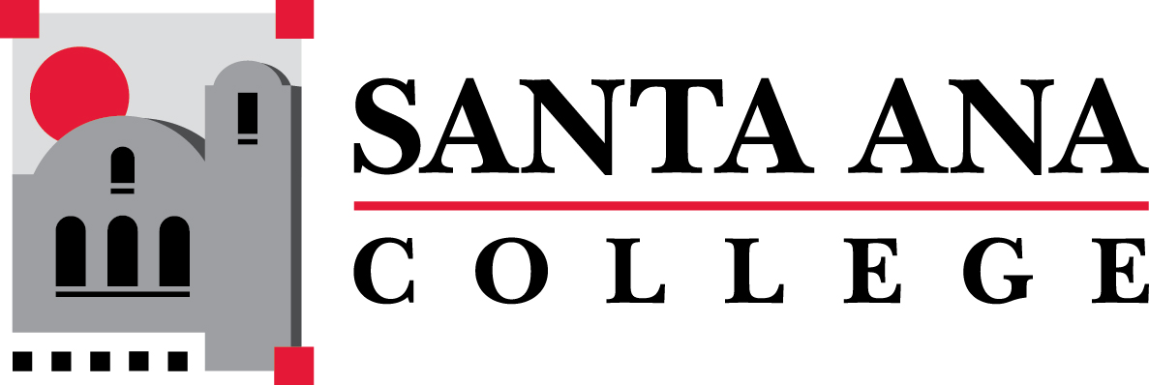

PROGRAM REVIEW REPORT

Academic Support Services - Division Office: Humanities and Social Science Office

General Information

General Information

General Information

Mission
The mission of the Humanities and Social Sciences Division is to provide students with a broad exposure to challenging and culturally relevant instructional program that assist them in accomplishing the academic and career goals
Our vision: "Inspiring, Transforming and Empowering our diverse community of learners through the Humanities and Social Sciences"
Humanities
Courses in the humanities study the cultural activities and artistic expressions of human beings. They assist in developing an awareness of the ways in which people throughout the ages and in different cultures have responded to themselves and the world around them in artistic and cultural creation, and in developing aesthetic understanding and an ability to make value judgments. This category includes introductory or integrative courses in foreign languages, literature, philosophy, religion, writing, English, and reading skills.
Social Sciences
Courses in the social and behavioral sciences focus on people as members of society. They assist in developing an awareness of the methods of inquiry used by the social and behavioral sciences. Critical thinking is stimulated about the ways people act and have acted in response to their societies, and appreciation is developed of how societies and social groups operate. This category includes introductory or integrative survey courses in cultural anthropology, economics, history, political science, psychology, sociology, cultural geography, and related disciplines.

Manager / Dean
Dr. Javier A. Galván, Dean of Humanities & Social Sciences

Annual Program Review

2021-2022

Annual Review Form

1. Progress Report: Review Previous Year’s Institutional Review
There is no information to report here on previous goals given that this is the inaugural year of program review at the divisional level. The following is an overview of the Humanities and Social Sciences Division:
The Division of Humanities & Social Sciences is part of Santa Ana College’s Office of Academic Affairs and the People, Ideas and Culture guided pathway. The division is made up of the following 12 departments (15 disciplines) and the college’s Learning Center:
- American Sign Language
- Anthropology, Sociology & Women’s Studies
- Economics & Geography
- English
- ESL/EMSL
- Ethnic Studies
- History
- Modern Languages
- Philosophy
- Political Science
- Psychology
- Reading
Currently, there are a total of 45 full-time faculty (including a full-time Learning Center Coordinator and 13 Department Chairs) in the division and 91 adjuncts. In addition, there are 2 full time classified Administrative Secretaries and 12 part time Learning Skills Instructional Assistants.
The Humanities and Social Sciences Division is one of the largest on campus offering over 300 sections of transferable courses per semester in the general education area.
The SAC Learning Center (LC) is a major source of support services for our students. Located on the third floor of the Dunlap Building (D-306), the LC provides comprehensive tutoring services for students both in-person and online. The Learning Facilitators, Instructional Assistants and Faculty are available for students Monday through Saturday in the mornings and evenings. The staff are there to help students in a variety of general education subjects in the Humanities and Social Sciences including support for Modern Languages, Math, Science and Nursing. In addition, many instructors have found it helpful to include the completion of DOTAs (Directed Outcome Tutoring Activities) as a part of their coursework as a way to direct students to the LC. Access to computers and study rooms also gives students assistance in completing their desired academic goals.

2. Provide effective data sources to evaluate this department
As one of the largest divisions at Santa Ana College, Humanities and Social Sciences plays a major role in facilitating student success and educational outcomes. The HSS Division Office quantifies its success in the following categories:
· Fiscal Management
· Communication
· Enrollment Management
· Student Contact and Support
· Campus Involvement
· Curriculum Oversight
· Department Support

Fiscal Management
The HSS Division’s total operational budget from all categories is $12,209,366. This is the combined budget from the division office, the academic departments and the SAC Learning Center. The operational budget for the HSS office is $520,148. The following items are included in the office budget:

1000
Academic Management
$194,433
2000
Classified Employees
$146,567
3000
Benefits
$172,868
4000
Non-Instructional Supplies
$2,926
5000
Lease/Copy/Repro
$3,354
The HSS Division office operational budget of $6,280 has been successfully encumbered and committed during the past fiscal year (2021-2022) and is on track to do the same for the current 2022-2023 year. However, additional funds may be necessary to cover the cost of office equipment and updated promotional items to support and promote the expanded activities of the division.
Metric for evaluation (MFE): encumbrance and commitment of all available funds

Communication
The HSS Division Office values and maintains regular and systematic communication with the departments, Academic Affairs and the SAC campus community. The Division office utilizes a variety of methods to enhance communication and provide information; these methods include the following:
Regular Meetings - The HSS Division Office coordinates both the fall and spring divisional meetings mandated by the faculty CBA. In addition, the Dean holds monthly meetings with the Department Chairs, the Learning Center Coordinator and the LC Classified staff.
Divisional Newsletter - The Dean publishes a monthly newsletter highlighting divisional and college-wide information often spotlighting cultural appreciation, accomplishments and editorials about campus-wide initiatives. The newsletter is distributed to the entire division, the Academic Affairs and President’s office.
Wellness Checks - The administrative staff in the HSS Division office has enhanced its communication with faculty and classified staff in the wake of the global COVID-19 pandemic. In response to legislative mandates, the staff have worked towards keeping the division aware of policies and provides “Wellness Checks” on those experiencing effects from this or other factors that may arise.
Student Information - The administrative staff is actively involved with communications directly and indirectly with students. In addition to on-ground student contact (covered in the section below under “Student Contact and Support”) the division office staff message students on open and closed class sections, batch transfers, student surveys and other correspondence. The staff often handles complex student issues and communicates with the Dean on confidential matters.
MFE: Continuation of current practice and documentation
Enrollment Management
The HSS Division office has oversight and final approval of course offering for all of the 12 departments. This includes the following enrollment management elements:
- Enrollment Trends - adding or canceling sections, monitoring reports, reviewing historical data and FTES analysis
- Establishing Pools - in conjunction with People & Culture (P&C), establishes instructional faculty pools to meet demand for additional sections
- Dual Enrollment - work directly with the DE staff and high school partners to meet the needs of the program
- Schedule Building - operate on a systematic annual calendar to build the HSS division schedule
- Faculty Hiring - assist the departments with the operation of recruiting, hiring and processing new faculty coordinating closely with P&C
It is the intention of the HSS Division to meet the needs of students in terms of offering course sections in demand based on current and historic trends. This includes monitoring offerings within the pattern of degree completion, adjusting classroom caps, monitoring the waitlists and complying with legislative trends (especially those designed to foster equity). In addition, the division will continue to work with its DE partners to ensure course offerings and coordination with faculty.
MFE: Analysis of enrollment data, waitlist monitoring and review of data on degree completion.

Student Contact and Support
The HSS Division office maintains regular business hours. The office is open Monday through Friday from 7:30am until 5:00pm. Also, faculty have access to the office in the evening in order to meet with students, make copies, use the grading machines, pick up instructional supplies, use the computers and utilize the break room.
The HSS staff have regular contact with students who walk-in or have appointments in the office. In spring 2023 the office will begin documenting the in-office student contacts to get a clearer understanding of student needs, trends in service, frequently asked questions and their satisfaction with services.
Finally, the HSS Division office offers bilingual (English/Spanish) services for students and their families.
MFE: Analysis and quantification of student contact log data

Campus Involvement
Each year the HSS Division office participates in a variety of campus-wide events in collaboration with its college partners. HSS has participated in the following events and collaborations:
ASO – The HSS Division office works with the Associate Student Organization to host student events. The Dean meets regularly with representatives from ASO and advisors who focus on Humanities and Social Sciences separately
Annual Open House – The division office will host its inaugural HSS Open House in Spring 2023 to highlight the outstanding departments, initiatives and opportunities to fellowship.
CAP Festival – The HSS Division office annually participates in the college-wide CAP festival that highlights the division to students on campus.
International Festival – The HSS Division office will participate in the college’s inaugural International Festival in fall 2022
Screening Committees – The division has actively participated in a variety of screening committee for positions from Classified to Executive.
MFE: Analysis and quantification of participation in event and initiatives

Curriculum Oversight
The HSS Division Dean oversees the development of curriculum for Social Sciences and Humanities. The Dean monitors the regular meetings, clarifies information, provides updates, reviews content and submits approval on Curricunet. The division Administrative Secretary launches the meetings, either in-person or on Zoom, and provides support as needed during and after the meetings.
MFE: Analysis and quantification of data submitted to the CIC

Departmental Support
There are two full-time Administrative Secretaries in the HSS Division office that provide support to the Dean and the operation of 13 departments within the division.

Beatrice Trujillo
· Women’s Studies
· Economics
· Modern Languages
· Sociology
· Geography
· EMLS
· History
· Anthropology
· Philosophy
Roxanna Pleitez
· American Sign Language
· English
· Ethnic Studies
· Political Science
· Psychology
· Reading

The Administrative Secretaries support the departments in the following ways:
· Schedule Building
· Ordering Instructional Supplies & Equipment
· Budget monitoring
· Processing paperwork
· Posting notices
· Coordinating with other offices
· Evaluation Audit
· Scheduling rooms
· Assisting the Dean with other duties
MFE: Monitoring of duties and evaluations

3. Program assessment
The following are Service Area Outcomes (SAO) for the HSS Division:
· The Humanities and Social Sciences Division Office will function as a responsive and comprehensive resource for students at SAC
· The Humanities and Social Sciences Division Office will provide high quality support for the departments within the division
· The Humanities and Social Sciences Division Office will participate in college-wide events, initiatives and committees that increase awareness for the division and support the mission of the college
· The Humanities and Social Sciences Division Office will maintain fiscal soundness
The SAOs represent the general functions of the division office and reflect the services that are vital for the operation. Each of the SAOs are measurable according to the MFEs in the above section.

4. List accomplishments department has made in the last year
While it is atypical for a Division office to receive college-wide accolades, it is important to highlight internal accomplishments that represent a sense of pride internally. The following are a list of such accomplishments:
· The HSS Division office has effectively streamlined the faculty evaluation process
· Utilized all available space in the Dunlap building for efficiency in classroom instruction
· The HSS Division office has moved forward and upgraded technology in several on-ground classroom in the Dunlap building
· The HSS Division office launched its monthly newsletter highlighting information and accomplishments from the entire division
· Administrative Secretary for the division, Roxanna Pleitez, participates as a member of the college-wide Planning, Organization and Effectiveness Committee
· The HSS division office has been actively integrating “Wellness Check-ins” within the office and throughout the division to increase trust and strengthen morale

5. Department's Current Goals and Objectives. Using the menu on the left, add 2 – 3 measurable goals that are congruent with Santa Ana College’s Strategic Master Planning Goals.
Report Prepared By (Name and Title):
Walter Jones

2022-2023

Annual Review Form

1. Progress Report: Review Previous Year’s Institutional Review
Evaluation of Goals from 2022-2023

Overview of HSS Division
The Division of Humanities & Social Sciences is part of Santa Ana College’s Office of Academic Affairs and the People, Ideas and Culture guided pathway. The division is made up of the following 12 departments (15 disciplines) and the college’s Learning Center:
- American Sign Language
- Anthropology, Sociology & Women’s Studies
- Economics & Geography
- English
- ESL/EMSL
- Ethnic Studies
- History
- Modern Languages
- Philosophy
- Political Science
- Psychology
- Reading
Currently, there are a total of 45 full-time faculty (including a full-time Learning Center Coordinator and 13 Department Chairs) in the division and 91 adjuncts. In addition, there are 2 full time classified Administrative Secretaries and 12 part time Learning Skills Instructional Assistants.
The Humanities and Social Sciences Division is one of the largest on campus offering over 300 sections of transferable courses per semester in the general education area.
The SAC Learning Center (LC) is a major source of support services for our students. Located on the third floor of the Dunlap Building (D-306), the LC provides comprehensive tutoring services for students both in-person and online. The Learning Facilitators, Instructional Assistants and Faculty are available for students Monday through Saturday in the mornings and evenings. The staff are there to help students in a variety of general education subjects in the Humanities and Social Sciences including support for Modern Languages, Math, Science and Nursing. In addition, many instructors have found it helpful to include the completion of DOTAs (Directed Outcome Tutoring Activities) as a part of their coursework as a way to direct students to the LC. Access to computers and study rooms also gives students assistance in completing their desired academic goals.
The three main goals of the HSS division office from 2022-2023 (listed below) align with the college’s Education Master Plan. The goals reflect the desire of the office to provide more meaningful services to students in an effort to understand their needs. The goals are also consistent with the research on student engagement which indicates a correlation between contact outside of the classroom and student success.

The following is an overview/evaluation of the Humanities and Social Sciences Division Goals for 2022-2023:

Goal #1: Establish an annual open house for the HSS Division Office (Vision Goal #3, SAC Cornerstone #5)
Objective: To create an opportunity for faculty and students to visit the HSS Division office, explore the programs and meet the staff that supports the area
Timeframe: Spring 2023 (April 11, 2023)
The inaugural HSS Division Office Open House took place on Wednesday, April 11, 2023. The event (occuring from 10am-4:00pm) was attended by twenty-four students and seventeen faculty members (according to the sign-in sheet). Attendees received information about the HSS programs from the staff and answered questions. Faculty were also on hand tyo answer questions and fellowship (light refreshments were served)
Assessment: Attendees were given a brief survey that asked the following questions:
(1) Have you visited the Humanities & Social Sciences Office before? Y(26) N(15)
(2) Did you find out something you did not know about the Humanities & Social Sciences Office? Y(12) N(29)
(3) Were the staff and faculty friendly and collegial? Y(41) N(0)
The results of the survey indicated that atteendees were familiar with the HSS Division office and that our operations are clear; 100% indicated that the staff was friendly and collegial!

Goal #2: Monitor in-office student contact/survey (Vision Goal #1, Strategic Goal #1)
Objective: To quantify the number of student contacts and the frequency/nature of the visits to the HSS Division office. The goal is to be proactive and anticipate student issues that may arise and our responsiveness.
Timeframe: Spring 2023
The HSS Division Office created a sign-in sheet for students who visit the office and have issues to be resolved, questions to ask or forms to be completed. Each time students visited the office they were prompted to give the following:
- Name
- Time of visit
- Call back number/email
- Reason for visit
- How Can we Help?
Assessment: According to the sign in sheet for spring 2023 there were 38 student contacts throughout the semester. The time of day showed no specific pattern but the reasons for visiting our office fell into the following categories:
- Late Adds (13)
- Classes (change class, find class) (6)
- Questions (class location, instructor office location, instructor contact information) (17)
- Complaints (2)
The data showed that petitions to add sections late was the most consistent issue students faced when they visited the office which prompted us to create a frequently asked question post for our bulletin board for students to review.

Goal #3: Fully integrate block scheduling into the schedule build process (Vision Goal #3)
Objective: To align the offerings of sections to a consistent block scheduling process with the result of utilizing instructional space more effectively and efficiently and to make room fro additional offering to meet enrollment demand
Timeframe: Spring to Fall 2023
Assessment: The HSS Division Office has worked within the guidelines of block scheduling to free up classroom space/section availability within the following time slots:
- 7:00pm-9:30 MW/TTH (Modern Languages) - freed to classroom spaces in spring and fall 2023
The data showed that adherence to block scheduling yielded additional classroom space in the evenings.

2. Provide effective data sources to evaluate this department
Department Evaluation

The Service Area Outcomes (SAO) represent the general functions of the division office and reflect the services that are vital for the operation. Each of the SAOs are qualitatively and quantitatively measurable and are a necessary rubric by which the HSS Division office documents its success and any justification for expansion of the program or budget.
The following are Service Area Outcomes (SAO) for the HSS Division and evaluative data:
- SAO #1: The Humanities and Social Sciences Division Office will function as a responsive and comprehensive resource for students at SAC
  - 100% of the attendees from the Open House indicated that the HSS staff was friendly and collegial
  - Student issues were addressed consistently according to the contact/survey form (there were no follow-up necessary-however some students who requested information may not have signed in)
- SAO #2: The Humanities and Social Sciences Division Office will provide high quality support for the departments within the division
  - The HSS office worked with the departments to process Late Add, class changes and student complaints
  - The HSS office provided programmatic information to students
  - Block scheduling helped to provide the availability of 5 classroom spaces in the evening for academic departments
The two full-time Administrative Assistants in the HSS Division office provide support to the Dean and the operation of 15 departments within the division. The division of labor functions as follows:
Beatrice Trujillo
- Women’s Studies
- Economics
- Modern Languages
- Sociology
- Geography
- EMLS
- History
- Anthropology
- Philosophy
Roxanna Pleitez
- American Sign Language
- English
- Ethnic Studies
- Political Science
- Psychology
- Reading
The Administrative Assistants support the departments in the following ways:
- Schedule Building
- Ordering Instructional Supplies & Equipment
- Budget monitoring
- Processing paperwork
- Posting notices
- Coordinating with other offices
- Evaluation Audit
- Scheduling rooms
- Assisting the Dean with other duties

- SAO #3: The Humanities and Social Sciences Division Office will participate in college-wide events, initiatives and committees that increase awareness for the division and support the mission of the college
  - Participated in the 2022-2025 Student Equity Plan with Student Services
  - Co-Chair: AB 705/1705 Monitoring Group
  - Participated in the International Students Day
  - Worked with ASG Humanities and Social Sciences Events
  - Participated in a variety of hiring committees
  - Participated in the college-wide Planning, Organization & Effectiveness Committee
  - Participated in the CAP Festival
- SAO #4: The Humanities and Social Sciences Division Office will maintain fiscal soundness
  - Annual meeting with Adminstrative Services to discuss budget for the entire division
  - Consistently distributed budget within spending guidelines

Please attach any data sources here.
HelpDeskSignIn.docx;
HSSDivisionOHS.docx

3. Program assessment
Program Needs
The Humanities and Social Sciences Division office supports one of the largest academic areas for general education/transfer on the entire Santa Ana College campus. The operations of the 15 departments and the SAC Learning Center are supported by only 2 Adminstrative Assistants who assist the Dean with a wide array of responsibilities including, but not limited to schedule building, office clerical functions, budget monitoring, room scheduling and other duties. The clerical tasks are often overwhelming, especially with the addition of the SAC Learning Center. Thus the HSS Division office will renew its request for the following clerical support position (also listed in the RAR request section of the Program Review):
- Position/Need: Senior Clerk (Part-time)
- Rationale: As one of the largest divisions on campus HSS is often pushed to the limit in terms of administrative work for the secretaries. The part-time clerk would help to increase the efficiency of operations in the office.
- Annual Total Cost of Position/Request: $26,884
In addition to the needs for support personnel, the HSS Division Office has a great desire to improve inter-office proficiency. Outdated equipment, especially computers, slows down the operational process in the office and negatively impacts the workflow. Outdated and inefficient projectors in classrooms (D204, 205, 206 and 207) have hampered the work of the faculty utilizing these instructional spaces (Again, the HSS Division office will renew its previous request for the following non-instructional equipment-also listed in the RAR request section of the Program Review):
- Position/Need: New CPU for Computers (2)
- Rationale: The CPUs for the administrative secretaries are more than 5 years old and have experienced dramatic deterioration in the past year
- Annual Total Cost of Position/Request: $2,350 (one-time cost)
- Position/Need: New Projectors (4)
- Rationale: The projectors in these four classes have been evaluated by M&O and determined to be outdated and inefficient for the instructional spaces in D204, D205, D206 and D207
- Annual Total Cost of Position/Request: $10,589.52
Also, HSS has a need to enhance the visibility of the division. Although the Dunlap Building commands a predominant position on campus, programs and services are often overlooked by students. Again, the HSS Division office will renew its request for the following non-instructional equipment (also listed in the RAR request section of the Program Review):
- Position/Need: Funding for Publications
- Rationale: The HSS Division office has an extremely limited budget for promotional items and advertising, yet the division offers the most transferable course and offers the services of the Learning Center which has no signage
- Annual Total Cost of Position/Request: $500

4. List accomplishments department has made in the last year
Accomplishments
The Humanities and Social Sciences Division office works in concert with the departments within the area and often share the accolades. However, it is important to highlight internal accomplishments that represent a sense of pride for the office internally. The following are a list of accomplishments from the HSS Division office:
- The HSS Division office has worked with Maintenanace & Operations to replace projection screens in D204, D205, D206 and D207 (the screens in those rooms were initially incorrectly installed-code violation)
- The HSS Division office coordinated the hiring of three full-time faculty members (English and Economics) and three classified workers (Learning Facilitators and Instructional Assistants) and one long term faculty member (Ethnic Studies)
- The HSS Division office has worked with Administrative Services and the University of La Verne in partnership to offer courses in the Dunlap Building (along with office space) for a satellite project
- The Student Help Desk sign-in survey has helped the HSS Division office identify ways to help students better
- Utilized all available space in the Dunlap building including available faculty office space
- Partnered with the Career Education/Dual Enrollment to assist with their internal operation
- Actively improved communication throughout the division

5. Department's Current Goals and Objectives. Using the menu on the left, add 2 – 3 measurable goals that are congruent with Santa Ana College’s Strategic Master Planning Goals.

2023-2024

Annual Review Form

1. Progress Report: Review Previous Year’s Institutional Review
Evaluation of Goals and Progress Report from 2023-2024.
Goal #1. Hold an Annual HSS Division Open House.
Objective: To create an opportunity for faculty and students to visit the HSS Division office, explore the programs and meet the staff that supports the area.
* Assessment and Progress: The division decided to postpone this activity. In the following years, it will change into more periodic gatherings in the division to increase collegiality among colleagues to incentivize a more active presence on campus and strategize for CAP events (People, Ideas, and Culture).
Goal #2. Transition of the Learning Center to Academic Affairs as part of the Reorganization.
Objectives: To Meet with Dean of Academic Affairs to discuss the potential transition of the budget, staffing needs, organizational structure, and implementation table.
* Assessment and Progress: The Reorganization has been paused. The HSS division will cooperate with the new Assistant Dean of Library and Learning Centers to work on the potential transition. The current plan is to keep the Learning Center at its current location and perhaps centralize the administration of all learning centers under academic affairs.
Goal #3. Refine Inter-office operations.
Objectives: To use a monthly newsletter to update faculty and department chairs of division activities, update chairs at monthly meetings, and promote professional development activities.
* Assessment and Progress: Last year, HSS faculty received sporadic newsletters. The new goal will be to have a more consistent delivery of information with monthly meetings and a bi-monthly newsletter.
Goal #4. Recruitment of Student Workers to Support Administrative staff at the division office.
Objectives: To assess division office needs and work with Student Placement Office to hire student workers.
* Assessment and Progress: The division hired 3 student workers. Only 1 of them worked out well. The needs of the division were reassessed, and it was determined that it needs an on-going Senior Clerk position to help with the heavy workload of a large division.

2. Provide effective data sources to evaluate this department

The Humanities and Social Science Division offers a wide variety of General Education courses. Most of the 12 departments and 18 academic disciplines have increased in the number of sections offered while also improving fill and retention rates. The 3 attached documents offer tangible evidence of enrollment growth and student success.

FTES Generated. Overall, the division has increased in the amount of FTES it generated (from 2951 FTES in 2022-2023) to (3347 TES in 2023-2024). That is an increase of 11%, which is significant after 2 years of sustained growth. See the attached document for specific evidence.

Dual Enrollment Retention and Success Data. The partnership between the HSS division and our community partners from multiple high schools have generated tremendous results. Not only are most departments in the HSS division now offering dual-enrollment classes, but the results show a tremendous improvement on student retention (91%) and class completion with a passing grade (83%). Those are excellent metrics of success. The goal is to have every department in our division offer dual enrollment classes. See attached document.

HSS Division Enrollment Data. The HSS division grew in the number of sections offered and the number of students enrolled. More importantly, both our efficiency and fill rates continue to improve, which means we are not just adding sections, but we are being more effective and strategic in our enrollment management. The attached document provides evidence of our increased growth. The challenge is to have enough faculty to teach in rapidly-expanding programs, such as Ethnic Studies, English, Psychology, Sociology, and American Sign Language.

Please attach any data sources here.
HSS Dual Enrollment Retention and Success Data 2019-2023.docx;
HSS FTES generated 2018-2024.docx;
HSS DIVISION ENROLLMENT DATA.docx

3. Program assessment
Division Office Needs
The Humanities and Social Sciences Division office supports one of the largest academic areas for general education/transfer on the entire Santa Ana College campus. We currently include 185 faculty members (45 full-time and 140 part-time). HSS manages 2 separate curriculum committees that are expected to be extremely busy with the adaptations in AB-1111 for Common Course Numbering and the implementation of the new IGETC. The operations of the 15 academic departments and the SAC Learning Center are supported by only 2 Administrative Assistants who assist the Dean with a wide array of responsibilities, including, but not limited to schedule building, office clerical functions, budget monitoring, coordination of evaluations, curriculum updates, purchasing, room scheduling, and other duties. In addition, the full-time faculty offices have furniture that is over 30 years old. While the desks are OK, the office chairs are old, dirty, and stained, which is not a welcoming sight to receive students for office hours. We will try to provide a more welcoming environment for students.

1. Personnel Needed: HSS Division Senior Clerk (Part-Time up to 19 hours a week)
Rationale: As one of the largest divisions on campus, HSS is often pushed to the limit in terms of administrative work for the secretaries. The part-time clerk would help to increase the efficiency of operations in the office. The clerical tasks are often overwhelming, especially with the addition of the SAC Learning Center and the curriculum demands due to AB-1705 legislation and AB-1111 for common course numbering. (also listed in the RAR request section of the Program Review).
Annual Total Cost of Position/Request: $26,699

2. Personnel Needed: Full-Time, Tenure-Track, Faculty in Geography.
Rationale: The current (and only) Professor of Geography at SAC is William Courter. He is on bank leave for the entire academic year (2023-2024), and he already filed the paperwork to retire in June of 2024. As a temporary fix, the division hired a Temporary, Full-Time Faculty member (John Conley) to replace him during his bank leave. However, he cannot serve on this position again. The Department is in desperate need of a full-time professor in Geography since there is literally nobody available to replace him. We only have 1 or 2 part-time instructors. We need a full-time faculty to teach Geography classes and labs, as well as update the department's curriculum, develop closer ties with dual enrollment, and oversee the course numbering project for Geography. (also listed in the RAR request section of the Program Review).
Total Annual Cost: $160,000

3. Speakers/Performers Series for the Humanities and Social Sciences (People, Ideas, and Culture) - Ongoing
Rationale: The division is deeply involved in multiple events that contribute towards anti-racism initiatives on campus and providing students with a sense of belonging on campus. Our departments play a significant role in showcasing events that promote Diversity, Equity, Inclusion, and Access. The funds for a speaker/performer series will be used to promote events throughout the year, possibly including poetry readings, guest lecturers in LGBTQ+ studies, historical series on Chicano/a lectures, English and foreign-language film series, discussions on undocumented scholars, topics on social justice, Asian-Americans in the Ethnic Studies curriculum, and the impact of education on formerly-incarcerated students. (also listed in the RAR request section of the Program Review).
Total Annual Cost $5,000

4. Replace 60 office chairs for Full-Time Faculty
Rationale: The existing chairs are dirty, stained, sometimes broken, and over 20 years old. They do not provide a very professional appearance for our students and staff. (also listed in the RAR section of the Progam Review).
Total amount: $38,564

5. Food and Food Services Supplies Account (4710 account) - Ongoing.
Rationale: The HSS division is planning 3 or 4 professional development events to enhance the level of cooperation across the division, increase visibility on campus, and develop intentional partnerships within our division and across campus. In addition, the HSS division hires multiple full-time faculty, and we form multiple hiring committees every year. The food supply account will allow the division to provide food, snacks, and water for division activities, professional development activities, hiring committees, CAP cultural events, and community promotional events. Please note that the division includes 185 faculty and 17 classified personnel. (also listed in the RAR request section of the Program Review).
Total Annual Cost: $7000

6. Marketing, Printing, and Promotional Materials (5940 account) - Ongoing.
Rationale: The HSS departments (including the Learning Center and the Honors Program) plan to promote their academic programs in multiple venues. The HSS division will request an on-going budget of $2,200 a year to support departments in their advertisement and promotional efforts. Since the division is the anchor for the CAP (People, Ideas, and Culture), the budget augmentation will also be used to support CAP activities throughout the year. The HSS programs plan to make their presence more visible in academic fairs, CAP displays, visits to the non-credit campus, and community activities. In addition, multiple departments and the Honors Program need professional brochures and fliers to promote their annual events. (also listed in the RAR request section of the Program Review).
Total Annual Cost: $2,300

7. Two utility carts (cart plus office dolly)
Rationale: To support the needs of faculty to carry materials to/from classes, cultural presentations, and promotional events.
Total Cost $785

4. List accomplishments department has made in the last year
The Humanities and Social Sciences Division office works in concert with the departments within the area and often share the accolades. However, it is important to highlight internal accomplishments that represent a sense of pride for the office internally. The following are a list of accomplishments from the HSS Division office:
- Coordinated events to promote the CAP Month of October for "People, Ideas, and Culture."
- Worked with Maintenance & Operations to replace projection screens in D204, D205, D206 and D207 (the screens in those rooms were initially incorrectly installed-code violation).
- Hired a full-time, temporary, 1 -year, faculty member (Ethnic Studies) to keep up with enrollment demand.
- Received and managed a state grant for $48,695 to work on the seamless transfer of community college students to the CSU system given the Ethnic Studies education requirements.
- Coordinated efforts with Administrative Services and the University of La Verne in partnership to offer courses in the Dunlap Building (along with office space) for a satellite project.
- Cooperated with the Office of Dual Enrollment and Career Education to create more opportunities for HSS departments offering general education classes.
- Actively improved communication throughout the division by using newsletters and more frequent division meetings.

5. Department's Current Goals and Objectives. Using the menu on the left, add 2 – 3 measurable goals that are congruent with Santa Ana College’s Strategic Master Planning Goals.
Report Prepared By (Name and Title):
Javier A. Galván

2024-2025

Annual Review Form

1. Progress Report: Review Previous Year’s Institutional Review
Evaluation of Goals and progress Report from 2023-2024.

Goal #1. Transition of the Learning Center to Academic Affairs as part of the Reorganization.
Objectives: To Meet with Dean of Academic Affairs to discuss the potential transition of the budget, staffing needs, organizational structure, and implementation table.
* Assessment and Progress: The Reorganization was completed by July 1, 2025. Associate Dean Parisa Samaie took over the administration of classified personnel, and Dean Javier Galván retained control over faculty working at the Learning Center since he also oversees their academic load.

Goal #2. Coordinate CAP events throughout the year to support student success.
Objectives: Schedule cultural events that provide students with a sense of belonging on campus. Offer a series of academic and cultural speakers to enhance materials covered in class. Promote CAP activities using the Canvas site and the PIO's Office.
* Assessment and Progress: The division supported multiple events, including a Literary Festival, Chicana/o Heritage Celebration Month; and Veteran's Honor Speaker and Documentary Screening.

Goal #3. Increase cooperation between credit and non-credit programs.
Objectives: Connect department chairs from ESL non-credit and EMLS credit programs; facilitate the hiring process for assigning classes to faculty from both campuses; explore credit courses to fulfill requirements for High School Diploma programs at non-credit campus; Coordinate Learning Center support for non-credit students at SAC.
* Assessment and Progress: HSS and non-credit held meetings of department chairs overseeing both ESL programs (credit and non-credit). EMLS hired 3 non-credit instructors to teach on the credit side. The new and extended proposal is to integrate our physical spaces by providing non-credit with multiple classrooms in Dunlap Hall so their students are also integrated into the Learning Center. The synergy that will be created around English, EMLS, ESL non-credit, and foreign languages will be beneficial for all students since they could all benefit from the services offering student support at the Learning Center.

2. Provide effective data sources to evaluate this department
The Humanities and Social Science Division offers a wide variety of General Education courses. Most of the 12 departments and 18 academic disciplines have increased in the number of sections offered while also improving fill and retention rates. The 3 attached documents offer evidence of enrollment growth and student success.
FTES Generated. After several years of continued significant growth, the division has increased in the amount of FTES it generated (from 3300 FTES in 2023-2024) to (3373 FTES in 2024-2025). See the attached document for specific evidence.
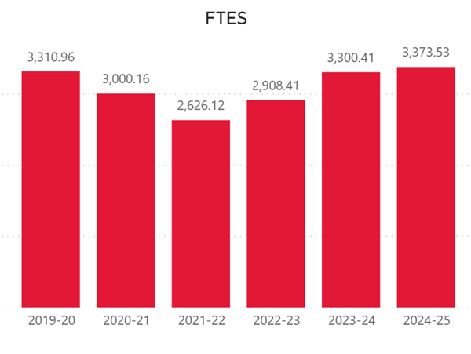
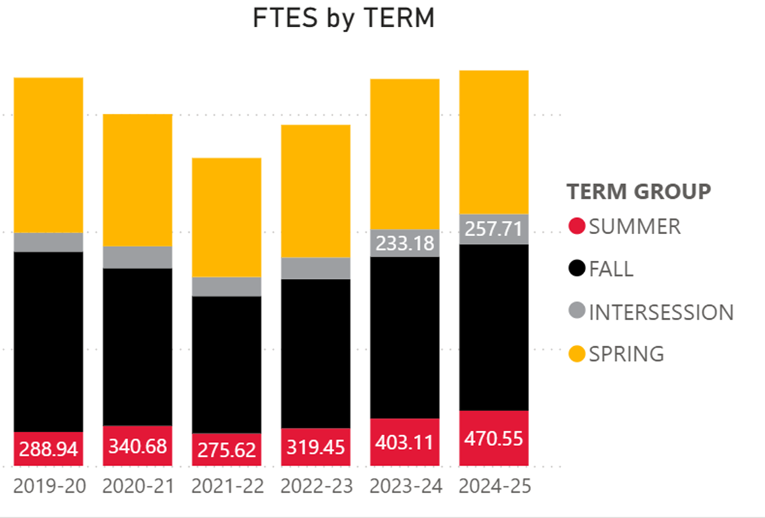

HSS Division Enrollment Data. The HSS division grew in the number of sections offered and the number of students enrolled. More importantly, both our efficiency and fill rates continue to improve, which means we are not just adding sections, but we are being more effective and strategic in our enrollment management. The attached document provides evidence of our increased growth. The challenge is to have enough faculty to teach in rapidly expanding programs, including, Ethnic Studies, English, Psychology, Sociology, and American Sign Language.
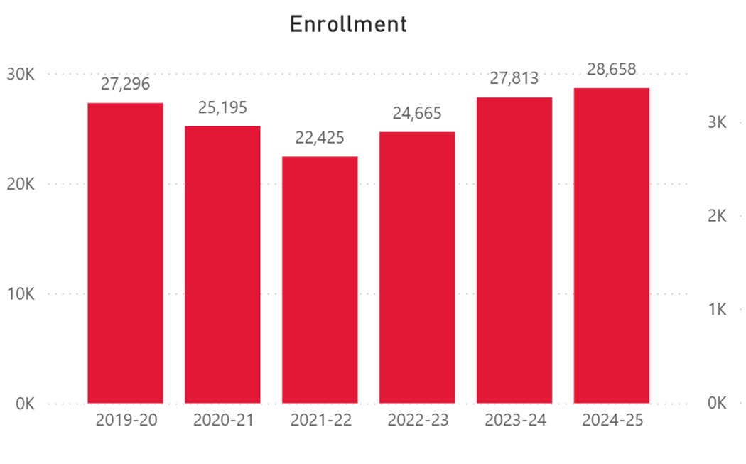
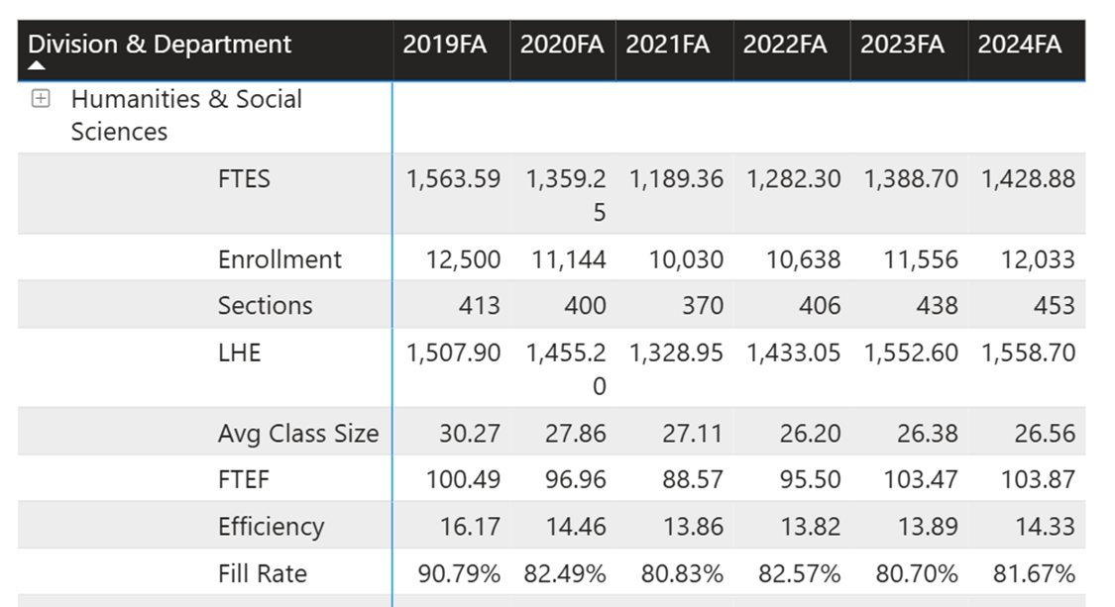

Dual Enrollment Retention and Success Data. The partnership between the HSS division and our community partners from multiple high schools have generated tremendous results. Not only are most departments in the HSS division now offering dual-enrollment classes, but the results show a tremendous improvement on student retention (93%) and class completion with a passing grade (81%). Those are excellent metrics of success. The goal is to have every department in our division offer dual enrollment classes. See attached document.
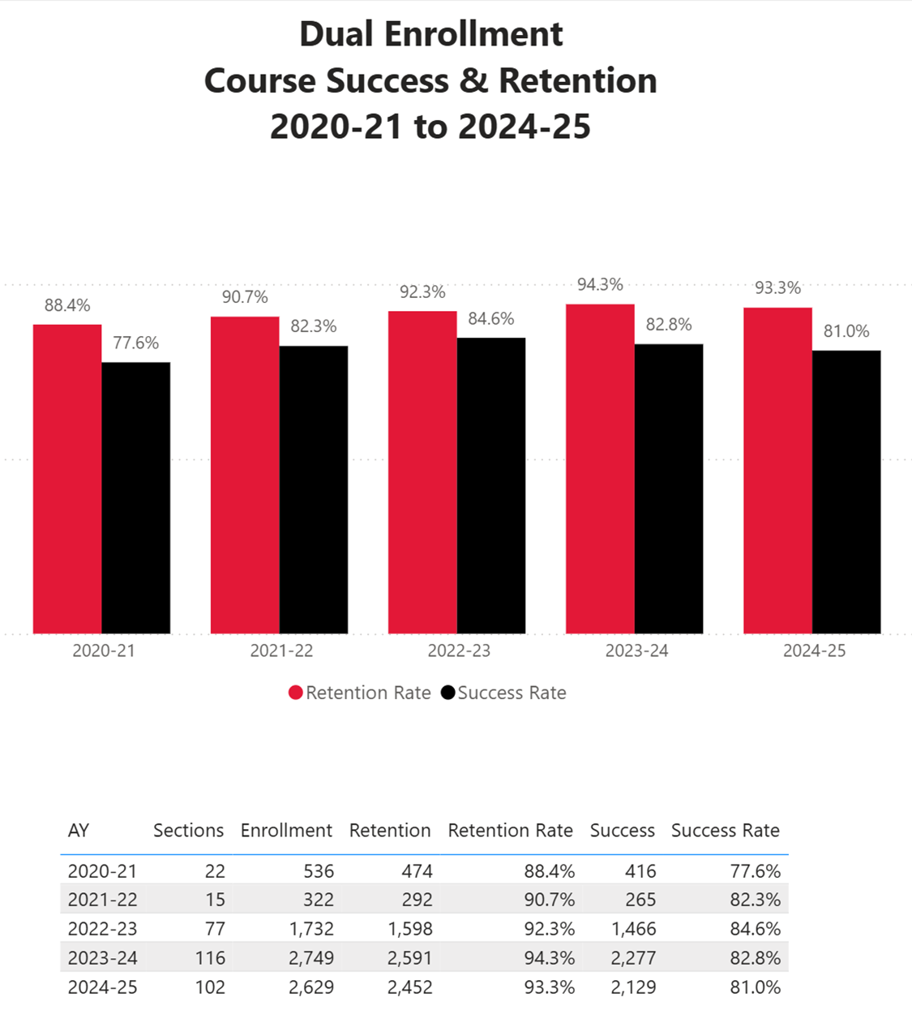

Please attach any data sources here.
HSS FTES 2020-2025.pdf;
HSs FTES by Term 2020-2025.pdf;
HSS Dual Enrollment Retention and Success Rates.pdf;
HSS Student Enrollment 2020-2025.pdf

3. Program assessment
Division Office Needs
The Humanities and Social Sciences Division office supports one of the largest academic areas for general education/transfer on the entire Santa Ana College campus. We currently include 185 faculty members (45 full-time and 140 part-time). The operations of the 15 departments and the SAC Learning Center are supported by only 2 Administrative Assistants who assist the Dean with a wide array of responsibilities, including, but not limited to schedule building, office clerical functions, budget monitoring, coordination of evaluations, curriculum updates, purchasing, room scheduling, and other duties. HSS also manages 2 separate curriculum committees that are expected to be extremely busy with the adaptations in AB-1111 for Common Course Numbering and the implementation of the new IGETC.
1. Personnel needed: HSS Division Senior Clerk (Part-Time up to 19 hours a week)
Rationale: As one of the largest divisions on campus HSS is often pushed to the limit in terms of administrative work for the secretaries. The part-time clerk would help to increase the efficiency of operations in the office. The clerical tasks are often overwhelming, especially with the addition of the SAC Learning Center. (also listed in the RAR request section of the Program Review).
Annual Total Cost of Position/Request: $30,000
2. Replace Division Office Desks and Furniture – One Time
Rationale: The HSS division has the original desks from the 1970s. Office desks and bookshelves are over 40 years old; they are dirty, stained, and partially broken and held together by masking tape. They do not present a very good image to our students and professors. (also listed in the RAR request section of the Program Review – Equipment/Non-Instructional).
Total Cost: $75,000
3. Podiums (total of 10). Needed in classrooms in Dunlap Hall (instructional equipment).
Rationale: Basic equipment for classroom management (in person classes).
Total Cost: $1500.00
4. Marketing, Printing, and Promotional Materials (5940 account) - Ongoing.
Rationale: The HSS departments (including the Honors Program) plan to promote their academic programs in multiple venues. The HSS division will request an on-going budget of $2,000 a year to support departments in their advertisement and promotional efforts. Since the division is the anchor for the CAP (People, Ideas, and Culture), the budget augmentation will also be used to support CAP activities throughout the year. The HSS programs plan to make their presence more visible in academic fairs, CAP displays, visits to the non-credit campus, and community activities. In addition, multiple departments and the Honors Program need professional brochures and fliers to promote their annual events. (also listed in the RAR request section of the Program Review).
Total Annual Cost: 2,000
5. Food and Food Services Supplies Account (4710 account) - Ongoing.
Rationale: The HSS division is planning 3 or 4 professional development events to enhance the level of cooperation across the division, increase visibility on campus, and develop intentional partnerships within our division and across campus. In addition, the HSS division hires multiple full-time faculty, and we form multiple hiring committees every year. The food supply account will allow the division to provide food, snacks, and drinks for division activities, professional development activities, hiring committees, CAP cultural events, and community promotional events. Please note that the division includes 185 faculty and 17 classified personnel. (also listed in the RAR request section of the Program Review).
Total Annual Cost: $4,000
6. Full-Time, Tenure-Track, Faculty in Sociology.
Rationale: Sociology is an extremely busy department, but it only has 1 full-time faculty member. The department is taking the lead in multiple forums, such as functioning as the academic anchor for the new Certificate in LGBTQ+ Studies. It is also exploring options for a degree in Social Justice. All tangible metrics (FTES generated, retention rates, success rates, and enrollment numbers) support the need for a new Sociology professor.
Total Annual Cost: $198,000

4. List accomplishments department has made in the last year
- Completed the transition of the Learning Center to the Associate Dean of Learning Centers.
- Increased FTES generated while maintaiing retention and success rates.
- Completed the creation of the Kathy Patterson Honors Center. Grand opening in November 2025.
- Transitioned the CAP project from a one-month event to engaging activities throughout the year.

5. Department's Current Goals and Objectives. Using the menu on the left, add 2 – 3 measurable goals that are congruent with Santa Ana College’s Strategic Planning Goals.
Report Prepared By (Name and Title):
Javier A. Galván

Goals

Develop Integration of Non-Credit and Credit Programs, including classroom space and access to the Learning Center
Goal
Develop Integration of Non-Credit and Credit Programs, including classroom space and access to the Learning Center
Rationale for Creating Goal
To create a synergy that will include students from English, ESL (non-credit), and EMLS (credit) feeding into support services at the Learning Center.
Goal Status
Active
Responsible Party(ies)
Dean of Humanities and Social Sciences; Dean at Non-credit
Objectives
Find possible classroom space; work put details of tutoring schedules at the Learning Center; department chairs working together to facilitate a transition from non-credit to credit ENGL/ESL/EMLS classes.
Expected Completion
Fall 2026

Mapping
Guided Pathways Pillars: (X)
- Pillar 2 - Enter the Path: (X)

Complete the LGBTQ+ Certificate
Goal
Complete the LGBTQ+ Certificate.
Rationale for Creating Goal
To provide students a certificate within the Social Justice academic environment that provides a sense of belonging on campus.
Goal Status
Active
Responsible Party(ies)
Dean of Humanities and Social Sciences; Department Chairs of Anthropology and Sociology
Objectives
Create new courses and coordinate efforts to complete the certificate; get it approved by the Division Curriculum Committee and the SAC Curriculum Council.
Expected Completion
Spring 2026

Mapping
Guided Pathways Pillars: (X)
- Pillar 2 - Enter the Path: (X)

Expand Dual Enrollment
Goal
Explore offering dual-enrollment sections in most of the academic departments in the HSS division.
Rationale for Creating Goal
Increase course and degree completion since HSS offers a significant number of general education courses
Goal Status
Active
Responsible Party(ies)
Dean and department chairs
Objectives
Increase dual enrollment in Geography, Anthropology, Economics, Philosophy, and American Sign Language.
Expected Completion
Spring 2026
Date Completed
04/20/2026

Mapping
2024 - 2027 Comprehensive Educational Plan: (X)
- Goal 2: Expand partnerships to optimize educational options and opportunities through innovative services and equitable practices. (X)

- Goal 4: Strengthen supportive infrastructure that facilitates equity, a sense of belonging, and trust among faculty, staff, and students. (X)

Guided Pathways Pillars: (X)
- Pillar 2 - Enter the Path: (X)

- Pillar 3 - Stay on the Path: (X)

2024 - 2025
Goal Status Update
HSS has increased the number of sections for dual enrollment and the departments that participate in the program.
Goal Progress
Completed
Percent Complete
100%

Convert from a "CAP month" to CAP activities throughout the year
Goal
Coordinate CAP events throughout the year to support student success
Rationale for Creating Goal
The HSS Division offers multiple academic, social, and student-centered events throughout the year, but they are not linked or coordinated in a cohesive manner. We need to be more intentional in how we organize activities that support student learning, persistence, and success.
Goal Status
Archived
Responsible Party(ies)
Dean and department chairs
Objectives
Coordinate CAP events with the Office of Student Success.
Schedule cultural events that provide students with a sense of belonging on campus.
Offer a series of academic and cultural speakers to enhance materials covered in class.
Promote CAP activities using the Canvas site and the PIO's Office by partnering with the student success coaches.
Expected Completion
Spring 2026
Date Completed
10/10/2025

Mapping
Guided Pathways Pillars: (X)
- Pillar 3 - Stay on the Path: (X)

- Pillar 4 - Ensure Learning: (X)

2024 - 2025
Goal Status Update
The division supported multiple events, including a Literary Festival, Chicana/o Heritage Celebration Month; and Veteran's Honor Speaker and Documentary Screening.
Goal Progress
On Schedule
Percent Complete
100%

Transition of Learning Center
Goal
Create a seamless transfer of the Learning Center to Academic Affairs as a part of the Reorganization
Rationale for Creating Goal
As a result of the reorganization in Academic Affairs, oversight of the Learning Center will require a seamless transition of operations, personnel and budget. This includes ongoing staffing needs, immediate supervision (revised organizational structure), liaisons with academic departments and coordination of annual events.
Goal Status
Archived
Responsible Party(ies)
Dean of Humanities and Social Sciences; Dean of Academic Affairs (Matthew Valerius); Learning Center Coordinator (Kathy Walczak); Department Chairs; Administrative Services
Objectives
(1) Meetings with Dean of Academic Affairs
(2) Transition of Budget
(3) Update Staffing needs/Organizational Structure
(4) Establish implementation time table
Expected Completion
Spring 2025
Date Completed
07/01/2025

Mapping
2024 - 2027 Comprehensive Educational Plan: (X)
- Goal 2: Expand partnerships to optimize educational options and opportunities through innovative services and equitable practices. (X)

Guided Pathways Pillars: (X)
- Pillar 3 - Stay on the Path: (X)

- Pillar 4 - Ensure Learning: (X)

Increase cooperation between credit and non-credit progams
Goal
Create intentional connections between credit academic programs and non-credit students
Rationale for Creating Goal
Increase transfer of non-credit to credit classes at SAC
Goal Status
Archived
Responsible Party(ies)
Dean and department chairs
Objectives
Connect department chairs from ESL non-credit and EMLS credit programs
Facilitate the hiring process for assigning classes to faculty from both campuses
Explore credit courses to fulfill requirements for High School Diploma programs at non-credit campus
Coordinate Learning Center support for non0credit students at SAC
Expected Completion
Spring 2026
Date Completed
10/10/2025

Mapping
Guided Pathways Pillars: (X)
- Pillar 1 - Clarify the Path: (X)

- Pillar 2 - Enter the Path: (X)

2024 - 2025
Goal Status Update
HSS and non-credit held meetings of department chairs overseeing both ESL programs (credit and non-credit). EMLS hired 3 non-credit instructors to teach on the credit side. The new and extended proposal is to integrate our physical spaces by providing non-credit with multiple classrooms in Dunlap Hall so their students are also integrated into the Learning Center. The synergy that will be created around English, EMLS, ESL non-credit, and foreign languages will be beneficial for all students since they could all benefit from the services offering student support at the Learning Center.
Goal Progress
On Schedule
Percent Complete
60%

Recruitment of Student Workers
Goal
Recruit 1-2 student workers to support the Administrative staff in the HSS Division office
Rationale for Creating Goal
The Humanities & Social Sciencs Division office previously made a request for an Administrative Clerk (part-time) to support the staff. However, that funding request has not been funding. Therefore, the HSS Division office will make efforts to recruit 1-2 part-time student workers to support the work of one of the largest division at the college
Goal Status
Archived
Responsible Party(ies)
Dean of Humanities & Social Sciences; HSS Adminstratives Assistants; Student Placement Office (Financial Aid)
Objectives
(1) Assess the current needs of the division and decide how many student workers are needed
(2) Work with the Student Placement Office to identify students
(3) Recruit, interview and hire student worker(s)
Expected Completion
Spring 2024
Date Completed
03/18/2024

Mapping
2024 - 2027 Comprehensive Educational Plan: (X)
- Goal 4: Strengthen supportive infrastructure that facilitates equity, a sense of belonging, and trust among faculty, staff, and students. (X)

Guided Pathways Pillars: (X)
- Pillar 4 - Ensure Learning: (X)

Refine Inter-Office Operations
Goal
Refine inter-office operations between the Humanities & Social Sciences office, the department chairs and faculty
Rationale for Creating Goal
The Humanities & Social Sciences division office will work towards setting up a system to proactively communicate important dates, required meetings and timelines for submission of materials. The division office currently coordinates the efforts, but a more streamlined process will facilitate improved communication. In addition, the HSS division office will provide periodic in-service professional development activities connected to inter-office processes.
Goal Status
Archived
Responsible Party(ies)
Dean of Humanities & Social Sciences; HSS Administrative staff; Department Chairs and Faculty
Objectives
(1) Provide a series of inter-office Professional Development Activities (in-person/online)
(2) Utilize the monthly newsletter to send reminders
(3) Update Chairs at monthly meetings
(4) Develop a timeline process through Outlook
Expected Completion
Spring 2024
Date Completed
05/18/2024

Mapping
2024 - 2027 Comprehensive Educational Plan: (X)
- Goal 3: Cultivate equitable campus culture to support student, faculty, and staff belonging and success. (X)

Guided Pathways Pillars: (X)
- Pillar 4 - Ensure Learning: (X)

Annual HSS Open House
Goal
• Continue annual open house
Rationale for Creating Goal
Aligns with Vision and Cornerstone goals of SAC. Highlights the people, departments and initiatives of the Humanities & Social Sciences Division
Goal Status
Archived
Responsible Party(ies)
Division Office and Academic Departments
Objectives
(1) Highlight Departments
(2) Increase collegiality among divisions
(3) Gives students a reason to visit HSS office
Expected Completion
Spring 2024
Date Completed
02/20/2024

Mapping
2024 - 2027 Comprehensive Educational Plan: (X)
- Goal 3: Cultivate equitable campus culture to support student, faculty, and staff belonging and success. (X)

Guided Pathways Pillars: (X)
- Pillar 1 - Clarify the Path: (X)

- Pillar 2 - Enter the Path: (X)

2022 - 2023
Goal Status Update
Successful Open House in spring 2023
Goal Progress
Completed
Percent Complete
100%

Complete Transition of General Education Courses to Common Course Number
Goal
Complete transition to Common Course Number in Curriculum Committees. HSS has a large number of general education courses that will transition to CCN in Phase III (Transfer).
Rationale for Creating Goal
Required by AB-1111
Goal Status
Active
Responsible Party(ies)
Humanities Curriculum Committee and Social Sciences Curriculum Committee
Objectives
To complete the conversion in Meta of courses to Common Course Numbering.
Expected Completion
Fall 2026

Mapping
Guided Pathways Pillars: (X)
- Pillar 1 - Clarify the Path: (X)

- Pillar 2 - Enter the Path: (X)

Resource Allocation Requests

Personnel (Instructional)
Fiscal Year
2024 - 2025
Requester's Name
Javier Galván
Requester's Department
Humanities and Social Sciences
Item Description
GEOGRAPHY Full-Time, Tenure-Track Faculty
Is this a Facilities Improvement/Repairs Request? (If Yes, please contact the Director of Physical Plant/Facilities to review your request.)
No
How will you measure the success of this resource?
Next year, we will not have a full-time professor in Geography due to retirement. We need a full-time Geography faculty member to coordinate the curriculum, run the department, schedule classes, evaluate faculty, etc. Complete the work related to Common Course Numbering project.
Will this request affect multiple departments and/or affect the entire campus?
Yes
If Yes, please explain how this request affects multiple departments and/or the entire campus.
Geography is part of the Economics and Geography Department. Each discipline only gets 1 full-time faculty member to carry out department chair duties (curriculum evaluations, hiring, etc.).
Has this request been submitted to other funding sources?
No
Rank this request
1
Estimated Cost (Enter numbers only)
189,000
Is this an annual on-going expense?
Yes

Mapping
Academic Support Services - Division Office: Humanities and Social Science Office: (X)
- Expand Dual Enrollment: Explore offering dual-enrollment sections in most of the academic departments in the HSS division. (X)

- Transition of Learning Center: Create a seamless transfer of the Learning Center to Academic Affairs as a part of the Reorganization (X)

- Increase cooperation between credit and non-credit progams: Create intentional connections between credit academic programs and non-credit students (X)

Budget Augmentation
Fiscal Year
2024 - 2025
Requester's Name
Javier Galván
Requester's Department
Humanities and Social Sciences
Item Description
Speakers and Performers to promote academic programs via cultural events that support our CAP of People, Ideas, and Culture.
Is this a Facilities Improvement/Repairs Request? (If Yes, please contact the Director of Physical Plant/Facilities to review your request.)
No
How will you measure the success of this resource?
Increase student attendance and participation in HSS academic programs. promote sense of belonging in campus.
Will this request affect multiple departments and/or affect the entire campus?
Yes
If Yes, please explain how this request affects multiple departments and/or the entire campus.
Cultural events are promoted and cross-referenced throughout multiple departments and divisions.
Has this request been submitted to other funding sources?
No
Rank this request
3
Estimated Cost (Enter numbers only)
5,000
Is this an annual on-going expense?
Yes

Mapping
Academic Support Services - Division Office: Humanities and Social Science Office: (X)
- Convert from a "CAP month" to CAP activities throughout the year: Coordinate CAP events throughout the year to support student success (X)

- Transition of Learning Center: Create a seamless transfer of the Learning Center to Academic Affairs as a part of the Reorganization (X)

Equipment (Non-Instructional) > $1,000 per item
Fiscal Year
2024 - 2025
Requester's Name
Javier Galván
Requester's Department
Humanities and Social Sciences
Item Description
60 office chairs for full-time faculty and division office
Is this a Facilities Improvement/Repairs Request? (If Yes, please contact the Director of Physical Plant/Facilities to review your request.)
No
How will you measure the success of this resource?
Office chairs are over 20 years old; they are dirty, stained, and partially broken. They do not present a very good image to our students and professors.
Will this request affect multiple departments and/or affect the entire campus?
Yes
If Yes, please explain how this request affects multiple departments and/or the entire campus.
We have 185 faculty (full-time and part-time) in 12 different departments and 18 disciplines in the Division of Humanities and Social Sciences.
Has this request been submitted to other funding sources?
No
Rank this request
4
Estimated Cost (Enter numbers only)
38,564
Is this an annual on-going expense?
No

Mapping
Academic Support Services - Division Office: Humanities and Social Science Office: (X)
- Refine Inter-Office Operations: Refine inter-office operations between the Humanities & Social Sciences office, the department chairs and faculty (X)

Budget Augmentation
Fiscal Year
2024 - 2025
Requester's Name
Javier Galván
Requester's Department
Humanities and Social Sciences
Item Description
Food and food contracted services - for division meetings, training sessions, hiring committees (for 185 faculty), and cultural events to promote our CAP
Is this a Facilities Improvement/Repairs Request? (If Yes, please contact the Director of Physical Plant/Facilities to review your request.)
No
How will you measure the success of this resource?
Returning to meetings in person will enhance cooperation among faculty, student groups, classified personnel, and division staff.
Will this request affect multiple departments and/or affect the entire campus?
Yes
If Yes, please explain how this request affects multiple departments and/or the entire campus.
The HSS division includes 185 faculty, 15 departments, 109 classified personnel, and multiple honor student societies. Food services will serve their meetings needs.
Has this request been submitted to other funding sources?
No
Rank this request
5
Estimated Cost (Enter numbers only)
7,000
Is this an annual on-going expense?
Yes

Mapping
Academic Support Services - Division Office: Humanities and Social Science Office: (X)
- Convert from a "CAP month" to CAP activities throughout the year: Coordinate CAP events throughout the year to support student success (X)

Budget Augmentation
Fiscal Year
2024 - 2025
Requester's Name
Javier Galván
Requester's Department
Humanities & Social Sciences
Item Description
Funding for publications and promotional materials
Is this a Facilities Improvement/Repairs Request? (If Yes, please contact the Director of Physical Plant/Facilities to review your request.)
No
How will you measure the success of this resource?
Resource is used to recruit students and enhance enrollment; data from student enrollment and degree choice
Will this request affect multiple departments and/or affect the entire campus?
Yes
If Yes, please explain how this request affects multiple departments and/or the entire campus.
Students will become more aware of subject and majors in the HSS division that are primarily general education and popular fields of study.
Has this request been submitted to other funding sources?
No
Rank this request
6
Estimated Cost (Enter numbers only)
2,300
Is this an annual on-going expense?
Yes
Was this item funded?
No

Mapping
Academic Support Services - Division Office: Humanities and Social Science Office: (X)
- Convert from a "CAP month" to CAP activities throughout the year: Coordinate CAP events throughout the year to support student success (X)

- Annual HSS Open House: • Continue annual open house (X)

Equipment (Non-Instructional) > $1,000 per item
Fiscal Year
2024 - 2025
Requester's Name
Javier Galván
Requester's Department
Humanities and Social Sciences
Item Description
Utility cart and office dolly
Is this a Facilities Improvement/Repairs Request? (If Yes, please contact the Director of Physical Plant/Facilities to review your request.)
No
How will you measure the success of this resource?
Increase office efficiency, support academic departments, and enhance CAP cultural events.
Will this request affect multiple departments and/or affect the entire campus?
No
Has this request been submitted to other funding sources?
No
Rank this request
7
Estimated Cost (Enter numbers only)
765
Is this an annual on-going expense?
No

Mapping
Academic Support Services - Division Office: Humanities and Social Science Office: (X)
- Refine Inter-Office Operations: Refine inter-office operations between the Humanities & Social Sciences office, the department chairs and faculty (X)

- Annual HSS Open House: • Continue annual open house (X)

Personnel (Instructional)
Fiscal Year
2025 - 2026
Requester's Name
Javier Galván
Requester's Department
Humanities and Social Sciences
Item Description
GEOGRAPHY Full-Time, Tenure-Track Faculty (Copied on 03/10/2025, 16:08:58)
Is this a Facilities Improvement/Repairs Request? (If Yes, please contact the Director of Physical Plant/Facilities to review your request.)
No
How will you measure the success of this resource?
Next year, we will not have a full-time professor in Geography due to retirement. We need a full-time Geography faculty member to coordinate the curriculum, run the department, schedule classes, evaluate faculty, etc. Complete the work related to Common Course Numbering project.
Will this request affect multiple departments and/or affect the entire campus?
Yes
If Yes, please explain how this request affects multiple departments and/or the entire campus.
Geography is part of the Economics and Geography Department. Each discipline only gets 1 full-time faculty member to carry out department chair duties (curriculum evaluations, hiring, etc.).
Has this request been submitted to other funding sources?
No
Rank this request
1
Estimated Cost (Enter numbers only)
189,000
Is this an annual on-going expense?
Yes

Mapping
Academic Support Services - Division Office: Humanities and Social Science Office: (X)
- Expand Dual Enrollment: Explore offering dual-enrollment sections in most of the academic departments in the HSS division. (X)

- Transition of Learning Center: Create a seamless transfer of the Learning Center to Academic Affairs as a part of the Reorganization (X)

- Increase cooperation between credit and non-credit progams: Create intentional connections between credit academic programs and non-credit students (X)

Personnel (Non-Instructional)
Fiscal Year
2024 - 2025
Requester's Name
Javier Galván
Requester's Department
Humanities and Social Sciences
Item Description
Senior Clerk for the HSS Division Office (Copied on 03/10/2025, 16:51:10)
Is this a Facilities Improvement/Repairs Request? (If Yes, please contact the Director of Physical Plant/Facilities to review your request.)
No
How will you measure the success of this resource?
Work performed at the division office to support academic departments, students, and classified personnel.
Will this request affect multiple departments and/or affect the entire campus?
Yes
If Yes, please explain how this request affects multiple departments and/or the entire campus.
The HSS division supports 15 departments, 18 academic disciplines, 2 curriculum committees, and a Learning Center. The senior clerk will provide support to the needs of all those programs.
Has this request been submitted to other funding sources?
No
Rank this request
2
Estimated Cost (Enter numbers only)
26,699
Is this an annual on-going expense?
Yes

Mapping
Academic Support Services - Division Office: Humanities and Social Science Office: (X)
- Expand Dual Enrollment: Explore offering dual-enrollment sections in most of the academic departments in the HSS division. (X)

- Convert from a "CAP month" to CAP activities throughout the year: Coordinate CAP events throughout the year to support student success (X)

- Recruitment of Student Workers: Recruit 1-2 student workers to support the Administrative staff in the HSS Division office (X)

Personnel (Non-Instructional)
Fiscal Year
2024 - 2025
Requester's Name
Javier Galván
Requester's Department
Humanities and Social Sciences
Item Description
Senior Clerk for the HSS Division Office (Copied on 03/10/2025, 16:53:28)
Is this a Facilities Improvement/Repairs Request? (If Yes, please contact the Director of Physical Plant/Facilities to review your request.)
No
How will you measure the success of this resource?
Work performed at the division office to support academic departments, students, and classified personnel.
Will this request affect multiple departments and/or affect the entire campus?
Yes
If Yes, please explain how this request affects multiple departments and/or the entire campus.
The HSS division supports 15 departments, 18 academic disciplines, 2 curriculum committees, and a Learning Center. The senior clerk will provide support to the needs of all those programs.
Has this request been submitted to other funding sources?
No
Rank this request
2
Estimated Cost (Enter numbers only)
26,699
Is this an annual on-going expense?
Yes

Mapping
Academic Support Services - Division Office: Humanities and Social Science Office: (X)
- Expand Dual Enrollment: Explore offering dual-enrollment sections in most of the academic departments in the HSS division. (X)

- Convert from a "CAP month" to CAP activities throughout the year: Coordinate CAP events throughout the year to support student success (X)

- Recruitment of Student Workers: Recruit 1-2 student workers to support the Administrative staff in the HSS Division office (X)

Personnel (Non-Instructional)
Fiscal Year
2025 - 2026
Requester's Name
Javier Galván
Requester's Department
Humanities and Social Sciences
Item Description
Senior Clerk for the HSS Division Office (Copied on 03/10/2025, 16:54:58)
Is this a Facilities Improvement/Repairs Request? (If Yes, please contact the Director of Physical Plant/Facilities to review your request.)
No
How will you measure the success of this resource?
Work performed at the division office to support academic departments, students, and classified personnel.
Will this request affect multiple departments and/or affect the entire campus?
Yes
If Yes, please explain how this request affects multiple departments and/or the entire campus.
The HSS division supports 15 departments, 18 academic disciplines, 2 curriculum committees, and a Learning Center. The senior clerk will provide support to the needs of all those programs.
Has this request been submitted to other funding sources?
No
Rank this request
2
Estimated Cost (Enter numbers only)
30,000
Is this an annual on-going expense?
Yes

Mapping
Academic Support Services - Division Office: Humanities and Social Science Office: (X)
- Expand Dual Enrollment: Explore offering dual-enrollment sections in most of the academic departments in the HSS division. (X)

- Convert from a "CAP month" to CAP activities throughout the year: Coordinate CAP events throughout the year to support student success (X)

- Recruitment of Student Workers: Recruit 1-2 student workers to support the Administrative staff in the HSS Division office (X)

Budget Augmentation
Fiscal Year
2025 - 2026
Requester's Name
Javier Galván
Requester's Department
Humanities and Social Sciences
Item Description
Guest Speakers and Performers to promote academic programs via cultural events that support our CAP of People, Ideas, and Culture. (Copied on 03/10/2025, 16:55:25)
Is this a Facilities Improvement/Repairs Request? (If Yes, please contact the Director of Physical Plant/Facilities to review your request.)
No
How will you measure the success of this resource?
Increase student attendance and participation in HSS academic programs. promote sense of belonging in campus.
Will this request affect multiple departments and/or affect the entire campus?
Yes
If Yes, please explain how this request affects multiple departments and/or the entire campus.
Cultural events are promoted and cross-referenced throughout multiple departments and divisions.
Has this request been submitted to other funding sources?
No
Rank this request
3
Estimated Cost (Enter numbers only)
5,000
Is this an annual on-going expense?
Yes

Mapping
Academic Support Services - Division Office: Humanities and Social Science Office: (X)
- Convert from a "CAP month" to CAP activities throughout the year: Coordinate CAP events throughout the year to support student success (X)

- Transition of Learning Center: Create a seamless transfer of the Learning Center to Academic Affairs as a part of the Reorganization (X)

Equipment (Non-Instructional) > $1,000 per item
Fiscal Year
2025 - 2026
Requester's Name
Javier Galván
Requester's Department
Humanities and Social Sciences
Item Description
60 office chairs for full-time faculty and division office (Copied on 03/10/2025, 16:55:49)
Is this a Facilities Improvement/Repairs Request? (If Yes, please contact the Director of Physical Plant/Facilities to review your request.)
No
How will you measure the success of this resource?
Office chairs are over 20 years old; they are dirty, stained, and partially broken. They do not present a very good image to our students and professors.
Will this request affect multiple departments and/or affect the entire campus?
Yes
If Yes, please explain how this request affects multiple departments and/or the entire campus.
We have 185 faculty (full-time and part-time) in 12 different departments and 18 disciplines in the Division of Humanities and Social Sciences.
Has this request been submitted to other funding sources?
No
Rank this request
4
Estimated Cost (Enter numbers only)
38,564
Is this an annual on-going expense?
No

Budget Augmentation
Fiscal Year
2025 - 2026
Requester's Name
Javier Galván
Requester's Department
Humanities and Social Sciences
Item Description
Food and food contracted services - for division meetings, training sessions, hiring committees (for 185 faculty), and cultural events to promote our CAP (Copied on 03/10/2025, 16:56:41)
Is this a Facilities Improvement/Repairs Request? (If Yes, please contact the Director of Physical Plant/Facilities to review your request.)
No
How will you measure the success of this resource?
Returning to meetings in person will enhance cooperation among faculty, student groups, classified personnel, and division staff.
Will this request affect multiple departments and/or affect the entire campus?
Yes
If Yes, please explain how this request affects multiple departments and/or the entire campus.
The HSS division includes 185 faculty, 15 departments, 109 classified personnel, and multiple honor student societies. Food services will serve their meetings needs.
Has this request been submitted to other funding sources?
No
Rank this request
5
Estimated Cost (Enter numbers only)
5,000
Is this an annual on-going expense?
Yes

Mapping
Academic Support Services - Division Office: Humanities and Social Science Office: (X)
- Convert from a "CAP month" to CAP activities throughout the year: Coordinate CAP events throughout the year to support student success (X)

Equipment (Non-Instructional) > $1,000 per item
Fiscal Year
2025 - 2026
Requester's Name
Javier Galván
Requester's Department
Humanities and Social Sciences
Item Description
Utility cart and office dolly (Copied on 03/10/2025, 16:57:21)
Is this a Facilities Improvement/Repairs Request? (If Yes, please contact the Director of Physical Plant/Facilities to review your request.)
No
How will you measure the success of this resource?
Increase office efficiency, support academic departments, and enhance CAP cultural events.
Will this request affect multiple departments and/or affect the entire campus?
No
Has this request been submitted to other funding sources?
No
Rank this request
7
Estimated Cost (Enter numbers only)
765
Is this an annual on-going expense?
No

Mapping
Academic Support Services - Division Office: Humanities and Social Science Office: (X)
- Refine Inter-Office Operations: Refine inter-office operations between the Humanities & Social Sciences office, the department chairs and faculty (X)

- Annual HSS Open House: • Continue annual open house (X)

Equipment (Non-Instructional) > $1,000 per item
Fiscal Year
2026 - 2027
Requester's Name
Javier Galván
Requester's Department
Humanities and Social Sciences
Item Description
Replace HSS Division Desks/Furniture - Over 40 years old
Is this a Facilities Improvement/Repairs Request? (If Yes, please contact the Director of Physical Plant/Facilities to review your request.)
No
How will you measure the success of this resource?
The office will provide a more efficient and welcoming setting for our faculty, staff, and students.
Will this request affect multiple departments and/or affect the entire campus?
Yes
If Yes, please explain how this request affects multiple departments and/or the entire campus.
It will benefit faculty, staff, and students in all 15 academic departments in our division.
Has this request been submitted to other funding sources?
No
Rank this request
#1 - Critical: Required to Sustain Core Program Operations
Provide a detailed explanation for ranking this as critical
The HSS division supports all 15 academic programs, student inquiries, and curriculum updates. This change will sustain all programs operations.
Estimated Cost (Enter numbers only)
42,000
Is this an annual on-going expense?
No

Mapping
Academic Support Services - Division Office: Humanities and Social Science Office: (X)
- Develop Integration of Non-Credit and Credit Programs, including classroom space and access to the Learning Center: Develop Integration of Non-Credit and Credit Programs, including classroom space and access to the Learning Center (X)

- Expand Dual Enrollment: Explore offering dual-enrollment sections in most of the academic departments in the HSS division. (X)

Budget Augmentation
Fiscal Year
2025 - 2026
Requester's Name
Javier Galván
Requester's Department
Humanities & Social Sciences
Item Description
Funding for publications and promotional materials (Copied on 03/10/2025, 16:58:17)
Is this a Facilities Improvement/Repairs Request? (If Yes, please contact the Director of Physical Plant/Facilities to review your request.)
No
How will you measure the success of this resource?
Resource is used to recruit students and enhance enrollment; data from student enrollment and degree choice
Will this request affect multiple departments and/or affect the entire campus?
Yes
If Yes, please explain how this request affects multiple departments and/or the entire campus.
Students will become more aware of subject and majors in the HSS division that are primarily general education and popular fields of study.
Has this request been submitted to other funding sources?
No
Rank this request
6
Estimated Cost (Enter numbers only)
2,300
Is this an annual on-going expense?
Yes
Was this item funded?
No

Mapping
Academic Support Services - Division Office: Humanities and Social Science Office: (X)
- Convert from a "CAP month" to CAP activities throughout the year: Coordinate CAP events throughout the year to support student success (X)

- Annual HSS Open House: • Continue annual open house (X)

Budget Augmentation
Fiscal Year
2025 - 2026
Requester's Name
Javier Galván
Requester's Department
Humanities and Social Sciences
Item Description
Purchase of non-instructional supplies to promote Honors Center and campus events
Is this a Facilities Improvement/Repairs Request? (If Yes, please contact the Director of Physical Plant/Facilities to review your request.)
No
How will you measure the success of this resource?
Promotion of honors events leads to a culture of belonging on campus. Honors students transfer at a higher rate than the non-honors counterpart.
Will this request affect multiple departments and/or affect the entire campus?
Yes
If Yes, please explain how this request affects multiple departments and/or the entire campus.
Honors courses are offered in almost every division on campus.
Has this request been submitted to other funding sources?
No
Rank this request
8
Estimated Cost (Enter numbers only)
1,000

Supplies (Non-Instructional)
Fiscal Year
2026 - 2027
Requester's Name
Javier Galván
Requester's Department
Humanities and Social Sciences
Item Description
Food for CAP Events, Cultural Presentations, and Training Sessions - Food Supplies Account (4710 account)
Is this a Facilities Improvement/Repairs Request? (If Yes, please contact the Director of Physical Plant/Facilities to review your request.)
No
Will this request affect multiple departments and/or affect the entire campus?
Yes
If Yes, please explain how this request affects multiple departments and/or the entire campus.
The HSS division is planning 3 or 4 professional development events to enhance the level of cooperation across the division, increase visibility on campus, and develop intentional partnerships within our division and across campus.
Has this request been submitted to other funding sources?
No
Rank this request
#3 - Important: Improves Program Delivery and Student Success
Estimated Cost (Enter numbers only)
4,000
Is this an annual on-going expense?
Yes

Mapping
Academic Support Services - Division Office: Humanities and Social Science Office: (X)
- Develop Integration of Non-Credit and Credit Programs, including classroom space and access to the Learning Center: Develop Integration of Non-Credit and Credit Programs, including classroom space and access to the Learning Center (X)

- Increase cooperation between credit and non-credit progams: Create intentional connections between credit academic programs and non-credit students (X)

Personnel (Instructional)
Fiscal Year
2026 - 2027
Requester's Name
Javier Galván
Requester's Department
Humanities and Social Sciences
Item Description
Sociology - Fully-Time, Tenure-Track Faculty
Is this a Facilities Improvement/Repairs Request? (If Yes, please contact the Director of Physical Plant/Facilities to review your request.)
No
How will you measure the success of this resource?
We need a full-time Sociology faculty member to coordinate the curriculum, run the department, schedule classes, evaluate faculty, manage the new LGBTQ+ certificate, etc. Complete the work related to Common Course Numbering project.
Will this request affect multiple departments and/or affect the entire campus?
No
Has this request been submitted to other funding sources?
No
Rank this request
#4 - Valuable: Supports Program Growth or Innovation
Estimated Cost (Enter numbers only)
198,000
Is this an annual on-going expense?
Yes

Mapping
Academic Support Services - Division Office: Humanities and Social Science Office: (X)
- Complete the LGBTQ+ Certificate: Complete the LGBTQ+ Certificate. (X)

Personnel (Non-Instructional)
Fiscal Year
2026 - 2027
Requester's Name
Javier Galván
Requester's Department
Humanities and Social Sciences
Item Description
Senior Clerk for the HSS Division Office (Copied on 10/10/2025, 11:47:07)
Is this a Facilities Improvement/Repairs Request? (If Yes, please contact the Director of Physical Plant/Facilities to review your request.)
No
How will you measure the success of this resource?
Work performed at the division office to support academic departments, students, and classified personnel.
Will this request affect multiple departments and/or affect the entire campus?
Yes
If Yes, please explain how this request affects multiple departments and/or the entire campus.
The HSS division supports 15 departments, 18 academic disciplines, 2 curriculum committees, and a Learning Center. The senior clerk will provide support to the needs of all those programs.
Has this request been submitted to other funding sources?
No
Rank this request
2
Estimated Cost (Enter numbers only)
35,699
Is this an annual on-going expense?
Yes

Mapping
Academic Support Services - Division Office: Humanities and Social Science Office: (X)
- Expand Dual Enrollment: Explore offering dual-enrollment sections in most of the academic departments in the HSS division. (X)

- Convert from a "CAP month" to CAP activities throughout the year: Coordinate CAP events throughout the year to support student success (X)

- Recruitment of Student Workers: Recruit 1-2 student workers to support the Administrative staff in the HSS Division office (X)

Supplies (Instructional)
Fiscal Year
2026 - 2027
Requester's Name
Javier Galván
Requester's Department
Humanities and Social Sciences
Item Description
Replace 15 Podiums in Dunlap Hall Classrooms
Is this a Facilities Improvement/Repairs Request? (If Yes, please contact the Director of Physical Plant/Facilities to review your request.)
No
How will you measure the success of this resource?
Faculty routinely use the podium for teaching in-person classes.
Will this request affect multiple departments and/or affect the entire campus?
Yes
If Yes, please explain how this request affects multiple departments and/or the entire campus.
15 academic departments teach classes in Dunlap-Hall.
Has this request been submitted to other funding sources?
No
Rank this request
#3 - Important: Improves Program Delivery and Student Success
Estimated Cost (Enter numbers only)
1,700
Is this an annual on-going expense?
No

Mapping
Academic Support Services - Division Office: Humanities and Social Science Office: (X)
- Develop Integration of Non-Credit and Credit Programs, including classroom space and access to the Learning Center: Develop Integration of Non-Credit and Credit Programs, including classroom space and access to the Learning Center (X)

- Increase cooperation between credit and non-credit progams: Create intentional connections between credit academic programs and non-credit students (X)

