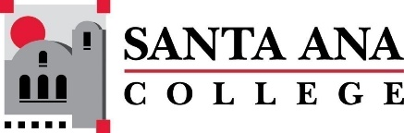 |  | SAC Program Review Committee Minutes  March 25, 2024  1:00 p.m. to 2:30 p.m.  Zoom: https://rsccd-edu.zoom.us/j/87584225311

1. Welcome

- Kim Smith chaired the meeting today in Matthew Beyersdorf’s absence. Quynh Mayer will take minutes.

2. Approval of February 26, 2024, minutes

- Merari Weber motions to approve, Saeid Eidgahy second. All approve.

3. Approval of March 11, 2024, minutes

- Passes with one abstention by Quynh Mayer.

4. Capstone Review presentation by Legal Studies (SAC)

- Legal Studies Capstone presentation led by Professor Kim Smith. Approved for bachelor’s program in Legal studies, proposed to launch fall 2025. Legal studies are tracking disproportionately impacted groups to increase success and retention. Community partnerships highlighted such as legal clinicals and tabletop community involvement. New goals presented, build out BA program, continue to grow staff to accommodate growth. Will be the first paralegal studies BA in the community college level.

5. New Business

- Request by Dr. Nery for Program Review to create a highlight report from capstone presentations about subjects that may not be in the presentation.

- Discussion of Program review of Academic Senate. Highlighting common themes such as facilities, staffing, etc. Topics to formally include in processes to identify outcomes, needs, etc.

6. Review of Completed Capstone Program Review Rubrics for ESL (SCE), English (SAC), Nursing (SAC), and the Speech-Language Pathology Assistant Program (SAC)

- Tabled.

