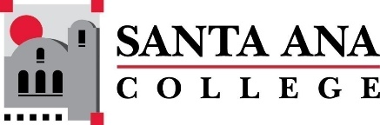 |  | SAC Program Review Committee Agenda  May 6, 2024  1:00 p.m. to 2:30 p.m.  Zoom: https://rsccd-edu.zoom.us/j/87584225311

1. Welcome

2. Capstone Review presentation by Auto/Diesel/Welding (SAC)

3. Capstone Review presentation by the Assessment Center (SAC)

4. Capstone Review presentation by Chemistry

5. Approval of April 29, 2024, minutes

6. Review of Completed Capstone Program Review Rubrics for ESL (SCE), English (SAC), Nursing (SAC), the Speech-Language Pathology Assistant Program (SAC), Legal Studies (SAC), Math (SAC), Fire Technology (SAC), Philosophy (SAC), Global Business and Entrepreneurship (SAC), Career Center (SAC), and Communication Studies (SAC).

7. Next meeting: Monday, May 20, 2024, from 1:00 p.m. to 2:30 p.m.

