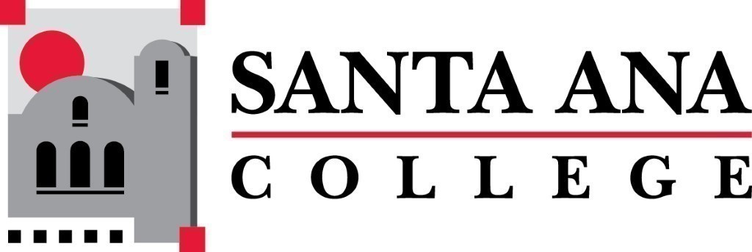 | SAC Program Review Committee  October 4th, 2021  1:00p.m. – 2:00 p.m.  Zoom: https://cccconfer.zoom.us/j/97587393216  Room: TBD
Attendance: Jaki King, Dr. Brenda Estrada, Kim Smith, Cristina Gheorghe, Mark Liang, Saeid Eidgahy, Catherine Emley, Kyle Bradley, Dr. Larisa Sergeyeva, Kathy Walczak, Stacey Bass, Matthew Beyersdorf, Dr. Walter Jones, Cherylee Kushida
Introductions and Welcome –Jaki welcomed us to the meeting at 1:02pm
September 20th, 2021, Minutes moved to approve by Matthew Beyersdorf, seconded by Catherine Emley. Minutes were approved unanimously.
Committee members discussed the creation of Fall 2021 Goals, and a document was created to forward to the IE&A Committee at the next meeting on the 22nd of September.
Jaki reported that the accreditation committee had requested follow up information from the Program Committee. Jaki and Brenda were able to forward several responses and email links to support the college's response to the accreditation inquiry.
Committee discussed the removal of old Program Review website as this has been causing confusion when individuals attempted to search the SAC website for the committee link. To further clarify, the committee information is very up to date, however an old page link lingers on the website and traffic is sometimes directed there.
Committee members discussed if there are more ways to close the PR assessment cycle, other than the rubric. Rubric overview and norming were discussed. A decision was made to add this inquiry to the yearly committee goals and to discuss at the November 1st meeting.
Fire Technology has not submitted their report. Discussed with Dr. Larisa Sergeyeva about the department formally requesting an extension.
Jaki King announced that she will be stepping down as co-chair of the program review committee after the 21/22 academic year.
Several committee members will host study Session Times, as scheduled below:
- Kim Smith & Tyler Johnson: Tuesday, October 12th 1:30pm-3pm.
- Kim Smith & Tyler Johnson: Thursday, October 21st 1:30pm to 3pm.
- Jaki King: Friday, October 8th 10am to 11:30am.
- Jaki King & Tyler Johnson: Monday, October 18th 10am – 11:30am.
- Matthew Beyersdorf & Kevin Kawa: Wednesday, October 20th 12pm - 1:30pm.
- Matthew Beyersdorf & Paula Kincaid: Monday, October 25th 12pm – 1:30pm
Meeting Schedule for the remainder of the year is as follows:
Monday, November 1st 12:30-1:30
Monday, December 6th 1pm-2pm
Meeting ended at 1:54pm.

