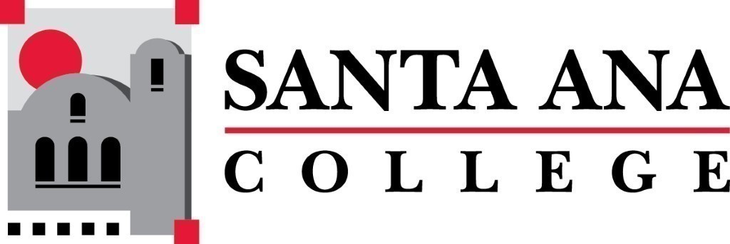 | SAC Program Review Committee  October 4th, 2021  1:00p.m. – 2:00 p.m.  Zoom: https://cccconfer.zoom.us/j/97587393216  Room: TBD
- Introductions and Welcome –Brenda & Jaki
- Approval of September 20th, 2021 Minutes
  - Announcements:
    - Creation of Fall 2021 Goals:
      - Accreditation complete
      - Removal of old Program Review website
      - Are their more ways to close the PR assessment cycle, other than the rubric?
    - Fire Technology – reaching out again
- Discussion - Rubric overview and norming
- Discussion/Announcement - Jaki will be stepping down as co-chair of the program review committee after the 21/22 academic year.
- Study Session Times:
  - Kim Smith & Tyler Johnson: Tuesday, October 12th 1:30pm-3pm.
  - Kim Smith & Tyler Johnson: Thursday, October 21st 1:30pm to 3pm.
  - Jaki King: Friday, October 8th 10am to 11:30am.
  - Jaki King & Tyler Johnson: Monday, October 18th 10am – 11:30am.
  - Matthew Beyersdorf & Kevin Kawa: Wednesday, October 20th 12pm - 1:30pm.
  - Matthew Beyersdorf & Paula Kincaid: Monday, October 25th 12pm – 1:30pm
- Meeting Schedule:
  - Monday, November 1st 12:30-1:30
  - Monday, December 6th 1pm-2pm

