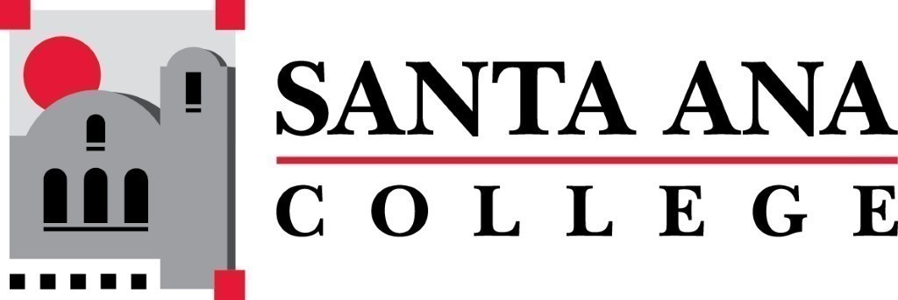 | SAC Program Review Committee  September 20th, 2021  1:00p.m. – 2:00 p.m.  Zoom: https://cccconfer.zoom.us/j/98484243535  Room: JSC 219-2
- Introductions and Welcome –Brenda & Jaki
- Approval of May 10th, 2021 Minutes
  - Announcements:
    - Creation of Fall 2021 Goals – Jaki and Brenda
    - Nuventive - Update
    - List of programs to submit 4-year review areas
    - Review paper document to be submitted
- Discussion - On combined Quadrennial Request from Counseling Dean *
- Discussion – EOPS/CARE/CalWORKs move due date to 2022- Due to AD retirement **
- Study Session times and volunteers
- Meeting Schedule:
  - Monday, October 4th 1pm-2pm
  - November – Monday, November 1st 12:30-1:30
  - Monday, December 6th 1pm-2pm
*Hi Dr. Hubbard and Dr. Estrada,

There is a request from all the Faculty Coordinators for Puente, ULink, MESA, Center for Teacher Education and Transfer Center (including Promise Program) to combine for the quadrennial with Transfer Center and all Transfer Programs. That means one report in the Fall 2021 and one joint presentation in the Spring 2022. Then they will continue to do Annual Program Reviews separately on the other years it is not quadrennial.

Thank you for your consideration,
Maria
**Dr. Hubbard,
I noticed that EOPS/CARE/CalWORKs Quadrennial Program Review is this 21-22 Academic Year. With the absence of an Associate Dean, I am requesting for EOPS/CARE/CalWORKs Quadrennial Program Review be the 22-23 Academic Year.

Thank you,
Maria

