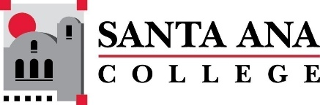 |  | SAC Program Review Committee  May 23rd, 2022  1:00p.m. – 2:30 p.m.  Zoom: https://cccconfer.zoom.us/j/95559225327
Introductions and Welcome – (Brenda & Jaki) - 2 min
Approval of May 9th, 2022, Minutes – 3 min
Presentations:
- Fire Technology – Jennifer Meloni (1:05 – 1:20pm)
- Veteran’s Resource Center – Mark Canett (1:25 -1:40pm)
- ABE-GED – Adrianna Gonzalez and Alexis Alegria (1:45 – 2pm)
- Academic Talent Search – Rosio Becerra (2 – 2:15pm)
- Geology/Earth Science – Claire Coyne and Phil Hughes (2:15 – 2:30pm)

Fall 2022 Meeting Schedule: Monday’s 1pm-2pm
September 19th
October 10th
November 14th
November 28th – special 30-minute planning meeting, 1pm-1:30pm
Holidays: September 5th, November 11th, November 24th-26th

