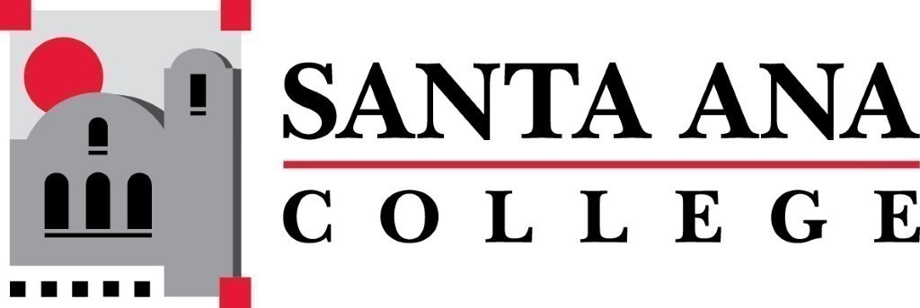 | SAC Program Review Committee  April 26th, 2021  1:00p.m. – 2:30p.m.  Zoom (link in meeting invite)

- Introductions and Welcome – Brenda (5 min)
- Approval of 04/26/2021 Minutes
- 4 Year Program Review Presentations
  - 1:10-1:30 – Manufacturing Technology
- Group Discussion with Rubric
- End of Year Report:
Note from Kim Smith: The report would be yearly, but the focus is on where different programs demonstrate advancement of the schools' goals (as articulated in the master plan, or elsewhere). Program reviews to report back to IE&A on progress towards the school wide goals in the master plan. At least those related to teaching.
  - 2020/2021 Goals
    - Create new plan and schedule for Kinesiology 4-year program reviews.
    - Create new plan and schedule for Student Services 4-year program reviews.
    - Develop a program review rubric for Spring 2021 presentations.
    - Develop a consistent training/workshop schedule for presenters.
    - Assemble a clear membership plan as well as a "purpose statement" by September 30th, 2020.
    - Institute an End of Year report
    - Pilot Nuventive for Program Review
- Creation of 2021/2022 Program Review Goals
- Fall 2021 Program Review Schedule
- Announcements
  - Nuventive Platform Edition – more robust tool. Will need some volunteers from the committee to meet with Nuventive and assist with the build out.
  - Enrollment Management – update question on form
Next Program Review meeting Fall 2021

