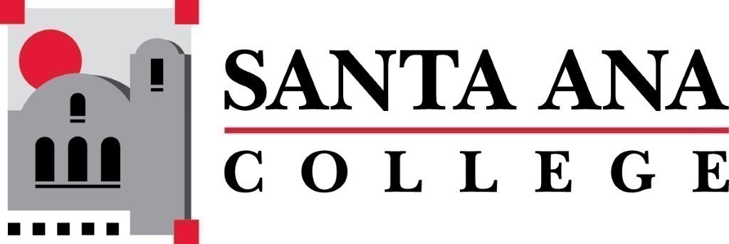 | SAC Program Review Committee  April 26th, 2021  1:00p.m. – 2:30p.m.  Zoom (link in meeting invite)

Members: Catherine Emley, Saeid Eidgahy, Becky Ettinger, Mark Liang, Janet Lechuga, Javier Galvan, Kim Smith, Jaki King, Brenda Estrada, Kathy Walzcak, Matthew Beyersdorf
Guests: Philip Marquez, Carrie Patton, Janice Love, Philipe Andrade (through pre-recorded video)
- Introductions and Welcome – Brenda (5 min)
- Approval of 04/12/2021 Minutes
  - Catherine Emley moved to approve the minutes, Saeid Eidgahy seconded. Approved by all members.
- 4 Year Program Review Presentations
1:15-1:35 – Art
- Accomplishments:
  - Hired a full-time photography instructor.
  - SAC Mural Program Project has accomplishments.
  - Additional Art Galley added to downtown Santa Ana.
  - OTC certified faculty
- Next Four Years Goals:
  - Space for Mural Program, Get Woodshop, hire new full-time employees, increase the presence of Art on the website and social media, lab technician hired for general support and maintenance.
- Facilities & Student Satisfaction
  - Facilities are severely limited and outdated.
  - Seeing more students transferring with distinction – success is going up.
- Analyzing your program & Achievements
  - Faculty regularly review data and discuss.
  - Mural Program – is often in the news with a focus on social justice representation. However, missing an area to house and maintain said murals.
  - Photography Program – now have a full-time faculty, photography has been a consistent and strong program even after pandemic.
  - Ceramics/3D program – New kiln development, updated standard ceramic studio equipment, developed and procured wood working facility.
- Strengths and Challenges
  - Department communicates and works very well together.
  - Down a full-time art history instructor, facilities are not clean, deteriorating facility, lack of instructional assistants.
  - 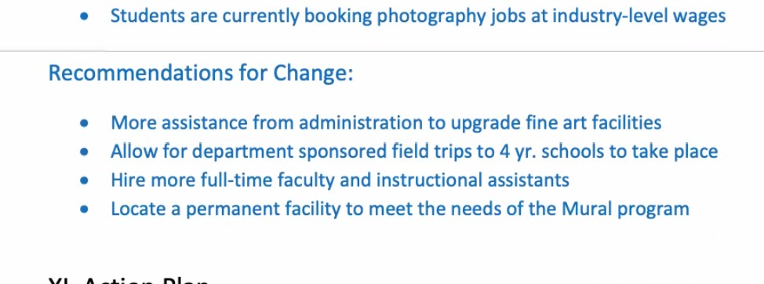
- Q&A – Brenda Estrada has a contact for field trip.
- Strong Workforce grants for scaffolding.

1:40 –2pm – Political Science (video presentation)
- Analysis
  - Students displayed a difficulty expressing counter arguments that demonstrate processing the viewpoints of others. (Communication) - Students are generally strong in retaining information, but much weaker in analyzing information.
  - Philippe Andrade began offering large-instruction courses in the fall 2014. These courses have maintained retention rates above 90% and success rates above 80%.
- Challenges
  - The greatest current challenge to the department is increasing success rates among 200-level students, as well as increasing the number of Political Science AAT degree completions.
- Accomplishments
  - The Political Science Department is the 4th largest department in the Social Sciences/Humanities Division and 10th largest academic department in the college (2018-2019 academic year).
  - The Political Science Department currently has one of the fastest transfer rates at SAC.
  - Question that Political Science would like to know is if the college wide success rate is actually 77%.
  - College-going? Does that mean transfer?

2:00pm – 2:20pm – High School Subjects (Adult Secondary Education)
- Key Accomplishments:
  - One full-time faculty hired.
  - Achieved transition goal for curriculum, professional development, and guided pathways.
- SLO’s
  - Completion rates in the reading and math courses are lower than the rest of the program.
  - English, Social Science, and Natural Science courses have remained relatively steady from semester to semester.
- Equity
  - 65% identify as Hispanic/Latino.
  - Male and Female enrollment numbers remained consistent.
  - Female students made up 9.6% more of the population and were 1.7% more successful.
- Action Plan
  - Pathways to credit.
  - Fully online high school diploma by spring 2022
    - Technology in curriculum and access for students
    - Technology in curriculum and training for teachers
Group Discussion with Rubric
  - Will have a week (May 3^{rd)} to add commendation, recommendations, and resources to the rubric for Art, Adult Secondary Education, and Political Science before it is sent to program chairs on May 4th.
  - Add note in Arts rubric about more data driven information added.
Announcements
- Jaki reports that all programs with a fall 2020 due dates have completed their 4-year review. One, Manufacturing Technology, still needs to present. Question for committee, should we add 30 minutes to the beginning of our May 10th meeting for them to present? Jaki motioned for this suggestion, Brenda Seconded. All in favor. Jaki and Brenda will reach out to Manufacturing Technology to schedule the presentation at 1pm on May 10th.
- Meeting adjourned at 2:18pm
Next Program Review meeting May 10th, 2021 at 1:00pm virtually through Zoom. Presentation by Manufacturing Technology and completion of the Program Review year-end report and development of 2021/2022 Program Review Goals.

