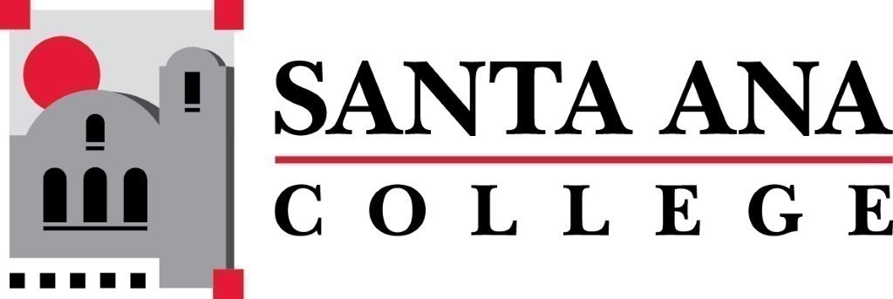 | SAC Program Review Committee  April 26th, 2021  1:00p.m. – 2:30p.m.  Zoom (link in meeting invite)

- Introductions and Welcome – Brenda (5 min)
- Approval of 04/12/2021 Minutes
- 4 Year Program Review Presentations
  - 1:15-1:35 – Art
  - 1:40 –2pm – Political Science (video presentation)
  - 2:00pm – 2:20pm – High School Subjects (Adult Secondary Education)
- Group Discussion with Rubric
- Announcements
Next Program Review meeting May 10th, 2021 at 1:30pm virtually through Zoom

