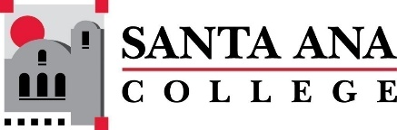 |  | SAC Program Review Committee  April 25th, 2022  1:00p.m. – 2:30 p.m.  Zoom: https://cccconfer.zoom.us/j/95559225327
Introductions and Welcome – (Brenda & Jaki) - 2 min
Approval of April 11th, 2022, Minutes – 3 min
Presentations:
1:05pm-1:20pm Parent Education – Nicholle Clark
Facilitated Round Table Discussion:
1:25pm –2:30pm Dance, Library, Occupational Studies (Heather Gillette, Leann Alduenda, Annie Knight, Susan Hoang, and Dawn McKenna- Sallade)
- Introductions
- Guided questions and discussion
  - What challenges did your program or service area overcome or are still tackling?
  - What were your prior or past goals? Summarize if they have been met, changed, or if the program was unable to complete.
  - How has “Guided Pathways” and/or “Equity Minded Practices” affected your program or service area?
  - In what ways, if any, has your program/service area collaborated with other programs/services on campus? Are there additional areas of collaboration that could be beneficial?
  - Is there an element of the college that you as a program or service area wish you knew more about or was better communicated?
  - What have you learned from completing your current 4-year review and what do you hope to accomplish in the next four years?
Upcoming Program Review Meeting Schedule: Mondays, 1pm - 2:30pm, Holidays: Feb 21st and May 30th
- May 9th
- May 23rd

