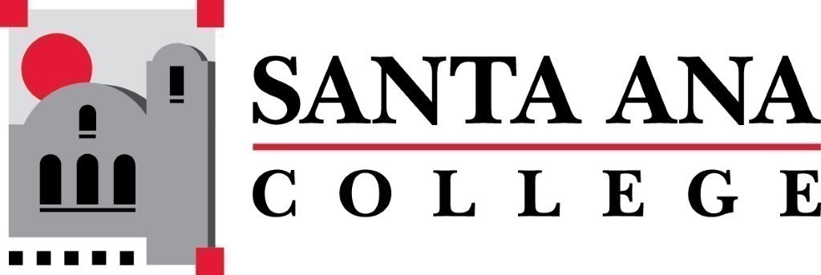 | SAC Program Review Committee  April 12th, 2021  1:00p.m. – 2:00p.m.  Zoom (link in meeting invite)

- Introductions and Welcome – Jaki (5 min)
- Approval of 03/22/2021 Minutes
- 4 Year Program Review Presentations
  - 1:15-1:35 – Citizenship
- Group Discussion with Rubric
- Announcements
Next Program Review meeting April 26th, 2021 at 1:00pm virtually through Zoom, presentations: Political Science, Art, and High School Subjects.

