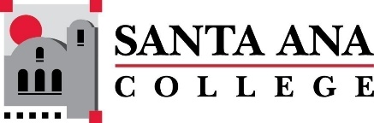 |  | SAC Program Review Committee Minutes  April 11th, 2022  1:00p.m. – 2:30 p.m.  Zoom: https://cccconfer.zoom.us/j/95559225327
Members present: Jaki King, Kim Smith, Catherine Emley, Linda Pabon, Kathy Walczak, Cherylee Kushida, Dr. Walter Jones, Mark Liang, Kyle Bradley
Guests: Brian Sos, Denise Bailey, Vaniethia Hubbard, Kyle Bradley, Kristen Nelson, Dr. Fernando Ortiz, John Ross Jr.
Introductions and Welcome – Jaki welcomed us to the meeting.
Approval of March 21st, 2022, Minutes were approved unanimously. Motion for approval, Kathy Walczak, seconded by Cherylee Kushida.
Announcements –
- PRT Meetings, overview. Kim gave an overview of her input to the meeting regarding the review process.
- Nuventive Update by Jaki.
Presentations:
Admissions and Records – Mark Liang presented on key accomplishments:

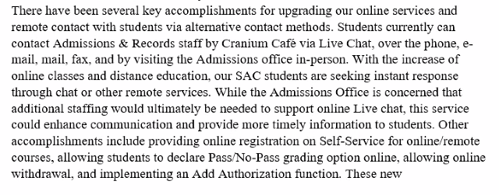
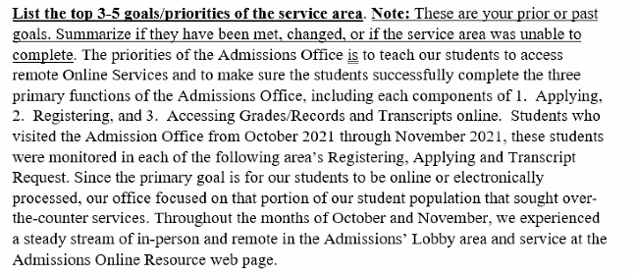
One area that needs to be build out: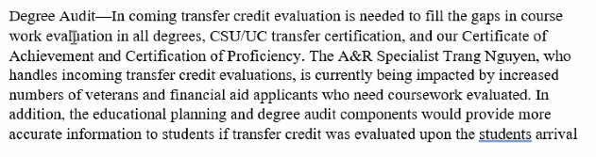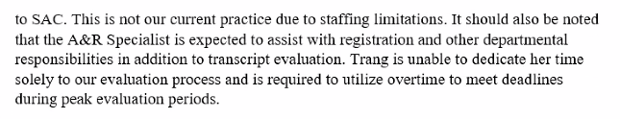
An additional goal mentioned by Mark was to hire a residency expert. Other budget numbers were presented below:
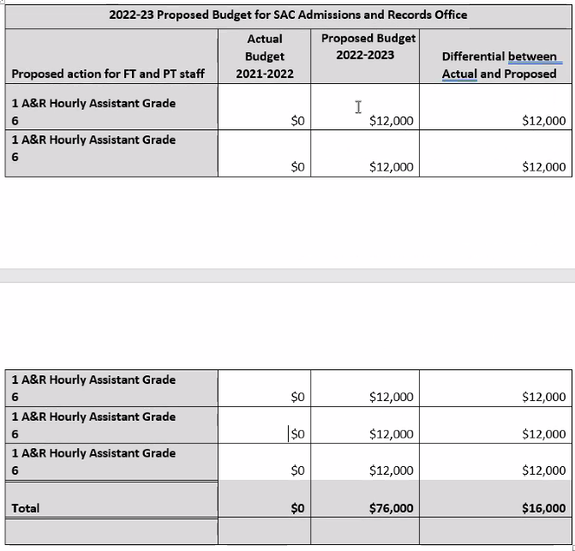
Future goals include:
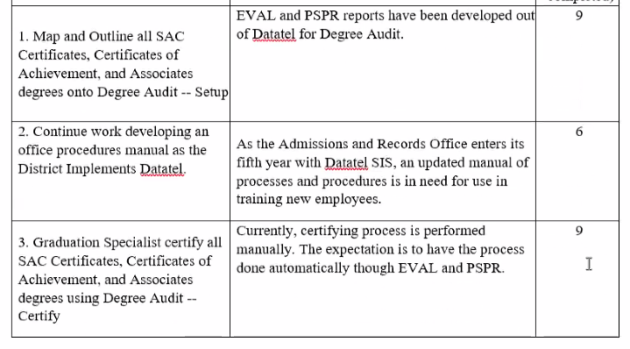
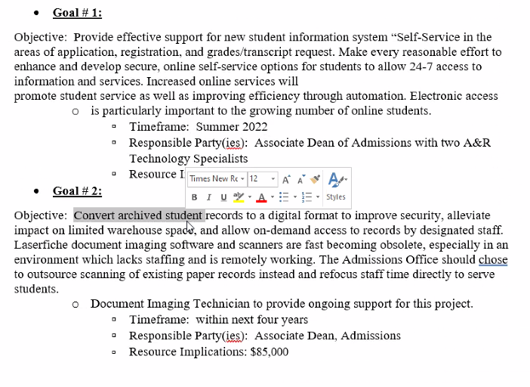
Dr. Hubbard specified that retirements have hit this department the hardest and replacement staff is a priority.

Pharmacy Technology – John Ross informed us that his entire department is made up of former SAC alumni.
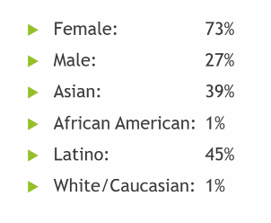
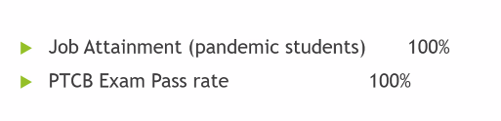
The PTCB is a national test. A department goal was to hit %100. The national pass rate is 58%.
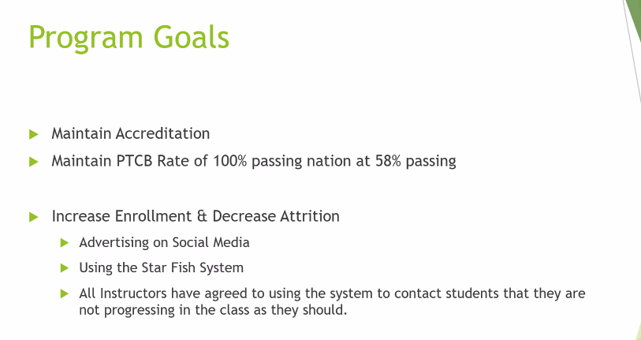
Kinesiology & Health
Brian Sos discussed several curriculum issues as a result of the number of disciplines, department reports, lab and lecture classes, etc., that create some confusion in completing the program review process. Not included was athletics. Degree achievement is admittedly pretty low at about 10%. Industry partners pull out a lot of fitness students, pulling them out of class. Covid has had a dramatic impact on the division.
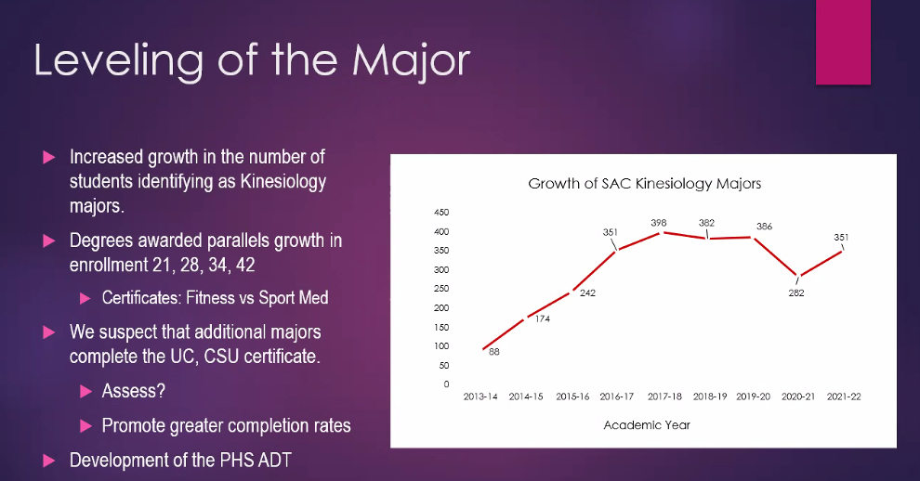
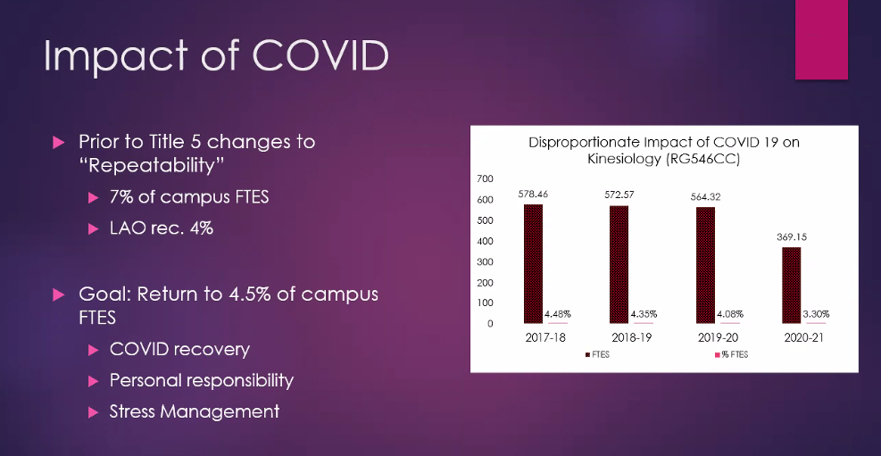
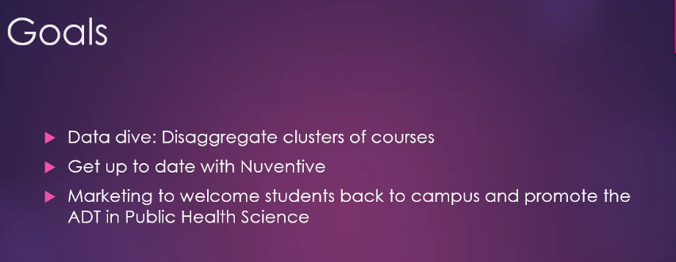
Planning and development for the April 25th round table discussion was discussed. This will be done through ConferZoom.
Kristen Nelson, a new business systems analyst with SAC, introduced herself.
Upcoming Program Review Meeting Schedule: Mondays, 1pm - 2:30pm, Holidays: Feb 21st and May 30th
  - April 25th
  - May 9th
  - May 23rd
Respectfully Submitted,
Kim Smith

