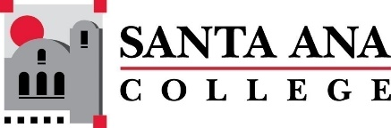 |  | SAC Program Review Committee  April 11th, 2022  1:00p.m. – 2:30 p.m.  Zoom: https://cccconfer.zoom.us/j/95559225327
Introductions and Welcome – (Brenda & Jaki) - 2 min
Approval of March 21st, 2022, Minutes – 3 min
Announcements – 5 min:
- PRT Meetings, overview
- Nuventive Update
Presentations:
1:010pm - 1:25pm Admissions and Records – Mark Liang
1:30pm-1:45pm Pharmacy Technology – John Ross
1:50pm-2:05pm Kinesiology & Health – Brian Sos
Planning and development for the April 25th round table discussion - 20 minutes
Upcoming Program Review Meeting Schedule: Mondays, 1pm - 2:30pm, Holidays: Feb 21st and May 30th
  - April 25th
  - May 9th
  - May 23rd

