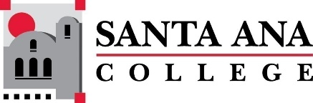 | Minutes: SAC Program Review Committee  March 22nd, 2021  1:00p.m. – 2:30 p.m.  Zoom (link in meeting invite)

Members: Kim Smith, Jaki King, Janet Lechuga, Kathy Walczak, Becky Ettinger, Saeid Eidgahy, Catherine Emley, Maribel Pineda, Javier Galvan
Guests: Mario Robertson, Steve Bautista, Jason Sim, Janice Love, Hugh Nguyen, Nicholas Quach, Maria De La Cruz, Madeline Grant, Stephanie Clark, Ana Meckes, Armando Soto, Shannon Muir
Introductions and Welcome – Jaki
Approval of 03/08/2021 Minutes was unanimous. First: Saeid Eidgahy Second: Catherine Emley
Program Reviews: The following was recorded during 4 Year Program Review Presentations
Counseling
Focus of the department for this report is on coursework and academic programs.
FEP was discontinued despite data showing higher levels of student engagement, higher through-put to English/Math, time to degree, and less accumulated units for completion…Department enrollment is way down as a result. Cost and institutional will was cited as the reason. Janice pointed out that the students served by FEP were typically lower GPA and difficult to reach. They are important in that respect. Janet with Math also stated support for the program and the committee was unclear why this program could not come back.
Alignment of specific sections of Career/Academic planning courses with specific CAPS
Screenshots of the report:
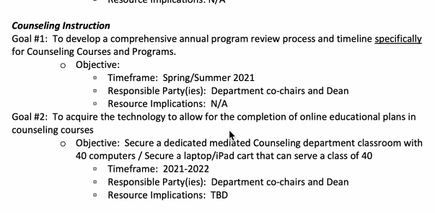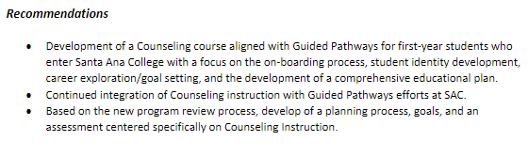
Anthropology/Sociology/Women’s Studies
Some key changes in the Department:
- All full and part time instructors have completed remote instruction certs and most have opted for online cert.
- Almost all (11/13) courses using OER
- Retirement of several key staff
- C. Emily asked about department make up of three distinct areas.
- Funding needs seem limited to hiring faculty to replace existing positions. Perhaps an additional sociology staff member.
Screenshots:
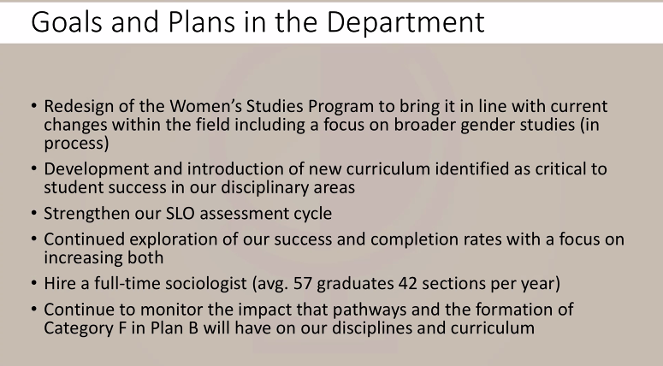

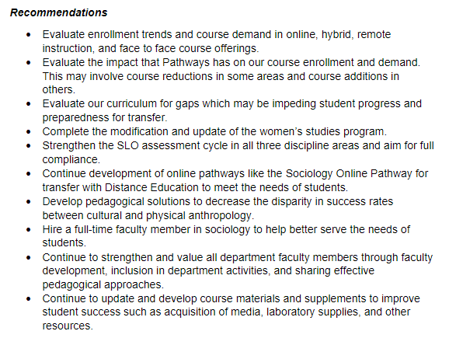
Computer Science
- Jim Hester retirement. Three new adjuncts have been hired. All full/adjunct are fully online certified.
- Working on supporting industry certs for students, connecting to industry.
- eSports is on the radar.
- Madeline gave kudos for the department for all they have accomplished in the last several years.

Screenshots:
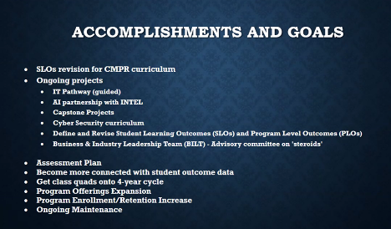

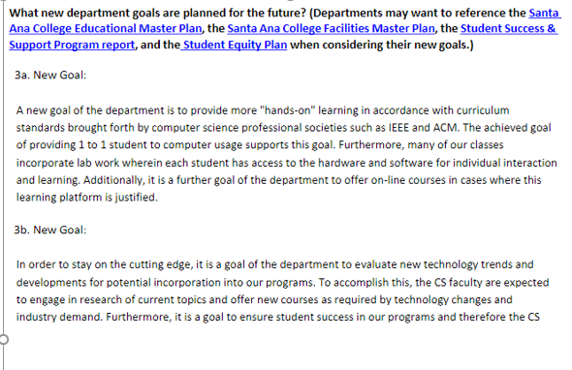

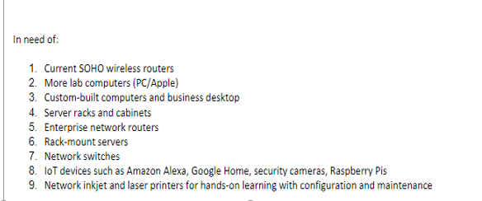

Rubric Discussion: A group discussion about the rubric. We decided to use the most recent iteration of the rubric, as provided by C. Emley.
Fire Tech and Manufacturing Tech have not submitted or signed up for Program Reviews. Jaki will seek support from IE&A Committee.
Final Announcements
Next Program Review meeting April 12th, 2021 at 1:00pm virtually through Zoom, presentations: Citizenship. Happy Spring Break!

