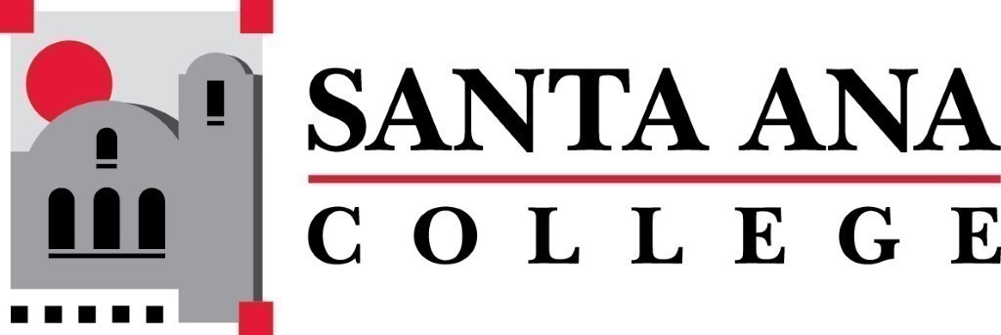 | SAC Program Review Committee  March 22nd, 2021  1:00p.m. – 2:30 p.m.  Zoom (link in meeting invite)

- Introductions and Welcome – Jaki (5 min)
- Approval of 03/08/2021 Minutes
- 4 Year Program Review Presentations
  - 1:15-1:35 – Counseling
  - 1:40-2pm – Anthropology/Sociology/Women’s Studies
  - 2pm-2:20 – Computer Science
- Group Discussion with Rubric
- Announcements
Next Program Review meeting April 12th, 2021 at 1:00pm virtually through Zoom, presentations: Citizenship. Happy Spring Break!

