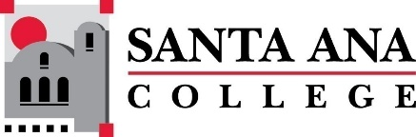 | SAC Program Review Committee  March 21, 2022  1:00p.m. – 2:30 p.m.  Zoom: https://cccconfer.zoom.us/j/95559225327

Members: Jaki King, Kim Smith, Kathy Walczak, Cherylee Kushida, Dr. Brenda Estrada, Cristina Gheorghe, Saeid Eidgahy, Catherine Emley, Kyle Bradley, Dr. Walter Jones, Stacey Bass
Guests: Ann Lockhart, Jeff Cutkomp, Linda Pabon, Abby Ramirez, Stephanie Clark, Melissa Baez, Deisy Romero, Daniel Horenstein, Dr. Larisa Sergeyeva, Melissa Baez, Michael Arambula, Natalie Rodriguez, Dr. Vaniethia Hubbard, Ricardo Castillo, Fernando Ortiz
Welcome & Announcements
- Minutes were unanimously approved. Cherylee moved to accept and Brenda seconded.
- IEPR coming up this Thursday the 24th
- Round table discussion – please remember to contribute. Be prepared to work on this over the next few weeks.
- If you are interested in being the faculty co- chair of the Program Review Committee starting in Fall 2022, please let Jaki know as soon as possible so she can begin training you.
Presentations:

1:010PM- 1:25PM Physics/Astronomy Presentation – Daniel Horenstein
Daniel Horenstein presented.
In the past 4 years they have had an almost 100% turnover, all new faculty. A department in transition.
“Some sections have been realigned (Fall/Spring/Summer) to minimize the time-to-degree metric”
Students Served: Main objective is to update the SLO’s. Some courses are missing SLO’s and when they do have them, they have been vague or hard to assess.
Significant personnel needs:
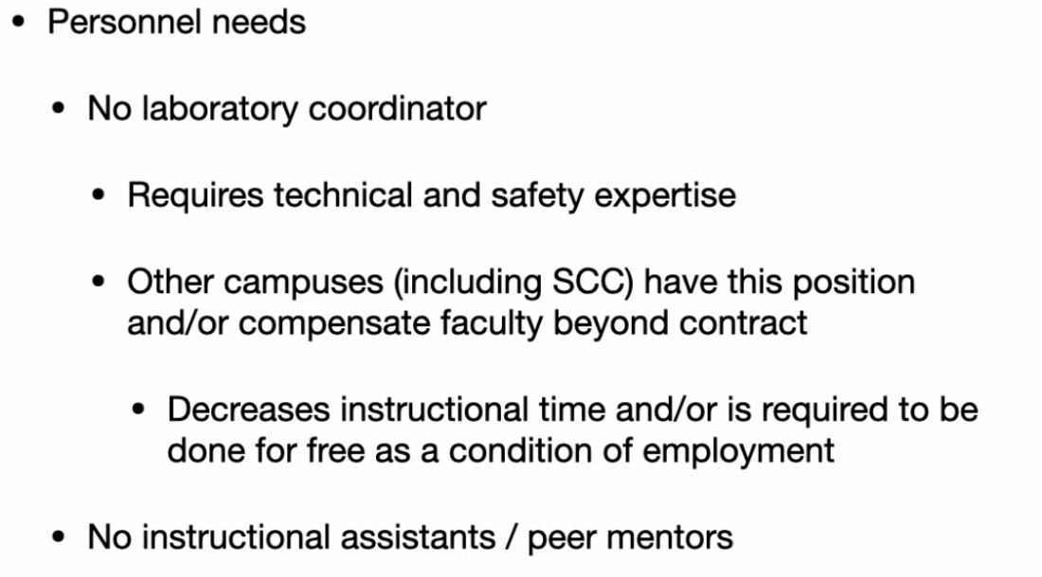
Plans for the remainder of the semester:
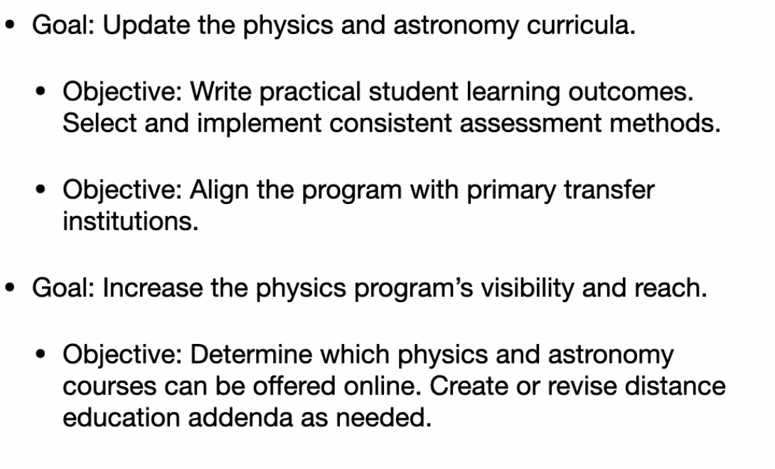

1:30PM-1:45PM Puente Presentation – Ann Lockhart
- Puente is a learning environment cohort. Educationally disadvantaged students are eligible for the program.
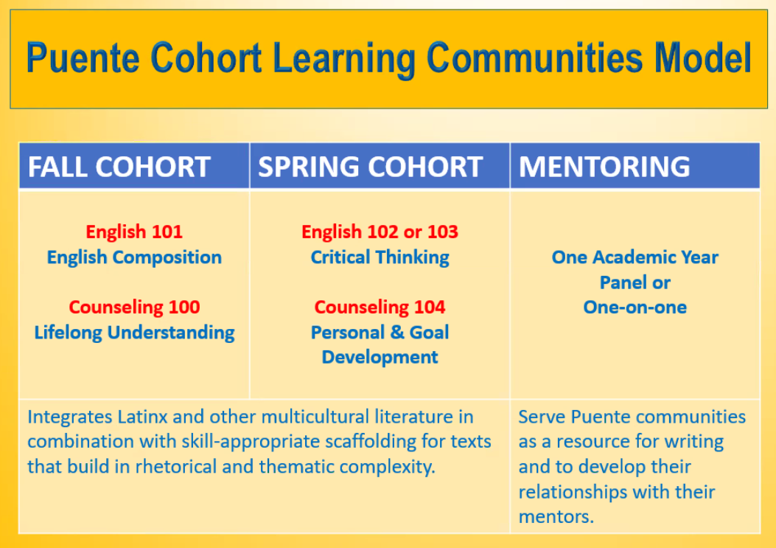
- Consistent collaboration between instructors. Multiple cultural, mentor & transfer activities. There is a significant difference between Puente and non-Puente students with respect to persistence. Puente Program is highly aligned with Pathways. Especially “Clarify...,” Enter...” and “Stay on the Path.”
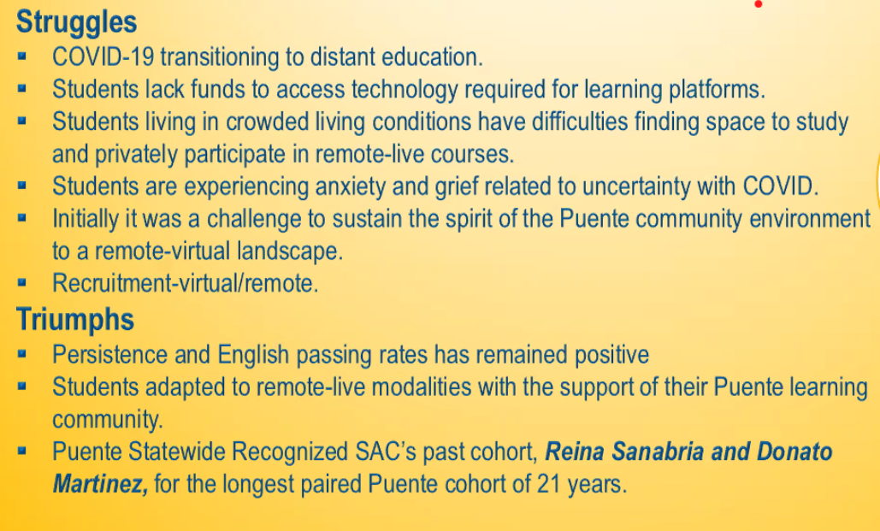
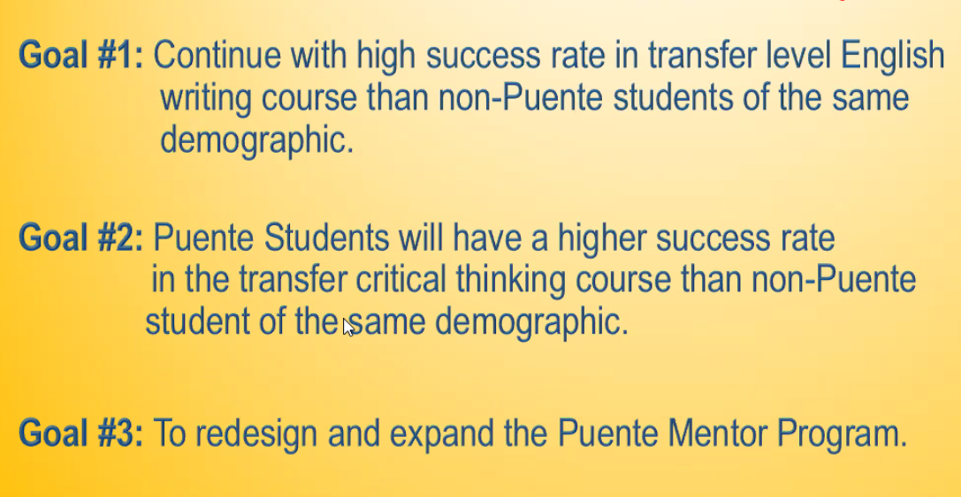

1:50PM-2:05PM MESA Presentation – Jeff Cutkomp
MESA is Math, Engineering, Science Achievement Program.
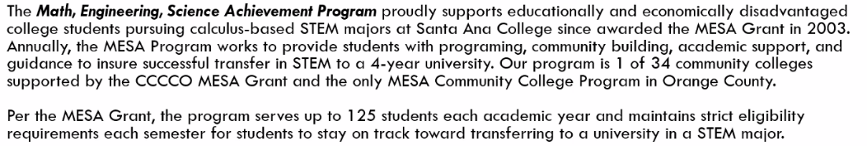
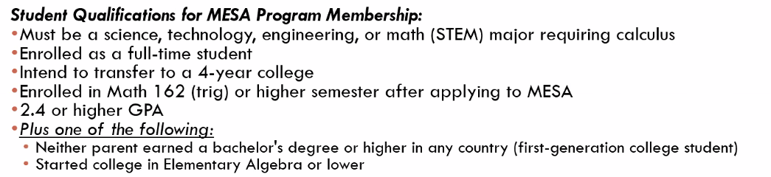
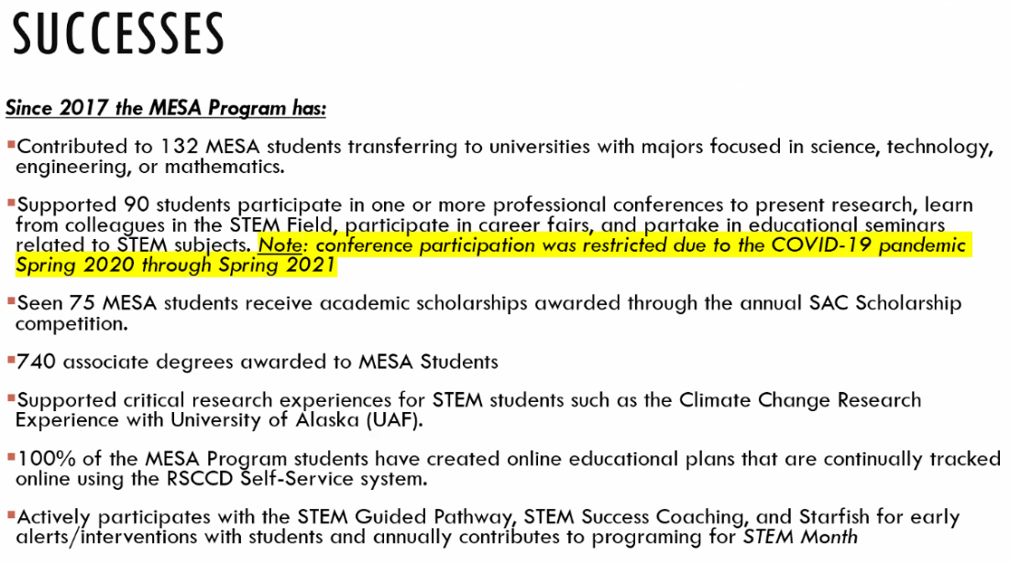
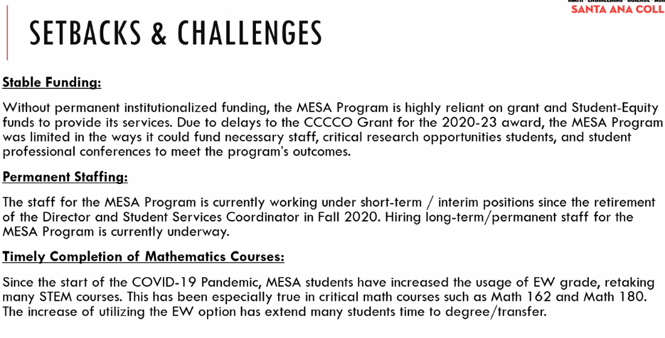
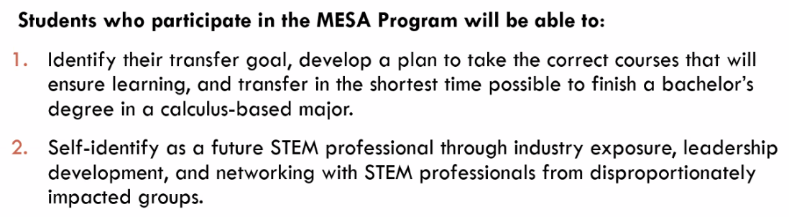
Action Plan:
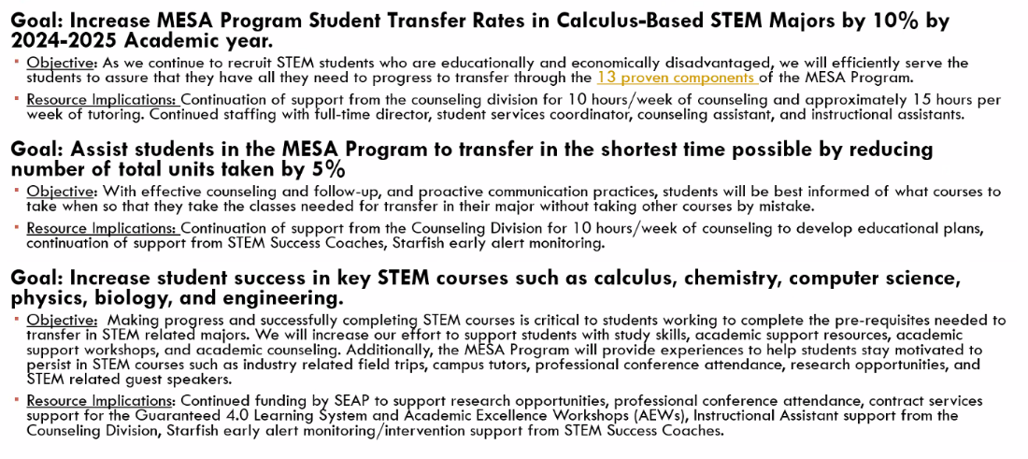

2:10PM-2:25PM Psychology Presentation – Rick Castillo
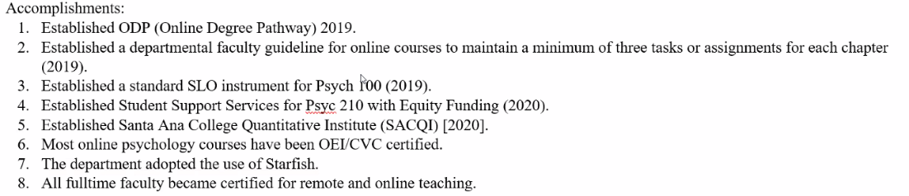
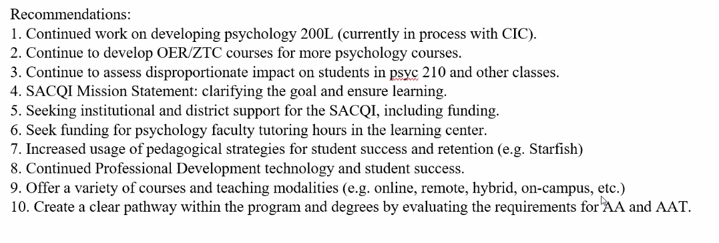
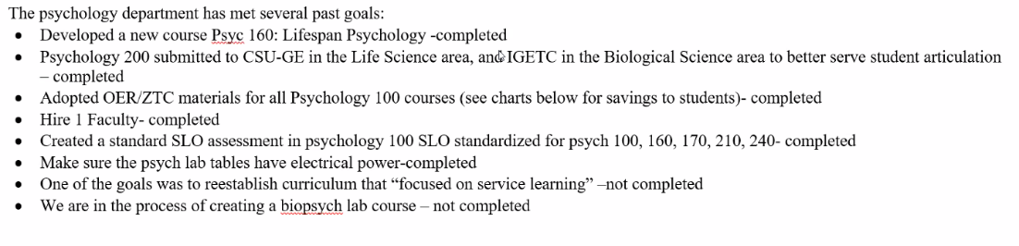
- Library may want to work with Psychology Department on the SACQI Institute.
- Cherylee suggested the Department offered us some benchmarks for Equity due to the size and success of their program.
Upcoming Program Review Meeting Schedule: Mondays, 1pm - 2:30pm, Holidays: Feb 21st and May 30th
  - April 11th
  - April 25th
  - May 9th
  - May 23rd

Respectfully submitted,
Kim Smith

