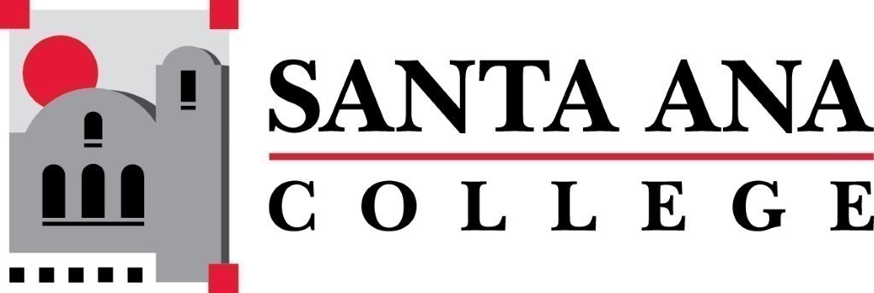 | SAC Program Review Committee  March 8th, 2021  1:00p.m. – 2:30 p.m.  Zoom (link in meeting invite)

- Introductions and Welcome – Jaki (5 min)
- Approval of 02/22/2021 Minutes
- Announcements: (10 min)
  - PR Rubric Resources/Recommendations - Kim Smith
- Approval of PR Rubric
- 4 Year Program Review Presentations
  - 1:15pm-1:35pm – Learning Center
  - 1:40pm-2pm – ASL
  - 2pm-2:20pm – Music
- Group Discussion with Rubric
- Announcements
Next Program Review meeting March 22nd, 2021 at 1:00pm virtually through Zoom.

