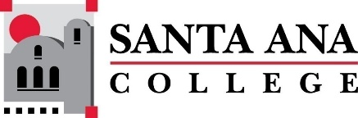 |  | SAC Program Review Committee  March 07, 2022  1:00p.m. – 2:30 p.m.  Zoom: https://cccconfer.zoom.us/j/95559225327
- Introductions and Welcome – (Brenda & Jaki) - 2 min
- Approval of February 14th, 2022, Minutes – 3 min
- Presentations:
1:05PM- 1:20PM Engineering Presentation – Craig Takahashi
1:20PM-1:35PM University Transfer Presentation – Leo Pastrana
1:40PM-1:55PM ULink Presentation – Courtney Beirne
2:15PM-2:30PM History Presentation – Moises Medina
- Announcements and Reminders - 5 min:
  - Accreditation Interview 11am-11:50 on March 8th
  - Round Table Discussion Document
- Upcoming Program Review Meeting Schedule: Mondays, 1pm - 2:30pm, Holidays: Feb 21st and May 30th
  - March 21st
  - April 11th
  - April 25th
  - May 9th
  - May 23rd

