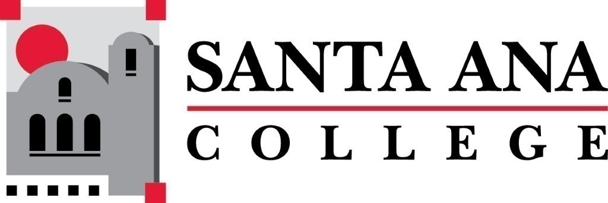 | SAC Program Review Committee  February 22nd, 2021  1:00p.m. – 2:30 p.m.  Zoom (link in meeting invite)

Program Committee Minutes for February 22, 2021
Members: Jaki King, Kim Smith, Janet Lechuga, Maribel Pineda, Javier Galvan, Catherine Emley, Stacy Bass, Matthew Beyersdorf, Kathy Walczak.
Guest: Amberly Chamberlain and Dawn Mckenna-Sallade
- Jaki facilitated introductions and Welcome.
- A11/30/2020 Minutes were approved unanimously. Kim Smith and Matthew Beyersdorf seconded the motion.
- Announcements
  - Nuventive update – Jaki reported that service areas and instructional forums have been put up into Nuventive. Completion is anticipated mid-semester. Unresolved is how resource allocation and SLO’s will connect. Maribel asked about Student Services contact. Brenda Estrada is co-chair and that point person.
  - Update on outstanding PR’s for 2020
    - Jaki reported that Art has a presentation date in March, Earth Science/Geology found a hidden quad that was actually three years ago and therefore reset their date for 2021, Adult Secondary Education has a presentation date, Manufacturing Technology is still MIA.
  - Jaki presented the possibility of accepting a recorded presentation in lieu of in-person. Citizenship has a schedule conflict. The committee discussed and no real problems were noted. The exception, not the rule. We would ask for the recording 5 days in advance and plan to watch the presentation during the scheduled time, fill out the rubric, and forward questions/amend the rubric as necessary. The committee approved unanimously.
- The Program Review Rubric Overview was presented by Jaki. We discussed areas such program responsibility to collect and report on data. The committee discussed a process for completing the rubric and noting commendations and/or recommendations. Rubric will provide the basis for our year end report. Kim with keep a draft document going in Teams. Matthew will edit rubric to be kinder and gentler.
- Occupational Therapy Assistant 4-Year Review Presentation was presented by Dawn McKenna-Sallade. A completed rubric will be included in the minutes.
- From 2pm-2:30pm the committee discussed and drafted rubric. Kim will post a version of the draft rubric and Jaki/Brenda will complete. Discussion centered on the sections related to commendations and recommendations.
The meeting adjourned at 2:30pm. Next Program Review meeting March 8th, 2021 at 1:00pm virtually through Zoom.

