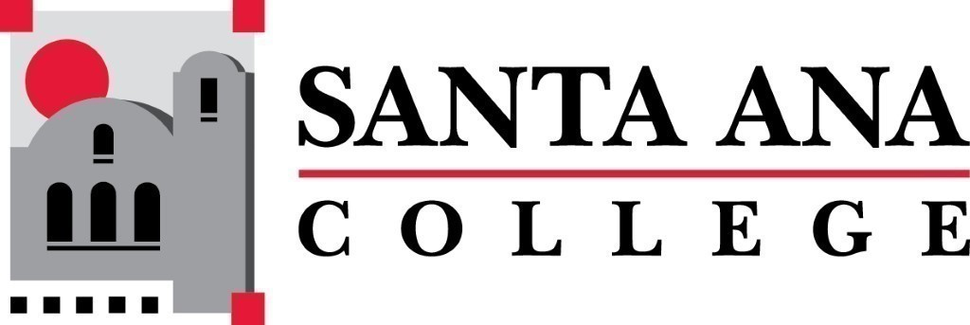 | SAC Program Review Committee  February 22nd, 2021  1:00p.m. – 2:30 p.m.  Zoom (link in meeting invite)

- Introductions and Welcome – Jaki (5 min)
- Approval of 11/30/2020 Minutes (5 min)
- Announcements: (10 min)
  - Nuventive update - Jaki
  - Update on outstanding PR’s for 2020 - Jaki
    - Art, Earth Science/Geology, Adult Secondary Education, Manufacturing Technology
  - Recorded presentation in lieu of in-person (citizenship) - Jaki
- Program Review Rubric Overview – group (20 minutes)
- 1:40pm – 2pm Occupational Therapy Assistant 4-Year Review Presentation
- 2pm-2:30pm Fill out rubric, discussion – group
- Announcements
Next Program Review meeting March 8th, 2021 at 1:00pm virtually through Zoom.

