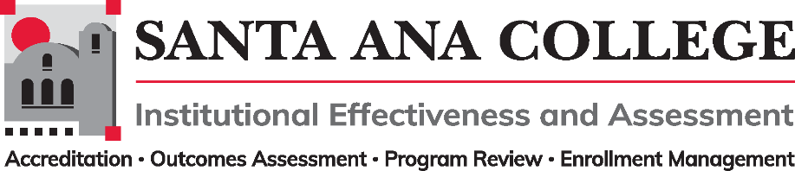
Minutes
November 2, 2022
2:00 – 3:00pm
Zoom- https://cccconfer.zoom.us/j/93732271856

Santa Ana College Mission: Santa Ana College inspires, transforms, and empowers a diverse community of learners.

Santa Ana College Vision Themes: I. Student Achievement; II. Use of Technology; III. Innovation; IV. Community; V. Workforce Development; VI. Emerging American Community

Voting Members: Dr. Fernando Ortiz (co-chair), Jim Isbell (Interim co-chair), Dr. Vaniethia Hubbard, Dr. Saeid Eidgahy, Tyler Johnson, Kim Smith, Ashly Bootman, Suzanne Freeman, Mike Everett, Andrew Barrios, Monica Macmillen, Robert Stucken, Alejandra Garcia
,
Ex-officio Members (Non-Voting): Monica Zarske, Dr. Brenda Estrada, Outcomes Assessment Coordinator (vacant), Dr. Jeffrey Lamb

Participants

- Introductions and Membership: Dr. Ortiz welcomed the group and began the committee meeting at 2:03p.m

- Public Comments: None

- Action Items:
- Approval of Minutes from October 5, 2022 meeting – Dr. Ortiz requested a review and approval of minutes – Motions made by Dr. Eidgahy and Tyler Johnson. 1 abstention, minutes passed.

- Information: None

- Discussion:
  - IE&A Committee Governance Document Update – 1st read: Comment/discussion was held regarding membership and the continued vacancies per department. Ex-officio possibility for the Director of Research – Prior Director of Research requested to be an active voting member – The committee recommended that all vacancies continue to be recruited as representation from all areas is needed for this committee.
  - 2022-2023 Goals Workgroup Updates: Document with 22-23 Goals was shared and listed the Participatory Governance, Planning Processes and Classified Representation Workgroups. These workgroups were created based on the IEPI inquiry for continuing improvement. Workgroups will meet in between IEA committee meeting days and will focus on the stated objectives, action steps and measures of progress. – IEA subcommittee members are encouraged to join.

- Subcommittee Reports:

- Outcomes Assessment – Dr. Ortiz and Jim Isbell have reconvened the OA committee. An updated OA Faculty Coordinator job description was developed and sent out to the committee.
- Accreditation – Monica Zarske – Dr. Lamb reported out and shared that the goal is to find ways to structurally improve accreditation efforts and to continuously keep at top of mind. Accreditation standards have been updated and look forward to align SAC practices with them.
- Program Review – Dr. Brenda Estrada – Program Review presentations will be held Spring 2023. Workshops will be available Tuesdays and Wednesdays and held by Kim Smith, Mathew Beyersdorf and the Research team.
- Enrollment Management- Dr. Jeffrey Lamb – EM Committee is finalizing membership, roles and calendar of practice. Prior meeting discussed data reports that inform schedule building and historical FTES.

- Upcoming 2022-2023 Meetings – All meetings are the first Wednesday of the month from 2:00-3:00pm unless otherwise noted

Meeting adjourned: 3:00pm

December 7, 2022

