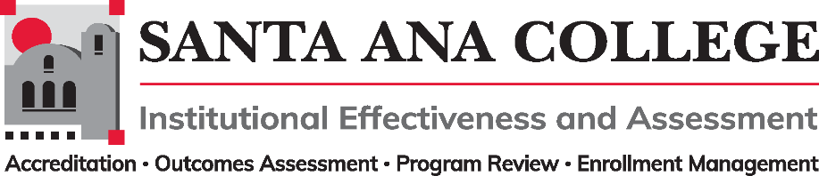
Minutes
June 1, 2022
2:00 – 3:00pm
Zoom- https://cccconfer.zoom.us/j/93732271856

Santa Ana College Mission: Santa Ana College inspires, transforms, and empowers a diverse community of learners.

Santa Ana College Vision Themes: I. Student Achievement; II. Use of Technology; III. Innovation; IV. Community; V. Workforce Development; VI. Emerging American Community

Voting Members: Dr. Fernando Ortiz (co-chair), Justin Tolentino (co-chair), Dr. Vaniethia Hubbard, Dr. Saeid Eidgahy, Tyler Johnson, Kim Smith, Ashly Bootman, Suzanne Freeman, Mike Everett, Andrew Barrios, Monica Macmillen, Rowena Valtairo/Carol Seitz

Zoom Participants: Ashly Bootman, ASL Interpreter – Liz, ASL Interpreter - Traci Spencer
ASL Interpreter - Traci Spencer, Carol Seitz, Cristina Miranda, Dr. Fernando Ortiz, Dr. Saeid Eidgahy, Dr. Vaniethia Hubbard, Heather Arazi, Jaki King, Janet Cruz-Teposte, Justin Tolentino
Kim Smith, Monica MacMillen, Monica Zarske, Peter's iPad, Suzanne Freeman, Tyler Johnson

Ex-officio Members (Non-Voting): Monica Zarske, Jaki King/Dr. Brenda Estrada, Dr. Jarek Janio, Dr. Jeffrey Lamb

- Introductions and Membership: Meeting began at 2:02 pm

- Public Comments: None

- Action Items:
- Approval of Minutes from May 4, 2022 meeting – Kim Smith made motion to approve, Ashly Bootman seconded – Minutes approved

- Information:

- Discussion:
A. Taskforce Updates -
- The Planning Taskforce met with the Planning and Budget Committee to coordinate and align vision in regards to annual and long-term planning calendars and goals. The Planning and Budget committee gave recommendations on who to connect with for specific plans and timelines. IE&A site to serve as reliable location for college plans to be housed to avoid multiple sites with older versions.
- Participatory Governance updates are in process, there is a pending SAC Management Professional Development update to be finalized and vetted for Fall 22 review. Handbook is available via the SAC Participatory Governance site.
B. Review and Evaluate 21-22 Goals- The committee reviewed goals from the beginning of the year and determined that goal #5 can be marked as completed for the time being but is always in progress. #13 objective met but will be ongoing, #4 objective met but will be ongoing, #12 objective met but will be ongoing.

- Goal Setting 22-23 – Committee agreed that the IEPI objectives will be utilized to set 22-23 goals. The goals selected were composed of the following 4 bullet points:
- Formally integrate the planning process, starting with defining the purpose and goals for each plan and then creating a college-wide planning calendar that includes update/refresh cycles for each plan/activity.
- Continue to refine the College’s decision-making process handbook so that it clearly identifies how governance committees are connected to one another, delineates roles and responsibilities, explains how work flows between committees, develops a common method of disseminating information, provides templates for post-meeting communication to the campus and establishes guidance on the representation of each constituency group and their value in the process. This process could also assist the College in evaluating equitable practices and diversity in membership in its committees.
- Ensure that the outcomes of each funded activity are clearly stated and then evaluated to provide a closed feedback loop for continuous improvement
- Structurally align/integrate Student Equity approaches with other college-wide efforts to promote support and sustainability

- Subcommittee Reports:

- Outcomes Assessment – Dr. Jarek Janio- No Report
- Accreditation – Monica Zarske – No Report
- Program Review – Jaki King/Dr. Brenda Estrada – All presentations have taken place and survey results form presentations have been received. Jaki King to continue as Library representative in the Fall.
- Enrollment Management- Dr. Jeffrey Lamb- No Report

- Upcoming 2022-2023 Meetings – All meetings are the first Wednesday of the month from 2:00-3:00pm unless otherwise noted

September 7, 2022 - October 5, 2022 – November 2, 2022 – December 7, 2022

