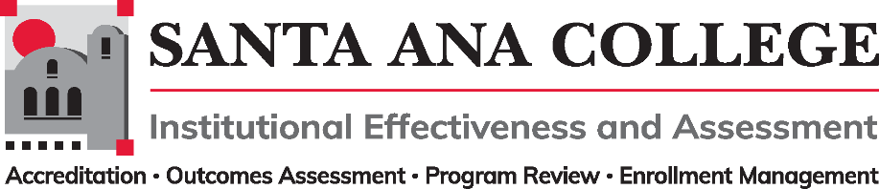
Agenda
December 7, 2022
2:00 – 3:00pm
Zoom- https://cccconfer.zoom.us/j/93732271856

Santa Ana College Mission: Santa Ana College inspires, transforms, and empowers a diverse community of learners.

Santa Ana College Vision Themes: I. Student Achievement; II. Use of Technology; III. Innovation; IV. Community; V. Workforce Development; VI. Emerging American Community

Voting Members: Dr. Fernando Ortiz (co-chair), Jim Isbell (Interim co-chair), Dr. Vaniethia Hubbard, Dr. Saeid Eidgahy, Tyler Johnson, Kim Smith, Mathew Beyersdorf, Suzanne Freeman, Mike Everett, Andrew Barrios, Monica Macmillen, Robert Stucken, Alejandra Garcia
,
Ex-officio Members (Non-Voting): Monica Zarske, Dr. Brenda Estrada, Outcomes Assessment Coordinator (vacant), Dr. Jeffrey Lamb

- Introductions and Membership:

- Public Comments:

- Action Items:
- Approval of Minutes from November 2, 2022 meeting
- IE&A Committee Governance Document Update - 2nd Read

- Information:
  - Participatory Governance Workgroup – Kim Smith
  - Planning Processes Workgroup – Dr. Fernando Ortiz
  - Classified Representation Workgroup – Tyler Johnson

- Discussion:

- Subcommittee Reports:

- Outcomes Assessment
- Accreditation – Monica Zarske
- Program Review – Dr. Brenda Estrada
- Enrollment Management- Dr. Jeffrey Lamb

- Upcoming 2022-2023 Meetings – All meetings are the first Wednesday of the month from 2:00-3:00pm unless otherwise noted

Spring 2023: February 8, 2023 | March 1, 2023 | April 12, 2023 | May 3, 2023

