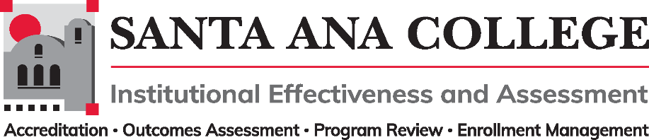
Agenda
October 5, 2022
2:00 – 3:00pm
Zoom- https://cccconfer.zoom.us/j/93732271856

Santa Ana College Mission: Santa Ana College inspires, transforms, and empowers a diverse community of learners.

Santa Ana College Vision Themes: I. Student Achievement; II. Use of Technology; III. Innovation; IV. Community; V. Workforce Development; VI. Emerging American Community

Voting Members: Dr. Fernando Ortiz (co-chair), Jim Isbell (Interim co-chair), Dr. Vaniethia Hubbard, Dr. Saeid Eidgahy, Tyler Johnson, Kim Smith, Ashly Bootman, Suzanne Freeman, Mike Everett, Andrew Barrios, Monica Macmillen, Robert Stucken, Alejandra Garcia
,
Ex-officio Members (Non-Voting): Monica Zarske, Dr. Brenda Estrada, Outcomes Assessment Coordinator (vacant), Dr. Jeffrey Lamb

Virtual Participants: Alejandra Garcia, Andrew Barrios, Cristina Miranda. Dr. Daniel Martinez, Dr. Brenda Estrada, Dr. Fernando Ortiz, Dr. Vaniethia Hubbard. Dr. Walter Jones, Dr. Jeffrey Lamb, Jim Isbell, John D. Steffens, Kim Smith, Mary Steckler, Mike Everett, Monica MacMillen
Robert Stucken. Saeid Eidgahy. Timothy Winchell, Tyler Johnson

- Introductions and Membership:

  - Public Comments: None

- Action Items:
- Approval of Minutes from September 7, 2022 meeting – Motions made to approve minutes by Dr. Saied Eidgahy and Kim Smith, minutes passed.

- Information:

- Discussion:
  - Reporting Change – SACTAC – First Read: John Steffens shared the newly approved College Council reporting change of SACTAC. SACTAC will now be a direct report to College Council to allow for better integrated planning with the District and Ed Master Plan. SACTAC will continue to provide tech recommendations to Planning and Budget. Participatory Governance edits will be made to reflect the placement and reporting change.
  - 2022-2023 Goals (IEPI Objectives): Dr. Fernando Ortiz shared the IEPI Objectives that focus on IEA, Outcomes Assessment, Accreditation, Program Review and Enrollment Management. Recommended a workgroup meet and tackle integrated planning action plans and define outcomes. Additionally, the workgroup can make recommendations to allocate funds to unique areas to help reach potential outcomes if necessary. Workgroup to meet in two Wednesday’s from today to go over goals and report out details/long term planning during the November 2nd meeting. Dr. Jeffrey Lamb made a comment/recommendation regarding self-assessment of membership, roles and review of vacant seats to fulfill IEA objectives

  - Self-Assessment of Participatory Governance Committees: Dr. Ortiz mentioned the need to define membership and address vacancies of the committee for future voting/approval of IEA items. Suggested to also review the purpose and charge of the committee to update the Participatory Governance Handbook.

- Subcommittee Reports:

- Outcomes Assessment: No Report – Dr. Fernando Ortiz to send a meeting invite to reconvene the OA Committee.
- Accreditation – Monica Zarske – No Report – Dr. Lamb recommended that items identified as needing yearly updates are reviewed and updated in a timely manner in order to only require mild refinements in the next accreditation cycle. The commission has updated the Accreditation standards, Dr. Lamb to send standards out to IEA once he receives them.
- Program Review – Dr. Brenda Estrada – Report out from Dr. Estrada mentioned that Mathew Beyersdorf is the new Academic Co-Chair and will be joined by Dr. Daniel Martinez and Mark Reynoso. Additionally, Jaki King is developing step-by-step videos for Nuventive use and FAQs
- Enrollment Management- Dr. Jeffrey Lamb - Report out from Dr. Lamb shared that the past Enrollment Management included a data report presentation form Dr. Daniel Martinez and Tyler Johnson. Additional meeting topics included class maximum discussions with processes and procedures and plans for an integrated planning workgroup.

- Upcoming 2022-2023 Meetings – All meetings are the first Wednesday of the month from 2:00-3:00pm unless otherwise noted

November 2, 2022 – December 7, 2022

