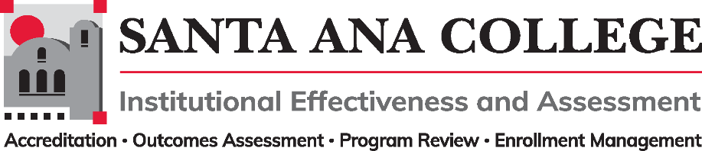
Agenda
April 13, 2022
2:00 – 3:00pm
Zoom- https://cccconfer.zoom.us/j/93732271856

Santa Ana College Mission: Santa Ana College inspires, transforms, and empowers a diverse community of learners.

Santa Ana College Vision Themes: I. Student Achievement; II. Use of Technology; III. Innovation; IV. Community; V. Workforce Development; VI. Emerging American Community

Voting Members: Dr. Fernando Ortiz (co-chair), Justin Tolentino (co-chair), Dr. Vaniethia Hubbard, Dr. Saeid Eidgahy, Tyler Johnson, Kim Smith, Ashly Bootman, Suzanne Freeman, Mike Everett, Andrew Barrios, Monica Macmillen, Rowena Valtairo/Carol Seitz

Ex-officio Members (Non-Voting): Monica Zarske, Jaki King/Dr. Brenda Estrada, Dr. Jarek Janio, Dr. Jeffrey Lamb

- Introductions and Membership:

- Public Comments:

- Action Items:
- Approval of Minutes from April 13, 2022 meeting

- Information:

- Discussion:
A. Taskforce Updates
B. Second Read – 2022-2023 Participatory Governance Handbook

- Subcommittee Reports:

- Outcomes Assessment – Dr. Jarek Janio
- Accreditation – Monica Zarske
- Program Review – Jaki King/Dr. Brenda Estrada
- Enrollment Management- Dr. Jeffrey Lamb

- Upcoming 2022-2023 Meetings – All meetings are the first Wednesday of the month from 2:00-3:00pm unless otherwise noted

June 1, 2022 Needed?

