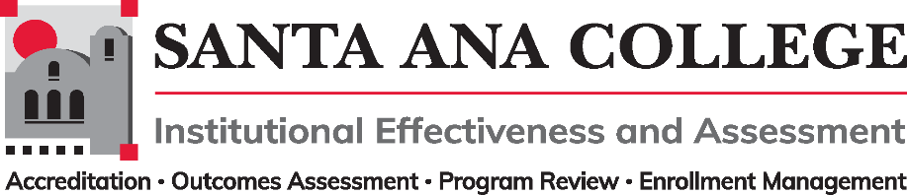
Minutes
May 3, 2023
2:00 – 3:00pm
Zoom- https://us06web.zoom.us/j/84031823721

Santa Ana College Mission: Santa Ana College inspires, transforms, and empowers a diverse community of learners.

Santa Ana College Vision Themes: I. Student Achievement; II. Use of Technology; III. Innovation; IV. Community; V. Workforce Development; VI. Emerging American Community

Voting Members: Dr. Jeffrey Lamb (co-chair), Jim Isbell (Interim co-chair), Dr. Vaniethia Hubbard, Dr. Saeid Eidgahy, Jaki King, Tyler Johnson, Kim Smith, Suzanne Freeman, Mike Everett, Andrew Barrios, Monica Macmillen, Robert Stucken, Alejandra Garcia

Ex-officio Members (Non-Voting): Monica Zarske, Matthew Beyersdorf, Outcomes Assessment Coordinator (vacant), Dr. Jeffrey Lamb, Dr. Daniel Martinez

Participants: Kim Smith, Saeid Eidgahy, Cristina Miranda, William Reardon, Dr. Marvin Gabut, Dr. Daniel Martinez, Andrew Barrios, Dr. Vaniethia Hubbard, Jim Isbell, Dr. Jeffrey Lamb, William Nguyen, Timothy Winchell, Monica Zarske, Suzanne Freeman, Christina Kim Wagner

- Introductions and Membership:

- Action Items:
- Approval of Minutes from April 12, 2023 meeting

- Information: IEPI Workgroups
  - Participatory Governance Workgroup – Kim Smith
  - Planning Processes Workgroup – Dr. Jeffrey Lamb
  - Classified Representation Workgroup – Tyler Johnson

- Discussion:
  - IEPI PRT Summary Report.
    - Next Steps and Areas of Focus – Dr. Lamb shared the IEPI report with summary notes and mention areas of focus for IE&A:
      - Review process on Participatory Governance Handbook. Create survey on doing a yearly update
      - Have a well organized Participatory Governance Website
      - Have a Participatory Governance Teams site with a security feature to protect documents.
      - Nuventive portions to be revisited with the review committee. Responsible manager for Nuventive is not in place at the moment. Question was asked if Nuventive will ever be what SAC needs it to be or is there a potential training issue
  - Planning Summit: Dr. Lamb shared planning summit goals:
    - Go over definition of integrated planning.
    - Identify SACs current process of integrated planning.
    - Identify SACs vision and goal for future planning
    - Creating timelines for systematic review

- Subcommittee Reports: Updates to take place in Fall 2023

- Outcomes Assessment-Dr. Jeffrey Lamb
- Accreditation – Monica Zarske
- Program Review – Matthew Beyersdorf
- Enrollment Management- Dr. Jeffrey Lamb

- Upcoming 2022-2023 Meetings – All meetings are the first Wednesday of the month from 2:00-3:00pm unless otherwise noted

Fall 2023: September 6, 2023 | October 4, 2023 | November 1, 2023 | December 6, 2023

