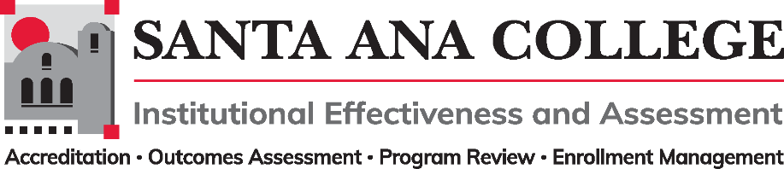
Minutes
April 13, 2022
2:00 – 3:00pm
Zoom- https://cccconfer.zoom.us/j/93732271856

Santa Ana College Mission: Santa Ana College inspires, transforms, and empowers a diverse community of learners.

Santa Ana College Vision Themes: I. Student Achievement; II. Use of Technology; III. Innovation; IV. Community; V. Workforce Development; VI. Emerging American Community

Voting Members: Dr. Fernando Ortiz (co-chair), Justin Tolentino (co-chair), Dr. Vaniethia Hubbard, Dr. Saeid Eidgahy, Tyler Johnson, Kim Smith, Ashly Bootman, Suzanne Freeman, Mike Everett, Andrew Barrios, Monica Macmillen, Rowena Valtairo/Carol Seitz

Ex-officio Members (Non-Voting): Monica Zarske, Jaki King/Dr. Brenda Estrada, Dr. Jarek Janio, Dr. Jeffrey Lamb

Virtual Participants: Here

- Introductions and Membership: Dr. Nery was welcomed to the meeting, will be presenting item IV- A

- Public Comments: No Public Comments

- Action Items:
- Approval of Minutes from March 2, 2022 meeting- Motions made for minute approval, minutes passed as presented.

- Information:
  - Program Review/Outcomes Assessment/Prioritization/Resource Allocation for 2022-2023 – Dr. Nery
    - Dr. Nery addressed the IE&A committee and shared that Program Review should be done for all areas of the college. For non-instructional areas and support services, Program Review will help asses staffing needs, resources and budget allocation/augmentation.
    - Action Item: It was requested the committee help in creating a Program Review template. Dr Nery to provide template examples.
    - Integrated planning calendar-long term and annual was discussed. Goal is to avoid working on plans in the same year. Dr. Nery would like to see annual planning calendars and regular reviews of plan progress to measure goals. Plan goals should be data-driven with student needs.
    - Action Item: Recommended a workgroup be created for this work.

- Discussion:
A. Taskforce Updates - Justin Tolentino
- Update shared on planning taskforce work and mentioned that the work being done in taskforce aligns with the vision Dr. Nery has in regards to the big picture/long term of where IE&A wants to be with SAC plan writing, organization, and creating an annual planning calendar to keep track of the most updated versions to share with the college. Justin shared a working document where the taskforce is drafting guidelines for writing plans and utilizing vision and strategic goals as starting points. Mentioned that the taskforce needs more participants and to please reach out to him to join.
- First Read – 2022-2023 Participatory Governance Handbook (PGH)
  - Dr. Ortiz shared the tracked changes version of the Participatory Governance Handbook. The PGH was reviewed by the taskforce and made edits to the organizational structure which included addition of the Intersectionality, Race, and Social Justice Advisory Group under Academic Senate and a merge of the Safety and Security Subcommittee and Facilities Committee. It also included updated SAC ILO’s and grammar corrections and changes in hyperlink presentation.
  - A comment/recommendation was made in regards to ensuring the document and links are correctly embedded for accessibility.
  - Updated handbook presentation and second read to take place in May meeting.

- Subcommittee Reports:

- Outcomes Assessment – Dr. Jarek Janio-Shared that meetings with Nuventive are still taking place and a survey of the platform will be sent out for users to assess how they understand the functions and data of the platform.
- Accreditation – Monica Zarske-No report
- Program Review – Jaki King/Dr. Brenda Estrada- Jaki King shared that they have all of their programs and services areas with completed 4-year reviews. Nuventive meetings are still taking place and the Program Review committee is reaching out to those that will be using the platform to ensure all information makes sense.
- Enrollment Management- Dr. Jeffrey Lamb-No report

Meeting ended: 3:00 pm

- Upcoming 2022-2023 Meetings – All meetings are the first Wednesday of the month from 2:00-3:00pm unless otherwise noted

May 4, 2022, June 1, 2022

