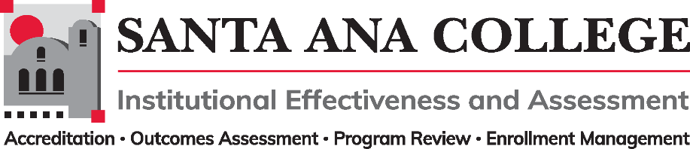

**Agenda**  
**April 12, 2023**

2:00 – 3:00pm

Zoom- <https://us06web.zoom.us/j/84031823721>

## Santa Ana College Mission: **Santa Ana College inspires, transforms, and empowers a diverse community of learners.**

**Santa Ana College Vision Themes**: I. Student Achievement; II. Use of Technology; III. Innovation; IV. Community; V. Workforce Development; VI. Emerging American Community

**Voting Members**: Dr. Jeffrey Lamb (co-chair), Jim Isbell (Interim co-chair), Dr. Vaniethia Hubbard, Dr. Saeid Eidgahy, Jaki King, Tyler Johnson, Kim Smith, Suzanne Freeman, Mike Everett, Andrew Barrios, Monica Macmillen, Robert Stucken, Alejandra Garcia

,

**Ex-officio Members (Non-Voting):** Monica Zarske, Matthew Beyersdorf, Outcomes Assessment Coordinator (vacant), Dr. Jeffrey Lamb, Dr. Daniel Martinez

1. Introductions and Membership:
2. Public Comments:
3. Action Items:
4. [Approval of Minutes from February](https://www.sac.edu/committees/IEA/_layouts/15/DocIdRedir.aspx?ID=HNYXMCCMVK3K-1109-779) 8, 2023 meeting (No March Meeting/Minutes) -Dr. Saied Eidgahy and Robert Stucken made motions to approve-Minutes approved.
5. Dr. Lamb opened the space for conversation on what the committee thought in regard to the standard operating procedures of efficiency for the IEA committee. Asked if the committee would find it beneficial to allocate the meeting recurrence for reserved workspace and time to accomplish IEA committee tasks in between meetings.
   1. Comments made regarding the possibility of meeting every other month to help with workgroup duties, strategic planning and organizing the committees time
   2. Discussion to continue
6. Information: IEPI Workgroups
   1. Participatory Governance Workgroup – Kim Smith- Report out:

Kim Smith, Daniel Martinez, Monica Zarske, and Walter Jones met several times over the past month to work and address issues related to the program governance, as directed by the IE&A Committee Chairs. Roy Shahbazian also participated to provide information about the PG handbook. Here is our report:

* **PG Handbook**: We inquired with college committee chairs about changes to the PG Handbook and received two suggestions that are included for review. With IE&A approval, we will forward back to stakeholders for those agendas.   
  [[](https://rsccd.sharepoint.com/:w:/s/IEACommittee/ES2DbflGykZCjUHlHu-9p0ABVLkRtFrcw6S7CZ7e3j0Ggw?isSPOFile=1)Amendments to CURRENT-SAC_PG_Handbook_January2023.docx](https://rsccd.sharepoint.com/:w:/s/IEACommittee/ES2DbflGykZCjUHlHu-9p0ABVLkRtFrcw6S7CZ7e3j0Ggw?isSPOFile=1)
* **Committee Survey:** We reviewed a Committee Information and Planning Survey and have a version for committee consideration. We were unable to clarify "Function" question 4 & 5, and will push that upward to this committee and college counsel for them to resolve and then issue the survey. [[](https://rsccd.sharepoint.com/:w:/s/IEACommittee/EZzW-tJhZJ5IumfC42menFMB_dJCCGSiYe87pl2xmO3pLw)Committee Information and Planning Survey.docx](https://rsccd.sharepoint.com/:w:/s/IEACommittee/EZzW-tJhZJ5IumfC42menFMB_dJCCGSiYe87pl2xmO3pLw)
* **Templates:** We were asked to consider developing templates for agendas and minutes. Our big ideas are 1) to make these optional and offer a variety of docs that committee chairs can have the option of using, and 2) to incorporate accreditation standards into some documents in the same way we now put mission and vision statements at the top on an agenda. We will pick up work here as time allows.
* **Professional Development:** We are engaging on this topic and plan to sign up for some PD training slots on governance. We obviously still need to do some work here.
  1. Planning Processes Workgroup – Dr. Jeffrey Lamb – Report out explained the work taking place within the committee – Details [found here](https://www.sac.edu/committees/IEA/_layouts/15/DocIdRedir.aspx?ID=HNYXMCCMVK3K-1109-786) (see highlight)
  2. Classified Representation Workgroup – Tyler Johnson – No report

1. Discussion:
2. Subcommittee Reports:
3. Outcomes Assessment-Dr. Jeffrey Lamb: Report shared the news of the approved support that OA will be receiving with a Curriculum/ Outcomes Assessment Specialist. Details to come as the Job Description comes together.
4. Accreditation – Monica Zarske- Report shared the intention to determine what the ongoing standing accreditation committee might look like. Possibly meet 4 times a year, Participatory Handbook to reflect those updates.
5. Program Review – Matthew Beyersdorf – Report shared that program presentations will be happening at the end of the semester.
6. Enrollment Management- Dr. Jeffrey Lamb-Membership passed – Participatory Handbook to reflect those updates.
7. Upcoming 2022-2023 Meetings – All meetings are the first Wednesday of the month from **2:00-3:00pm** unless otherwise noted

**Spring 2023**: May 3, 2023