Onboarding

CCC MyPath (Chancellor’s Office Technology Center)
The College has set a goal to increase the yield rate of applicants to actual enrollments. It has mounted vigorous efforts each term to help students complete their application for admission, matriculation steps, and enrollment in classes. Those efforts should continue. SAC is currently paying for high school students to use the Super Strong Assessment Inventory in order to help them select a potential career technical education (CTE) program of study and may want to continue to do so.

According to the Student Success Metrics Scorecard, SAC has steadily improved the numbers of all categories of students who actually enroll after applying to the college (yield rate) from 47% in 2014-15 to 49% in2017-18. The lowest yield rate category of students, an average of 42% from 2014-15 to 2017-18, was among the students seeking short-term career curriculum.

A study by the Chancellor’s Office revealed that only 46.7% of the students who completed a CCC Apply application for a California community college ever followed through and enrolled at that college. To address that modest yield rate the Chancellor’s Office Technology Center collaborated with the Economic Modeling Specialists International (EMSI) to develop a software solution to assist colleges to increase the yield rate by keeping prospective students engage with the college before registration and enrollment dates. The CCC MyPath software also represents an effort to help students explore career options; however, that aspect of the technology is optional and does not have to be implemented. Both the CCC MyPath and the embedded career coach functionality are currently supported by the Chancellor’s Office and therefore are free to any college interested in implementation. The CCC MyPath technology is another means to help students enter college.
As of December 2019, 45 California community colleges have adopted CCC MyPath, including all nine colleges of the Los Angeles Community College District. Of these 45 colleges, 25 were live and 20 were in the process of deploying CCC MyPath for their students. One of CCC MyPath’s strengths that college personnel regularly point to is that it helps to keep students engaged before, during and after enrollment, and especially in the timeframe immediately following an application submission. Between January 2019 and November 2019, students at colleges where CCC MyPath was live completed a total of 568,095 tasks related to enrolling and onboarding. Students completed 1,576 tasks daily between January and June, and 2,067 tasks daily from July through September during the busy Fall 2019 college application season.
From July to September metrics showed that 84.4% of all Golden West College’s incoming applicants engaged in the CCC MyPath onboarding experience, and 75.3% did so at Solano Community College. These high percentages indicate that students were engaged during the time between application and enrollment, a time when a drop off between the number of students that apply and those that enroll had been noted to be statistically significant.
Among the 25 college that have implemented CCC MyPath there are six colleges using Ellucian/Datatel Colleague. Although the CCC MyPath is independent of the student information system the college uses, SAC leadership may want to speak with one or more of these six colleges about their experiences. Each point of contact is listed below.
- Cabrillo College, Amy Lehman, Dean for Counseling and Educational Support Services (CESS) Dean for Guided Pathways, amlehman@cabrillo.edu
- College of the Canyons, Gina Bogna, Dean of Career Services, gina.bogna@canyons.edu
- College of the Desert, Frank Ramirez, Counselor, frramirez@collegeofthedesert.edu
- Crafton Hills College, Larry Aycock, A & R Coordinator, laycock@sbccd.cc.ca.us
- Evergreen Valley College, Adela Swinson, Vice President of Student Affairs, adela.swinson@evc.edu
- Lassen Community College, David Corley, IT Director, dcorley@lassencollege.edu
- Ohlone College, Robert Smith, Student Success Coordinator – New Student Orientation & Outreach, rsmith55@ohlone.edu
- Yuba College, Jeremy Brown, Dean of Student Success, jbrown2@yccd.edu

Sierra College was an early adopter of CCC MyPath and has done a great deal to exploit the reporting capabilities of the product. Julia Arreguy, Software integration Manager in the Office of Enrollment and Student Success jarreguy @ sierracollege.edu led the implementation. As previously mentioned, the Los Angeles CCD is currently implementing CCC MyPath in all nine of its colleges.

The Enrollment Services team at SAC has been studying the CCC MyPath technology and is encouraged to contact the CCC MyPath Technology Center college relationship manager for this project, Monica Zalaket (mzalaket@ccctechcenter.org), and move forward with implementation.

“Rural Development” CTE Articulation and Get Focused-Stay Focused (Bakersfield)
SAC serves a community in Orange County that is fourth from the bottom in median household income among the 40 places listed by the U.S. Census in the County. In 2019 the City of Santa Ana was estimated to have 32% of the population with less than a high school education. That is more than twice the 14% in Orange County. Conversely, residents in the City of Santa Ana who completed a Bachelor’s Degree represent 15% of the population while in the whole of Orange County the population with a Bachelor’s Degree represents 26% of the population. The magnitude of the challenge to raise the educational level of the service area that SAC faces is similar to that faced by Bakersfield College (BC) in Kern County.

BC is the largest of the three colleges in the Kern Community College District (KCCD). The KCCD covers nearly 32,647 square miles in California in parts of Kern, Tulare, Inyo, Mono, and San Bernardino counties.

Much of Kern County, outside of the Bakersfield City limits, is rural and the economy is primarily driven by either agriculture or energy production Many of the occupations in the agriculture industry are low-wage or seasonal jobs. The decline in the price per barrel for oil has left scores of workers unemployed. Both of these circumstances contribute to the ongoing circumstances of poverty and unemployment that have plagued Kern County for decades. Limited public transportation often isolates these rural communities because it is difficult for residents interested in pursuing postsecondary education to travel to the College’s Bakersfield or Delano Campus locations.

Educational attainment is linked to employment opportunities and income levels. The Public Policy Institute of California (PPIC) research has shown that college graduates do far better in the labor market than do individuals with less education. The proportion of adults in Kern County who have a bachelor’s degree or higher is 15.4% compared to the state, at 31.4%.

The College had launched a series of Rural Initiatives, primarily career technical education, but also general education coursework. These initiatives targeted the small, rural, isolated communities in Kern County with the intent of promoting a college-going mindset within the public-school students. The initiatives called for intensive and substantive collaboration with community partners, local high schools, industries, and four-year institutions to advance a shared vision for economic development, workforce preparation, and education.

As is the case at SAC, BC has developed a host of career technical education course and program articulation agreements with high schools that are grounded in the career clusters at the high schools and bridging to the many College career pathways. These have been one foundation for expanded dual enrollment among the high school students. A second foundation is the career exploration and planning curriculum required by the high schools in the BC service area. Those public-school districts have implemented the national Get Focused-Stay Focused curriculum and allowed BC faculty to teach the curriculum as a three-unit credit, transferable course (STDV B3- Career and Life Planning) offered by the College. As of spring 2020 BC is offering 28 sections of this course in area high schools, see Appendix D for details. From fall 2015 to fall 2019 BC has moved from 747 to 5,238 special admit students.

The Get Focused-Stay Focused program model is a classroom-based, comprehensive guidance curriculum designed to increase high school and college completion and propel successful entry into the workforce with the skills required to succeed. The high school curriculum consists of three interrelated components:
- Students complete a semester or year-long freshman, comprehensive guidance course that helps them identify their interests and life goals, discover a career aligned to those interests and goals, and develop an educational pathway to prepare for that career.
- The freshman course culminates with the development of an online, skills-based, 10-year career and education plan that is updated each year throughout high school and can be used for counseling and by instructors for academic coaching.
- During the 10th, 11th, and 12th grades students update their 10-year plans as they take a series of follow-up instructional modules that help them expand their career and education options. They’ll learn the process for selecting and applying to postsecondary education and identifying the skills needed in the workforce.

Points of contact at Bakersfield College are:
Able Guzman, Executive Director of Rural Initiatives, abel.guzman@bakersfieldcollege.edu, 661 720-2054
Richard McCrow, Dean of Instruction (formerly lead on rural initiatives), rmccrow@bakersfieldcollege.edu, 661 395-4921
Steve Watkins, Executive Director of Outreach and School Relations, steven.watkin@bakersfieldcollege.edu, 661 395-4551

The Garden Grove Unified School District has recently started to implement the Get Focused-Stay Focused curriculum.

The College is encouraged to engage the Garden Grove Unified School District in discussions about a potential collaboration that might allow the College to teach a credit course and collect the FTES for enrolled students.

Appendix A: SAC Coordinated Calendar (11 x 17, 2 pages)

These documents will need to be folded into the final report with the 17” side horizontal.

Appendix B: Trends Credit Instructional Programs, Details by TOP

Source: California Community Colleges Chancellor’s Office. Data Mart Queries; analysis by Cambridge West Partnership, LLC

Appendix C: Trends in Non-Credit Instructional Programs
Source: Santa Ana College School of Continuing Education. Quick Facts; analysis by Cambridge West Partnership, LLC

Appendix D: Bakersfield College and the Get Focused-Stay Focused Curriculum Offerings

Spring 2020 Schedule of Classes

Source: Bakersfield College. Spring 2020 Schedule of Classes. Retrieved January 19, 2020 from https://ssb-prod.ec.kccd.edu/PROD/kwskpsch.p_search?term=202030

Three-Year Trend in the rural communities of Arvin, Shafter, Wasco, McFarland, and Delano.
Source: Richard McCrow, Formerly Director of Rural Initiatives, Bakersfield College. Personal Correspondence. January 22, 2020

Appendix E: Pasadena City College Registration Audit Table Report

Source: Office of Institutional Effectiveness, Pasadena City College. Registration Audit Table Reporting.

Appendix F: Long Beach Schedule Planning/Student Demand Dashboards

Each of the following dashboards have been developed for the Vice President, instructional deans, and department heads to use. The view presented to each user is limited, based upon their role and current area of assignment. In general, when the cursor is held over a number in the dashboard an additional information box automatically displays to provide more details about the number values. In some dashboards the data displayed is a comparison of the current date in the term compared to the same date, relative to the start of the term, in the prior year. For example, an overview of FTES is available on a daily basis using the exact same dates, current term vs. past same dates in prior terms, comparison.

The icons in the top right of each dashboard provide access to additional information as follows:

- The “i” symbol allows for an annotations about different parts of the data to become popup windows with explanations of the numbers.
- The triangle “!” warning symbol evokes two tables with additional course information. In one table is a listing of courses with the highest counts of students on the waitlist. A second table is a listing of courses with particularly low enrollments relative to the enrollment capacity.
- The eye glass symbol takes the user to the next level of detail.
- The funnel is a filter mechanics to look at greater levels of detail.

The following dashboard displays total enrollment, empty seats (based on section caps), waitlists and drops summed up for each school. Next to that display is an accounting of the total active sections broken down by how many are full vs have empty seats. The arrow/equal sign indicator at the far right displays whether or not the current enrollment amount is higher/equal/lower than last year at the same point in time relative to the start of the term.

A dean or department head might want to drill down to individual courses which can be done in the dashboard in order to see all the same information, but for courses.

As Associate Degrees for Transfer (ADTs) were adopted more students began to follow the Plan B California State University General Education Breadth Pattern. About one year ago the College decided to encourage all students seeking an Associate of Arts or Associate of Science degree to also follow the Plan B general education pattern because most of those students were interested in transferring to a four-year institution. That has increased the demand for seats in courses that are a part of the Plan B general education pattern.

Lastly, deans and department heads can drill down to the section level of a given course.

The following dashboard allows deans and department heads view potential demand for courses. It was developed by the Institutional Effectiveness and Academic Services Offices to help in planning out future terms as well as to familiarizing department heads with the education planning process because many of the department heads do not know much about the process.

The power of this dashboard is in its interactivity. The key bit of information in the display below is in the blue bars, which denote that there are active students at LBCC with that course on their education plan who have not yet taken the course. The light blue color denotes the numbers of students who intend to take the course in the immediate future; the slightly darker blue color denotes the numbers of students who intend to take that course at some semester in the future; and, the darkest blue color denotes the numbers of students who should have taken the course in this term or some past term.

Recently the College has had a very large expansion in the demand for ENGL3, which is something that is noted both from its high fill rate and it could have seen ahead of time by looking at its high incidence on education plans. The Institutional Effectiveness and Academic Services Office staff groups are working to training department heads to look at this kind of data to anticipate changes they might need to make in the future schedule of classes proposals.

LBCC launched the Tableau online software in January 2018 and organized a series of orientation workshops for all full-time faculty with particular attention to department heads and deans. By the end of that year about 75% of the “target audience” of end users had establish an account. The current emphasis is to get deans and department heads to regularly use the dashboards.

Some of the dashboards are summary displays that only get updated at the end of the academic year and are used for longer range planning.

Appendix G: LACC FTEF Distribution Model Example

(a 11 x 17 spreadsheet folded into the report)

Appendix H: LACC Excel Schedule Planning Tool Example

Excel Schedule Planning Tool (ESPT) Guide

1) On the top of the table, only fill out the yellow boxes: Department Name, Standard Hour Allocation and FTES target
2) Within the table, filter your department using column “Department” (B).
3) Within the table, input numbers only in columns: “Reg.” (L), “Online”(M) and “Comb Hours” (N).
a. Under “Reg.,” indicate the number of regular (face to face) sections.
b. “Online,” indicate the number of online sections.
c. “Comb Hours,” indicate the number of hours you will save from combining sections of the course
d. Please note the information provided in the following columns:
i. Last Term (H) –the major term when the course was last offered between Fall 2014 to Fall 2016
ii. Avg. Enr. (J) – average enrollment during the last term the course was offered.
iii. Sect# (K) - the total number of sections during the last term
4) Once you reach a total value at the bottom of the table, please refer back to the top. If “St. Hours” has a RED value, you have overused your hours. You must reduce the number of sections scheduled. If “FTES” is red, the classes have not met your FTES target. Thus, you need to reallocate the hours to more efficient classes.
5) The sections with Accounting Method = 3 (Positive Attendance) are not included in FTES calculations, but the hours need to be scheduled

(a 11 x 17 spreadsheet folded into the report)

Appendix I: LACC Program-Course Matrix Example

(a 11 x 17 spreadsheet folded into the report

Appendix J: SAC Enrollment Management Related Reports

District Enrollment Management Database
The District created a web-based Enrollment Management Tool (EMT) that provides a comprehensive set of data variables at the section and meeting pattern level of detail but has data aggregation capabilities for campus, division, departments, subjects, and course as well as subtotals for type of attendance collection. It displays forecasted FTES, actual FTES, and achieved FTES (census FTES for non-positive attendance classes plus the actual FTES for positive attendance classes). Several performance indicators (enrollment, revenue/cost, and forecasting) have been included in the reporting. At run time colleges and centers, year and terms, and student resident status, and apprenticeship classes can be used as filters. The EMT was created as an operational data store with nightly extracts and uploads from the Datatel system that are then used to support reporting. In short, it is “Excel on steroids.”

The output can be in PDF or Excel spreadsheets. The built-in reports are:
- EMT0300 State Apportionment. Provides term-specific attendance data by college. Run-time variables allow for the selection of residency status , apprenticeship status, and accounting method. Additional run-time choices included start/end dates, subject, course, and section.

- EMT0310 Term Comparison Analysis. Facilitates comparisons of FTES, enrollment faculty load, attendance hours between two terms. Location selection is a run-time variable.
  - Campus leaders have tried to use this report but note that if it is run during a term the comparison becomes the results at the conclusion of a past term vs. the fluid circumstances of the present term. The report’s value may be in comparing two completed terms.

- EMT0330 Schedule Cost. Provides an estimate of instructional costs for a specific term and location. Run-time variables include section start/end date Boolean logic choices, sorting options (division, department instructor, date, GL object code, section number), and contract type selections. A detail or summary report as well as summaries are available.
  - Campus leaders have tried to use this report to project instructional costs but have found that it does not produce accurate results.

- EMT0320 Section/Crse Comp. The EMT0320 compares the fixed values of the course to the values in the named term to flag cases where the values differ. Run-time variables include location and comparison of less than catalog’s or more than the catalog’s values.
Planning Future Schedules
RG0540 Census Reporting Enrollment and FTES Computation provides an FTES and census enrollment counts along with other schedule details for each section.

RG0541 Term Enrollment Information is similar to the RG540 but the criteria may differ and aggregated FTES data is provided by attendance type.
- The Vice President for Academic Affairs uses this to extract data which is placed into an Excel pivot table to develop FTES and FTEF history and future targets for the divisions.

CU0321 Active Courses With The Last Term Offered provides a list of all active courses with the last semester a section of the course was offered. Sections must have been active the entire term, not cancelled. Selection criteria include location.

Monitoring Current Schedules
The College has organized data entry for the schedule of classes in a decentralized way with staff in division offices responsible for the maintenance of the schedule data. While a future schedule of classes is being developed there are several data audit reports that could be run to locate and edit potentially faulty data which will impact enrollments and FTES. It would be useful for the administrative secretaries to run these some of these reports either nightly or once a week, perhaps on a day that is not too busy, then fix any errors identified by the reports.

CU0201 Schedule Audit Report What does this audit report show?
Selection criteria include term, location, subject, funding method, section status.

CU0202 Weekly and Daily Contact Hours vs. Scheduled Hours Audit identifies those cases in which the contact hour values in the schedule differ from those in the official course outline of record and College catalog. Selection criteria include term and location.

CU0300 Section Contact Measure identifies those cases of daily census attendance class sections in which the contact hours are either less than or exceed the maximum allowed by the Student Attendance Accounting Manual (SAAM). Selection criteria include term and location.

DASHBOARD Executive Dashboard provides a quick graphical overview of some of the most commonly asked for elements: number of sections, seat count, unduplicated headcount, enrolled units, contact hours, FTES broken down by campus, attendance collection methodology, and finally attendance collection methodology by campus in pie charts. There are also breakouts for Criminal Justice/Fire Academy positive attendance and Career Development-College Preparation (CDCP) enhanced funding FTES. The dashboard is updated nightly based on the reporting term. Selection criteria include term and date.

RG0020 Current Registration and Waitlist provides a list of active sections with current registrations and counts of students on a waitlist.
  - Deans could use this report to monitor the counts of students on a waitlist for sections of any course.
RG0540 Census Reporting Enrollment and FTES Computation provides an FTES and census enrollment counts along with other schedule details for each section.
  - The Vice President for Continuing Education uses this report on a weekly basis to tract the generation of FTES once the term has started.

RG0542 Term Based Enrollment Comparison. This newer report is run daily from the Vice Chancellor for Educational Services to provide a point in time comparison of credit enrollments (seat counts), headcounts, section counts, and class size average plus percentage change calculations. Data is grouped by all students (less academies), academy students, dual enrollment, and positive attendance classes. The noncredit edition distinguishes between all students and enhanced funding student enrollments.
  - It is used by the Vice President of Academic Affairs and Vice President for Continuing Education to track enrollments.

RG0740 Enrollment Summary What does this report show?

RG0745 Enrollment Summary Report by Dates is a date-driven enrollment summary document. What does this report show?

RG0945 Census Enrollment Summary What does this report show?

RG0946 CDCP Non Credit FTES What does this report show?
- The Vice President of Continuing Education uses this report to monitor FTES weekly

Attendance Reporting
To quality control the attendance reporting at least one audit report has been developed.

CU0203 Positive Attendance Hours Audit compares student attendance hours in NSMA against the course contact hours to find any over-collected hours. Selection criteria include term and location.

Appendix K: Lake Tahoe Example Reports

Planning for Future Schedules

Course Offering History (full offering history for active courses at LTCC, prompt to choose from list) Music 128A, Beginning Electric Guitar example

Enrollment Management Report (key performance indicators for enrollment and scheduling) Tabs include:
  - Section Analysis (like quarters over three terms)
  - Section Detail
  - Section Averages
  - Demographic Analysis
  - Faculty Analysis
  - Faculty Detail
  - Meeting Detail
  - GE Detail

Fall quarters 2012-14 partial example

Cancellation Rates (percentages of sections cancelled over several terms)

2011-12 to 2013-14 partial example

Annual Course Planning Report (2-year span)
  - Listing by subject, course, and LTCC GE Areas
  - Count of sections offered and enrollments

Class Schedule Grid Reports (by subject or groups of subjects)

Time Block Usage by Subject or General Education Area example
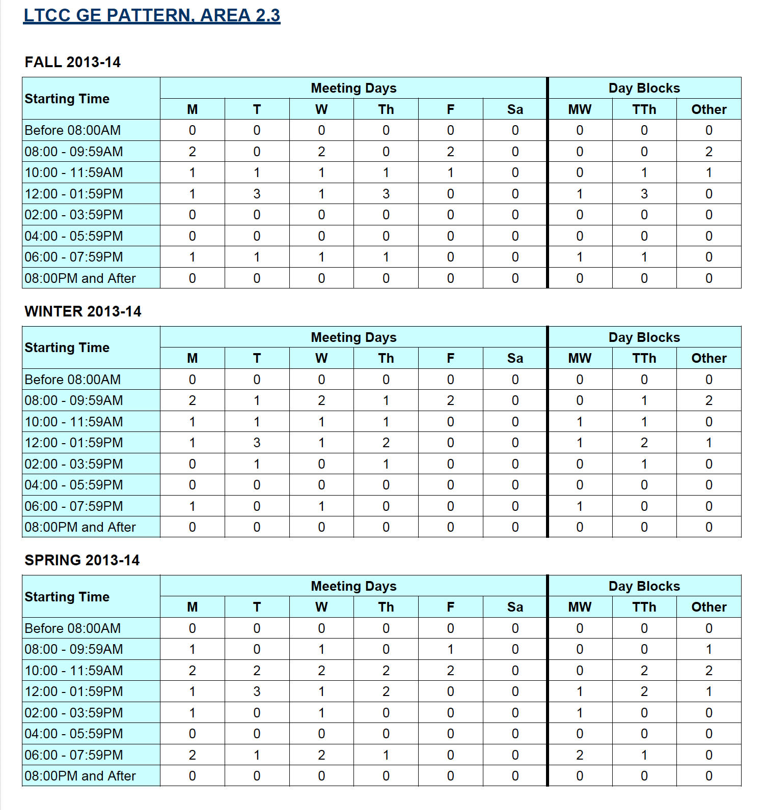

Time Block Heat Map Example

Cancellation Rate Trends Report (percentages of sections cancelled over several terms) partial example

Course Section Cancellation Trends Crosstabulation partial example

Monitoring Implementation of the Schedule

Daily Enrollment Alert Reports Detail partial examples

Point in Time Enrollment (current, last year, two years ago at the same time) partial example
A chart and summary table are also available in this report
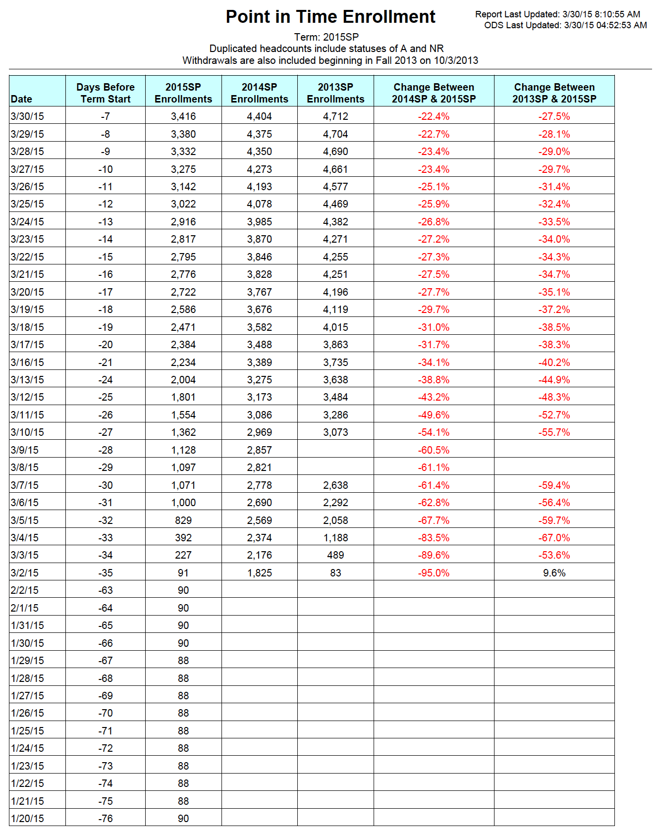

Cancellation Impact on Student Report one class example
Source: Lake Tahoe Community College District

Appendix L: Santa Ana, Chaffey, Pierce, and State Time Blocks for Scheduling

Fall 2019 SAC 16-Week Scheduling Pattern Analysis

54 Total Classroom Hours, 16-Weeks, Fall 2019 SAC

Just over 90% of these classes were located in a concentrated instructional period pattern or as online (TBA). All but six of these classes were offered either one or two days-per-week.
72 Total Classroom Hours, 16-Weeks, Fall 2019 SAC

Just over 50% of these classes were located in a concentrated instructional period pattern or as online (TBA). All but six of these classes were offered either one or two days-per-week. The six sections were offered over four meetings per week with irregular start and end times.

90 Total Classroom Hours, 16-Weeks, Fall 2019 SAC

Just under 60% of these classes were located in a concentrated instructional period pattern or as online (TBA). All of these classes were offered either one or two days-per-week.

108 Total Classroom Hours, 16-Weeks, Fall 2019 SAC

Only half of the133 sections could be located in a concentrated instructional period pattern or as online (TBA). All of these classes were offered either one or two days-per-week.

Although Chaffey College is not using a compressed calendar, these time blocks conform to what is expected of a college using a 16-week compressed calendar.

54 Total Classroom Hours

72 Total Classroom Hours

90 Total Classroom Hours

To facilitate a mid-morning passing time among classes of different meeting lengths.

Source: Cambridge West Partnership, LLC

Time Matrix: Equivalents to 18-week Semester

Source: LACCD, Pierce College analysis

Source: LACCD, Pierce College

Appendix M: Notes on Enrollment Management Plans

CWP reviewed a number of institutional enrollment management plans and found the ones prepared by Laney College and Berkeley City College to be particularly well done. The Laney College plan is very concise. The Berkeley City College plan is highly integrated with other planning documents, includes some self-evaluation, and emphasizes alignment with the SCFF. Notes about the plans from these two colleges are found in Appendix M. The enrollment management plans reviewed, the ones from these two institutions have the best well thought-out goals/actions section. All the other plans have a section or two that stands out but overall are lacking. Of the other plans CWP reviewed none included all of the elements that were expected in an enrollment management plan.

CWP reviewed plans from these institutions:

- Peralta CCD
  - Berkeley City College
  - Laney College
  - Merritt College
- City College of San Francisco
- San Mateo CCD
  - Canada College
- Riverside CCD
  - Riverside City College
- Los Angeles CCD
  - Los Angeles Valley College
- El Camino College
- Compton College
- San Bernardino CCD
- Kern CCD
  - Porterville College
- Gavilan College
- Ventura CCCD
  - Moorpark College
- Long Beach CCD

BERKELEY CITY COLLEGE (2018-2021)

Introduction
- Many of the planning documents are highly integrated thereby potentially allowing efficient action to be taken. Integrated Strategic Enrollment Plan (ISEMP) is aligned with five goals from Berkeley’s own 2018-2020 Strategic Plan. The five goals are based on Berkeley’s Education Master Plan.
- Additionally, the ISEMP aligns with Peralta CCD’s 2017 Strategic Plan and the CCCCO’s Vision for Success. Appendix 1 of the College Plan shows the relationship between the goals of the aforementioned documents.
- Berkeley has been slow in implementing AB 705. Proper implementation along with supporting NC and CR courses will dramatically increase the number of students who complete transfer level math and English in the first year.

Student Centered Funding Formula and Enrollment Management Goals for BCC
- Heavy emphasis on using the SCFF calculator to make realistic projections and to review data and trends.
- Projected areas of growth are based on SCFF elements (Pell and Promise Grant Recipients, Special Admit students and students who complete transfer level math and English in one year).

BCC ISEMP Goals
- Every action is related to an element of BCC’s 2018-20 Strategic Plan, process of the 2018-2019 Guided Pathways Plan and component of the SCFF.
- The goals table in the College Plan illustrates the element, process, and component that relates to every action as well as the personnel responsible for the action.
- There are very broad directives that relate to other advertising efforts (see section C of the Plan).
- Clear directives are described in sections A through I. Those directives allow the personnel responsible to work directly on the task and actions that require further development of the idea.

LANEY COLLEGE (2019-2021)

Introduction
- Much more concise introduction than Berkeley’s.

Plan Development Chronology

Strategic Enrollment Management Committee

Strategic Enrollment Management Plan Framework (equivalent section to BCC ISEMP Goals)
- Clearly stated goals.
- Appendix 3 of the College Plan: shows timeline for completion, personnel responsible for action.
- Metrics for success will properly measure how effective actions are at addressing the goals.
- Timeline for completion is good for knowing when to start measuring actions.
- Many of the actions are extremely broad and can be interpreted many different ways.
- Missing analysis on the effect actions have on any specific student group or component of the SCFF.

Vaniethia Hubbard, Vice President for Student Services, SAC. Personal Correspondence. January 16, 2020

