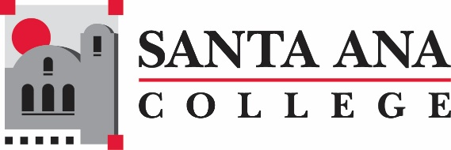
Civic Engagement Meeting
Wednesday, August 5, 2020 10:30am, Zoom Meeting

Present: Maria Aguilar Beltran, Stephanie Clark, Amanda Farah, Dana Herrera, Susan Hoang, Young Kim, Megan Lange, Jonathan Medina, Teresa Mercado-Cota

Not able to attend: Ashley Gonzalez, Janet Cruz-Teposte, Charles Little, Michelle Sandoval, Raquel Serratos, Roy Shahbazian—Student Representative
Agenda Items | Notes/ Required Action
- Welcome  - Introductions | All introductions were made and everyone shared a bit about their summer.
- Partnerships  - Meetings: SAC and Others  - Invites  - Sub-committee or committee  - Other | +The ALL IN Campus Democracy Challenge Action Plan was submitted at the end of May, 2020.  +U.S. Census videos have been developed with SAC and SCE students discussing the importance of participation. Young indicated he has 11 videos that will be reviewed and distributed using social media. In addition, the County of Orange Complete Count Committee has agreed to help boost the videos on social media at no cost to SAC.  +The USCIS, Congressman Lou Correa’s office held a Drive-Through Citizenship Event at SAC on July 29. A total of 290 new U.S. Citizens celebrated their accomplishment. SAC distributed Voter Registration, U.S. Census, and SAC/SCE materials.  +Student Life is holding Civic Engagement Workshops on Sept. 9 & 23  and an event around National Voter Registration Day.  Jonathan will send out a DRAFT calendar of planned activities.  NEEDS: Speakers and Volunteers—Everyone will assist.  +Michelle, who was unable to attend the meeting, reported that SCE ASG will hold U.S. Census events on Sept. 11, 25 and Voter Registration events on Oct. 14, 15, 16. They are also working with NAACP and NAMI. Another webinar will be held on Sept. 18 at 5:30.  Michelle will send a DRAFT calendar of planned activities.  NEEDS: Final reviews and coordination with SAC and SCE.
- Calendar  - Fall  - Event/Activities  - Institution/Conferences  - Webpage  - Other | +Discussion of encouraging faculty to use key backgrounds in ZOOM meetings and other venues promoting the U.S. Census and Voter Registration—Megan, Danna. Also, faculty may consider student projects in these areas—ALL  +Election Guide will be developed to assist voters--Susan  +Create a vanity URL for Student Services to allow staff to refer students for support and a live chat (similar to the large posters which have been placed on buildings)—Maria, Young, ALL  +The Civic Engagement website will be updated—Young, Teresa  +Social media will also be utilized to promote Voter Registration and the U.S. Census—Young, Teresa  +A slide deck with the above and other important information will be sent to faculty and other key team members beginning the first week of Sept and each week, if possible--Stephanie
- Current Initiatives  - U.S. Census  - Other | +U.S. Census deadline was change from October 31 to September 30  +The O.C. Registrar of Voters has asked to use SAC again, possibly the SPOT, IF in-person elections are held.
- Next Meeting  - Dates and Details | Early September (Wednesday) 10:30am-11:30am  Early October (Wednesday) 10:30am-11:30am

H: SAC Public Affairs.AF.Civic Engagement Meeting.08.05.2020

