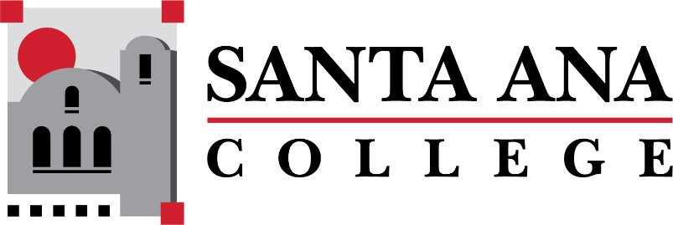

[Dual Enrollment Workgroup](https://www.sac.edu/AcademicAffairs/Dualenrollment/Pages/Dual_Enrollment_Workgroup.aspx) Agenda

Tuesday, November 15, 2022 2:00-3:00pm., Hybrid

S-215 & Zoom

1. Report out - Working Subgroups
   1. Timelines
   2. Faculty Handbook
   3. A&R
   4. SAUSD Team
2. Canvas Report Out – Distance Education
3. Assessment Center – Maria Aguilar Beltran (streamlining waivers for student placement and assessment)
4. Bookstore Costs Discussion – Basti Lopez
   1. Spring 2023 Updates

**Upcoming Meetings:** December 6, 2022 | 2:00-3:00pm Hybrid

**Save the Dates: DuE Retreats**

* January 25, 2023 | 9:00am-12:00pm | JSC 219
* May 12, 2023 | 9:00am-12:00pm | JSC 219