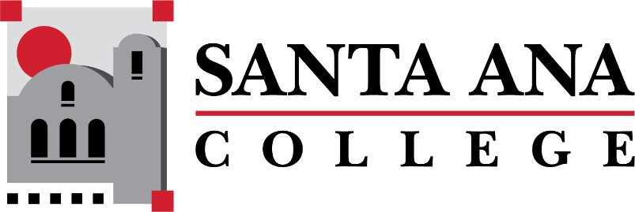

[Dual Enrollment Workgroup](https://www.sac.edu/AcademicAffairs/Dualenrollment/Pages/Dual_Enrollment_Workgroup.aspx) Minutes

Tuesday, December 15, 2022 2:00-3:00pm., Hybrid

S-215 & Zoom

1. Information sharing with high school partners – Matthew Valerius
   1. Matthew Valerius – New Associate Dean of Career Education Workforce Development and Dual Enrollment
2. Faculty onboarding and information sharing – Matthew Valerius
   1. Amberly Chamberlain shared current onboarding process for DuE Faculty: Dept Chairs reach out to the HS faculty to get syllabus, and provide them with WebAdvisor username.
   2. Admissions and Records provides add and drop details, how to clear rosters and submit grades.
   3. Matthew Valerius recommends future onboarding processes include Zoom calls led by the DuE office which can share expectations, instructions on how to find rosters, etc.
      1. Question came up regarding compensation for any training time period
      2. Suggestions of providing various routes of access for information sharing would be ideal – Zoom, Webpages, Canvas Shells, Subtab for DuE Faculty on SAC DuE Website
      3. Suggestion of creating a 1 pager high level items to share with new DuE Faculty to include: Roster, Drop/No-Show guidelines, key dates, when grades are due, key contacts.
      4. Suggestion was made of providing DuE trainings during flex week.
      5. Question was asked of what the process will be for departments that are not currently DuE like History & Law- Process TBD.
      6. There are concerns on the Faculty Handbook that should be clarified before creating a new handbook
      7. Matthew Valerius mentioned he would like current handbook updated to be a starting point to share out for Spring 2023
3. Course request process & SAC course deadlines (need for annual calendar) – Matthew Valerius
4. Limiting changes to dual enrollment course rosters – Matthew Valerius
   1. Process to include confirming rosters early and ensure timelines are being followed.
   2. Teams Site- Tabs by division of courses, course deadlines, course requests.
5. Bookstore Costs Discussion – Basti Lopez
   1. Spring 2023 Updates – Looking for competitive book rates for DuE sections – Possible OER/ZTC.

**Upcoming Meetings:**

**Save the Dates: DuE Retreats**

* January 25, 2023 | 9:00am-12:00pm | JSC 219
* May 12, 2023 | 9:00am-12:00pm | JSC 219