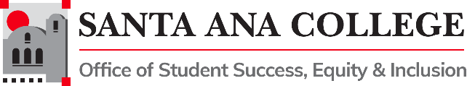
Agenda
Student Equity and Achievement Program Committee
Thursday, May 12, 2022 3:00pm-4:30pm
Zoom: https://cccconfer.zoom.us/j/97418392727

SEAP Committee Vision:
SAC is a college where students can achieve their educational goals and a defined course of study free from racism and sexism, homophobia and any other assumptions and prejudices

SEAP Committee Mission
The Mission of the Santa Ana College Student Success and Equity Committee is to boost achievement for all students with an emphasis on eliminating opportunity gaps. To do this we make recommendations on how equity funding is allocated, evaluate the use of that funding, and explore strategic ideas grounded in institutional research in order to support an education free from racism and sexism, homophobia and any other assumptions and prejudices

Voting Members: Dr. Fernando Ortiz (co-chair), Maria Aguilar Beltran (co-chair) Janet Cruz-Teposte, Annie Knight, Ray Hicks, Dr. Maria Dela Cruz, Dr. Kevin Kawa, Dr. Vaniethia Hubbard, Dr. Jeffrey Lamb, Mark Liang, Cristina Gheorghe, Vanessa Orozco, Leo Pastrana, Maribel Pineda, Kim Smith, Dr. Merari Weber, Dr. Marty Romero, Rebecca Barnard, Tommy Strong, Patty Siguenza, Amberly Chamberlain, Dr. Oziel (Ozzie) Madrigal, Kathy Walczak, Alicia Kruizenga, Dr. Stephanie Paramore-Jones, Nandini Puri, Dr. Armando Soto, Angela Tran

- Welcome and Introductions:
- Action Items:
  - Approval of Minutes April 14, 2022

- Public Comments:

- Discussion:
- Subcommittee, Workgroup, and Task Force Reports: Progress Towards 2021-2022 Goals
  - Funding Request Evaluation Subcommittee
  - SEAP Plan Subcommittee
  - Allocation and Planning Subcommittee
  - Guided Pathways Core Team Subcommittee
  - OER/ZTC
  - Civic Engagement
  - AB943 Workgroup
  - Men of Color Task Force
  - SAC College Mascot Task Force

- Other Committee Reports:
  - AB705 Monitoring – Dr. Armando Soto
  - Professional Development – Amberly Chamberlain

- Information/Reminders:
  - 2021-2022 SEAP Goals Reporting

- Adjournment:

Meeting Materials: Download Here
Upcoming Meetings: September 8, 2022- October 13, 2022 – November 10, 2022 – December 8, 2022

