Student Equity and Achievement Program Committee
Draft Minutes
Thursday, February 10, 2022 3:00pm-4:30pm
Zoom: https://cccconfer.zoom.us/j/98037314473

SEAP Committee Vision:
SAC is a college where students can achieve their educational goals and a defined course of study free from racism and sexism, homophobia and any other assumptions and prejudices

SEAP Committee Mission
The Mission of the Santa Ana College Student Success and Equity Committee is to boost achievement for all students with an emphasis on eliminating opportunity gaps. To do this we make recommendations on how equity funding is allocated, evaluate the use of that funding, and explore strategic ideas grounded in institutional research in order to support an education free from racism and sexism, homophobia and any other assumptions and prejudices

Voting Members: Dr. Fernando Ortiz (co-chair), Maria Aguilar Beltran (co-chair) Janet Cruz-Teposte, Annie Knight, Ray Hicks, Dr. Maria Dela Cruz, Dr. Kevin Kawa, Dr. Vaniethia Hubbard, Dr. Jeffrey Lamb, Mark Liang, Cristina Gheorghe, Vanessa Orozco, Leo Pastrana, Maribel Pineda, Kim Smith, Dr. Merari Weber, Dr. Marty Romero, Rebecca Barnard, Tommy Strong, Patty Siguenza, Amberly Chamberlain, Dr. Oziel (Ozzie) Madrigal, Kathy Walczak, Alicia Kruizenga, Dr. Stephanie Paramore-Jones, Nandini Puri, Dr. Armando Soto, Angela Tran

Virtually Present:
Alicia Kruizenga, Amberly Chamberlain, Ana Diaz, Annie Knight, Bart Hoffman, Basti Lopez, Cristina, Cristina Miranda, Dr. Armando Soto, Dr. Fernando Ortiz, Dr. Jeffrey Lamb, Dr. Kevin Kawa, Dr. Maria Dela Cruz, Dr. Marty Romero, Dr. Merari Weber, Dr. Rebecca Barnard, Dr. Stephanie Paramore Jones, Dr. Vaniethia Hubbard, Janet Cruz-Teposte, John Nguyen, Kathy Walczak, Kim Smith, Leo Pastrana, Linda Sung, Maria Aguilar Beltran , Mark Liang, Mark Reynoso, Patty Siguenza, Raven Cantoran, Song Hong, Stephanie Clark, Tanisha Burrus, Teresa Mercado-Cota, Vanessa Orozco-Martinez

- Welcome and Introductions: Maria Aguilar Beltran began the meeting at 3:03pm. She welcomed SEAP’s new student representative- Raven Cantoran. Raven shared that she is the ASG Cultural Awareness Commissioner and a Computer Science major. The committee welcomed her and are very glad to have her join.

- Action Items:
  - Approval of Minutes December 9th, 2021- Alicia Kruizenga moved to approve minutes, Dr. Maria Dela Cruz seconded. Minutes approved with no objections
  - Dr. Fernando Ortiz requested a motion to amend the agenda and allow Dr. Kevin Kawa to present at the top of the agenda. Kim Smith approved and Dr. Maria Dela Cruz seconded

- Public Comments:
  - Dr. Jeffrey Lamb made a public comment sharing details regarding the March 8-9 virtual Accreditation visit and upcoming PRT. Encouraged SEAP Committee to join the planned zoom and provide input on Core Inquiries.
  - Marty Romero asked the committee if anyone was aware of a space for students to connect after 7:00pm. Dr. Hubbard mentioned that the Johnson Center was available.
- Discussion:

  - Research Presentation-Dr. Kevin Kawa-
    - Dr. Kevin Kawa presented the District Research Dashboard and provided an interactive view of the DI calculator.
  - SEPI Team & Student Equity Plan Update-
    - Maria Aguilar Beltran shared a PowerPoint that explained the Student Equity Plan 2.0 and stated that it focused on being transformational, community driven, thoughtful/meaningful, reflective and race-conscious. She mentioned that it also looks deeply into funding and looks to move away from funding lots of activities and focuses on efforts/initiatives that can help eradicate the inequities that exist.
    - Maria shared details on Student Equity Planning Institute (SEPI)
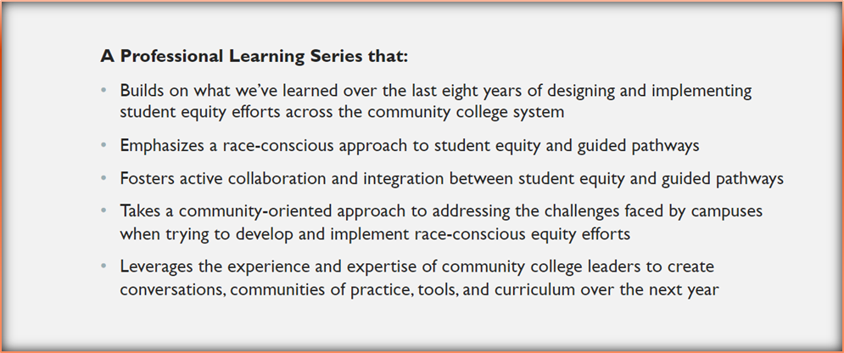

  - SEAP Application Process- Maria Aguilar Beltran shared the following SEAP application award timeline:
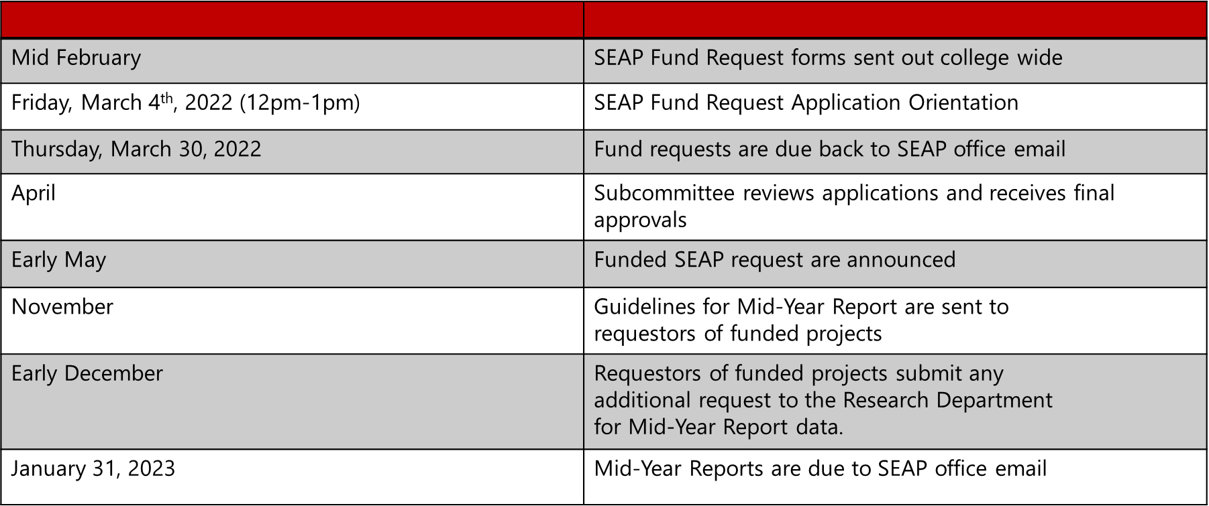
    - Comments were made regarding the purchasing deadlines and inability to spend or plan far in advance due to very early district deadlines.
  - SEAP 2022-2023 Goals Review

- Subcommittee, Workgroup, and Task Force Reports:
  - Funding Request Evaluation Subcommittee:
    - Maria Aguilar Beltran shared that the committee will be meeting to review Mid-Year reports: Reports were due January 31, 2022 to SEAP email. If you would like to become a member it is asked that you are not submitting a request for funding.
  - SEAP Plan Subcommittee:
    - Maria Aguilar Beltran shared that The SEPI team (Dr. Felix, Equity Coaches, & GP Regional Coordinators, etc.) will be working over the next month to prepare a “Campus Feedback Memo” that outlines what the team observed, insight on navigating challenges and opportunities on campus, and support with next steps
  - Allocation and Planning Subcommittee- No report
  - Guided Pathways Core Team Subcommittee
    - Stephanie Clark shared that the Success Team Summit on February 2nd went very well. Mentioned that topics of focus were: Percent of Students with Online Ed. Plans, FAFSA, and Dream Act Applications Submitted by CAP, Top 5 Academic Programs/Majors per Career and Academic Pathway in Fall 2021, Student Demographics by CAP and Demographics of Students who Used Counseling Services in Fall 2021
    - Pathway to Equity Conference to be held Wednesday, March 16th. Via Zoom
  - OER/ZTC-
    - Annie Knight shared that OER week will begin Monday, March 7-10. This week focuses on textbook affordability and programming
  - Civic Engagement:
    - Teresa Mercado Cota shared that the Civic Engagement team met and have begun working on website, links, agendas and voting guides. Also, looking for ways to bring Orange County registrar of voters and provide a vote mobile.
  - AB943 Workgroup:
    - Maria Aguilar Beltran shared that the AB943 application opens during the week of February 28th -March 4th. Spring 22 Semester will be awarding 50k to students that meet the criteria. Mentioned that prior semesters they have been able to award from 200-300 students. Social media requests will be made to target as many students as possible.
  - Men of Color Task Force:
    - Dr. Fernando Ortiz shared that the team will be focusing on reaching out to the research team to get specific data on Men of Color and have been in communication with groups like U2 scholars to ensure that the Men of Color work compliments and not duplicates the work they are doing.
  - SAC College Mascot Task Force:
    - Maria Aguilar Beltran is hoping for robust student participation and will be convening the taskforce in March

- Other Committee Reports:
  - Professional Development – Amberly Chamberlain
    - Amberly shared that faculty engagement has tripled on gateway. Attendance was down this Spring 22 for Convocation. She went over the PD Update document found here (Feb PD Report)
  - AB705 Monitoring – Armando Soto
    - Dr. Soto is meeting with the AB705 committee and will be providing a full report at the April SEAP meeting

- Information/Reminders: SEAP Committee will not be meeting in March to work on taskforce duties and will reconvene in April.

- Adjournment: 4:30 pm

Meeting Materials: Download Here
Upcoming Meetings: April 14. 2022, May 12, 2022

