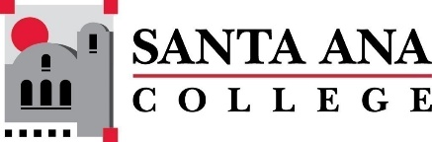 |  | SAC Program Review Committee Agenda  September 25, 2023  1:00p.m. – 2:00 p.m.  Zoom:  https://rsccd-edu.zoom.us/j/88157127065
Introductions, Welcome, and Good-Byes – Matthew Beyersdorf
Approval of February 27 and May 15, 2023, Minutes
Announcements:
- Is this a good time for everyone to meet?
- Dr. Estrada will remain on for this academic year
- Nuventive – Videos are now on the site to use Nuventive for four-year reviews
- Deans and Managers will need to submit a yearly Program Review on Nuventive for Dr. Nery and President’s Cabinet to Review
- Review of Professional Development Week workshop (Kim Smith and Matthew Beyersdorf)
- List of programs with four-year reviews due:
- English as a Second Language (SCE)
- Global Business and Entrepreneurship
- Legal Studies
- Communication Studies
- Philosophy
- English
- Auto/Diesel/Welding (three programs)
- Fire Technology
- Child Development and Education Studies
- SLPA
- EMLS
- Chemistry
- Mathematics
- Nursing
- Disabled Student Programs & Services (Student Services)
- International Students (Student Services) The VP of student Services has request this 4 year be moved to Fall 2027
- Assessment (Student Services)
- Career Center (Student Services)
- Health and Wellness Center (Student Services) The VP of Student Services has requested this be moved to Fall 2025 as Manager over area retired
Action Items:
- Creation of 2023/2024 Goals – Matthew Beyersdorf
  - Review SAC I&E Plan_DRAFT for potential Goals
- Study Session dates, times, and volunteers
- Review of “Program Review Committee: Purpose, Charge, Membership Structure”
Fall 2022 Meeting Schedule: Monday’s 1:00 p.m.-2:00 p.m.
October 23
November 27
December ??? Do we want to have a special 30-minute planning meeting, 1:00 p.m.-1:30 p.m.
Holidays: November 10 and November 23 -24

