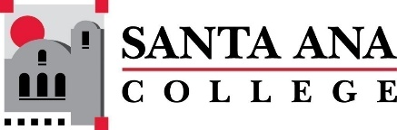 |  | SAC Program Review Committee Agenda  November 27, 2023  1:00p.m. – 2:00 p.m.  Zoom:  https://rsccd-edu.zoom.us/j/88157127065
Introductions, Welcome- Matthew Beyersdorf
Dr. Brenda S. Estrada (not present at this meeting)
Approval of October 23, 2023 Minutes
- All updates made to Program Review Updates
- Dr. Kennedy Requested to add new areas to program review for Counseling Continuing Education
- Program Review Workshops
- List of programs with four-year reviews due:
- English as a Second Language (SCE)
- Global Business and Entrepreneurship
- Legal Studies
- Communication Studies
- Philosophy
- English
- Auto/Diesel/Welding (three programs)
- Fire Technology
- Child Development and Education Studies
- SLPA
- EMLS
- Chemistry
- Mathematics
- Nursing
- Disabled Student Programs & Services (Student Services)
- Assessment (Student Services)
- Career Center (Student Services)
- Health and Wellness Center (Student Services) The VP of Student Services has requested this be moved to Fall 2024 as Manager over area retired
Action Items:
- Creation of 2023/2024 Goals – Matthew Beyersdorf
  - Review SAC I&E Plan_DRAFT for potential Goals
- Study Session dates, times, and volunteers
- Review of “Program Review Committee: Purpose, Charge, Membership Structure”
December ??? Do we want to have a special 30-minute planning meeting, 1:00 p.m.-1:30 p.m.
Holidays: November 10 and November 23 -24

