1530 W 17th St, Santa Ana, CA 92706 714-564-6000 sac.edu

**Santa Ana College**

**Education Master Plan**

**2021 - 2024**

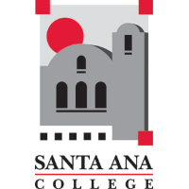

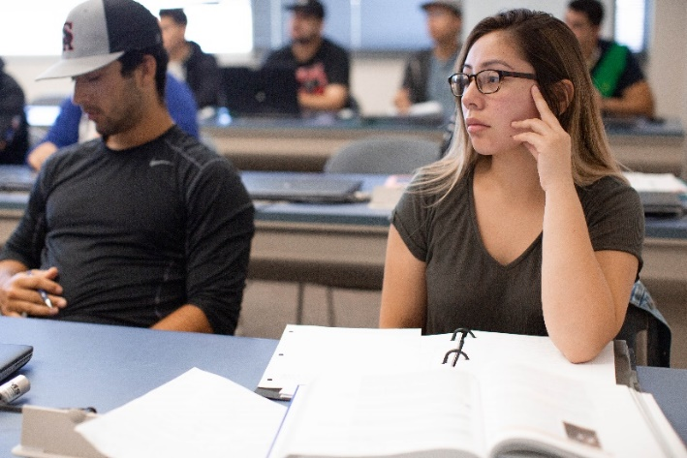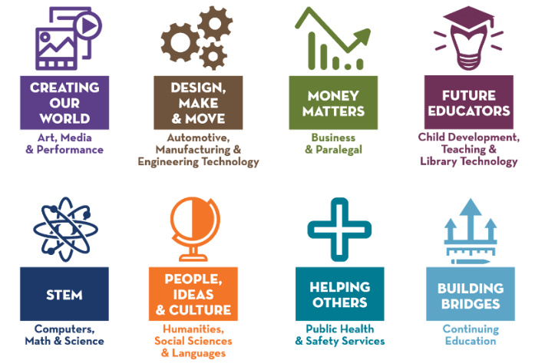

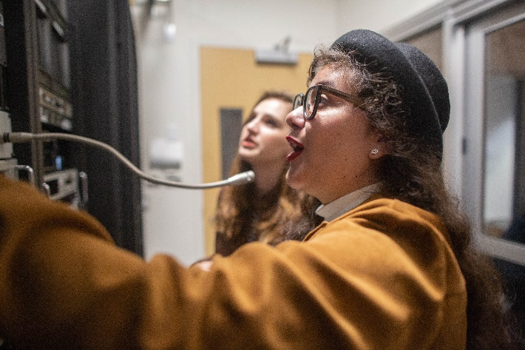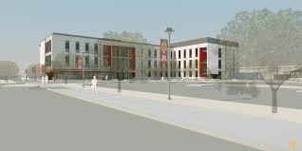

Place holder picture. Publications will format and add design/pics to this document

**01/13/2021**

**fix**

**repl**

**Contents**

Executive Summary 4

Vision Goal #1: Completion 4

Vision Goal #2: Transfer 4

Vision Goal #3: Unit Accumulation 4

Vision Goal #4: Workforce 5

Vision Goal #5: Equity 5

Education Master Plan Development 5

Overview of Santa Ana College 6

The Coronavirus (COVID-19) Pandemic and Civil Unrest 7

Continuing Impact 8

Santa Ana College’s Transformation 10

Mission, Vision, Cornerstones and SAC Personality Traits 12

Mission Statement 12

Vision Statement 12

Cornerstones 12

Personality Traits 13

Core Competencies and Student Learning Outcomes 14

Vision Goals 17

SWOT: Strengths, Weaknesses, Opportunities, Threats 20

Opportunities: 20

Vision and Strategic Goals 22

Vision Goal #1: Completion 22

Vision Goal #2: Transfer 26

Vision Goal #3: Unit Accumulation 28

Vision Goal #4: Workforce 29

Vision Goal #5: Equity 32

Strategies: 32

Initiatives 34

Guided Pathways 34

Professional Development 34

Technology for Student Success 34

Communication Improvements 35

Course Restructuring 35

Program Review 35

Applicants / New Students 35

Branding and Outreach 35

Financial Aid 36

Alignment of Program Review Objectives (Activities) to Strategic Goals 37

Completion 37

Transfer 37

Unit Accumulation 38

Workforce 38

Equity 39

Current Environment 40

Table 1 – Median Household Income of Surrounding Cities 40

Table 2 – Ethnic/Racial distribution of the City of Santa, surrounding cities and Orange County 41

Table 3 – Santa Ana Unified School District Total Enrollment 41

Table 4 – Percent of High School Graduates Enrolling at SAC by School District 42

Table 5 – Headcount by City of Residence, credit students 43

Table 6 – Headcount by City of Residence, noncredit students 44

Table 7 – School of Continuing Education Weekly Accumulated Attendance Hours, spring 2020 45

Table 8 – Santa Ana College Annual Enrollment by Racial Group, Credit Students 46

Table 9 – Santa Ana College Annual Enrollments by Course Instructional Method 47

Table 10 – Measures of Student Satisfaction 47

Table 11 – Employment Status of Santa Ana College Credit Students (Excluding Criminal Justice/Fire Academy Students) 48

Table 12 – Degrees and Certificates Awarded (Credit) 49

Table 13 – Transfers to Four-Year (Credit) 50

Table 14 – Employee Voice: Sense of Connection/Engagement 51

Table 14 – Student Survey Spring 2020 (COVID-10 Check-in) 52

ADDITIONAL RESOURCES 53

# Executive Summary

The Santa Ana College 2021 Education Master Plan outlines Santa Ana College’s plan for meeting the needs of its diverse student body and achieving the ambitious goals described in the California Community College Chancellor’s Office Vision for Success.

In recent years, Community Colleges in California have experienced a major transformation. This request has come in many ways such as funding of the Strong Workforce Program, and the integration of three major funding streams: Student Support Services Program (SSSP), Basic Skills Initiative (BSI), and Student Equity. The establishment of the California Guided Pathways Project, the rollout of California Community Colleges Chancellor’s Office Vision for Success Goals, and the requirement that California colleges write an Equity Plan quickly followed. California colleges were further impacted by passage of California bills AB 705, with its focus on completion of transfer level English and Math within the first academic year, and AB 1809 (Student Centered Funding Formula), which incentivizes outcomes related to financial aid, equity and student achievement. In addition, California leaders allocated $150 million from California Proposition 98 funds for grants to implement a Guided Pathways Framework. As one of the 20 California Guided Pathways Institute participating institutions, Santa Ana College was an early adopter of Guided Pathways. Transformation has occurred at Santa Ana College as it embraced the Framework.

The California Community College’s Vision for Success states that California colleges are poised to “accelerate the pace of improvement”. This new Education Master plan provides the roadmap to how Santa Ana College intends to address the Vision for Success challenges to increase degree/certificate completion, increase transfer to a 4-year university, reduce excess units, meet the needs of the non-traditional student population such as older adult and working students, maximize financial aid and reduce equity gaps within a short-time frame. The following local vision and strategic goals shape the work that Santa Ana College is undertaking:

## Vision Goal #1: Completion

* **Strategic Goal #1:** Santa Ana College will provide support services that remove barriers for timely completion of educational goals of students.
* **Strategic Goal #2:** Santa Ana College will provide Career and Academic Pathways (CAPs) to all students together with academic and student support services they need to complete their educational goals in a timely manner.

## Vision Goal #2: Transfer

* **Strategic Goal #3:** Santa Ana College will increase the number of students transferring annually to 4-year institutions.

## Vision Goal #3: Unit Accumulation

* **Strategic Goal #4:** Santa Ana College will provide services that support student integration into college life, retention, and persistence and the accumulation of fewer units that will result in the efficient achievement of a chosen educational goal by 50% of our students within 5 years.

## Vision Goal #4: Workforce

* **Strategic Goal #5:** Santa Ana College will prepare students for successful, livable-wage employment closely related to their field of study.
* **Strategic Goal #6:** Santa Ana College will develop a comprehensive career education marketing, outreach and recruitment plan.
* **Strategic Goal #7:** Santa Ana College will develop and offer innovative, high quality, workforce-ready, industry-driven career and technical programs.

## Vision Goal #5: Equity

* **Strategic Goal #8** In order to reduce achievement gaps in all areas by 40% by 2022, Santa Ana College, within the context of its diverse community, will systematically equitize its practices leading to culturally responsive programs and services

# Education Master Plan Development

Key stakeholders participated in the writing of this new Education Master Plan. Santa Ana College faculty, administration, staff and students participated in activities and brainstorming sessions to create this document which was subsequently vetted through the College’s participatory governance structure.

# Overview of Santa Ana College

Santa Ana College is located in Orange County, California (City of Santa Ana) and serves a student body that is diverse in ethnicity/race, age, citizenship status, economic status, and educational goal. It is the sixth oldest community college in California and the second largest by headcount (2017-2018). Its combined credit and noncredit unduplicated student headcount exceeds 60,000 annually.

Santa Ana College is recognized for its highly regarded academic programs as well as its top-ranked student services. . Santa Ana College offers over 270 degrees and certificates in credit programs, including 28 Associate Degrees for Transfers. Its noncredit (adult education) program is one of the largest in the state. A wide variety of courses and degrees are available in business, mathematics, sciences, arts, humanities, and career education including emerging fields like biotechnology and culinary science.

Santa Ana College has received recognition for its fire and criminal justice academies, has a highly sought nursing program, and was one of only 15 California Community Colleges to offer a Bachelor’s Degree (Occupational Studies program).

Santa Ana College is one of 20 California Community Colleges recently selected as a demonstration college for Guided Pathways implementation. The California Guided Pathways model is an integrated, institution-wide approach to student success based on intentionally designed, clear, coherent and structured educational experiences. This approach is informed by evidence that guides each student effectively and efficiently from their point of entry through to attainment of high-quality postsecondary degrees/certificates and careers with value in the labor market.

# The Coronavirus (COVID-19) Pandemic and Civil Unrest

The Coronavirus (COVID-19) pandemic erupted in the spring 2020 term during the writing of this document. Its impact on the College’s operations was immediate and substantial. California’s March 19, 2020 “Stay at home except for essential needs” order deemed educational institutions as part of the “critical infrastructure” that must continue to provide services as much as possible with allowances for social distancing. Spring 2020 instruction ceased for three days while the College trained faculty and staff to work from home. The College moved both its credit and noncredit programs to a Temporary Remote Instruction (TRI) format for classes previously delivered face-to-face. All college staff received instruction to work at home beginning March 20, 2020 with a small group of employees remained on campus in compliance with the Center for Disease Control and Prevention, CDC. Within a week, most of the regular business of the College was conducted remotely with minimal face-to-face instruction and college operations in essential areas.

In fall 2020, the college began plans to the shift back towards face-to-face instruction but COVID-19 cases continued to increase around the country and in Orange County so most courses remained under TRI format with some student services opening for in person services.

In addition to the pandemic, the country was experiencing civil unrest triggered by the death of Mr. George Floyd. These events triggered a period of reflection regarding equity at the District and College level.

What follows is just a sample of the steps the College completed to continue operations and support students and staff during the COVID-19 pandemic.

Operation Focus:

* Encouraged faculty and staff to sign up for CCCCO’s ConferZoom
* Scheduled information technology employees on campus to distribute laptops and provide technology support.
* Trained faculty in the use of Canvas and Zoom software for remote instruction
* Trained staff and work study students on use of Cranium Café
* Transitioned most meetings to Zoom format

Community Focus:

* Established a drive-through food distribution service through an external partnership
* Initiated weekly chats with the Chancellor and other local government officials through the el Don Newspaper
* Provided community support by using the campus as a site for the USCIS Drive through Citizenship Ceremony, COVID testing, Red Cross Blood Drive, and a voting center.

Student Focus:

* Adapted SAC webpages for distance learning, including livechat, remote student services, and information on free or low-cost technological tools
* Expanded online tutoring
* Expanded online counseling
* Expanded online professional development
* Expanded digital library resources and online reference desk help
* Expanded communication via social media
* Implemented new rules with respect to Pass/No Pass grading
* Provided loans of laptops and webcams to staff and students.
* Provided Disabled Students Program and Services remotely to students including interpretation and assistive technology
* Provided Assistive Technology trainings and Student Success workshops to students via Zoom or online resources
* Transitioned registration, orientation, transfer, and career center orientations and workshops online.
* Transitioned all planned Student Life and the Associated Student Government events to a virtual format

The following actions were taken by the College’s non-credit programs in response to the pandemic:

* The College’s School of Continuing Education Division met to discuss how each of the departments would help the teachers continue via Temporary Remote Instruction (TRI).
* A website was created to help the teachers access remote instruction resources
* Zoom workshops were led by the faculty that were successfully working with TRI tools. Workshops were recorded and shared with all.
* All of the College’s School of Continuing Education Division ESL full-time faculty were assigned part-time faculty mentees to help on a one-on-one basis.
* The College’s School of Continuing Education launched “SAC GO”, free online continuing education courses.
* Qualified teachers, holding a Canvas Bronze Certification, were hired to teach the “SAC Go” pilot courses. Demand for these courses exceeded expectations.
* Staff assembled in support of equity and the Equity Coordinator immediately coordinated laptops to lend to the neediest students.
* Guided Pathways “Meet and Greets” were scheduled weekly to allow students to learn about the College’s School of Continuing Education programs and services

## Continuing Impact

The initial impact of the coronavirus (COVID-19) pandemic on the College’s spring term 2020 enrollment was an immediate spike in dropped credit courses (22%) and a loss of 40% of noncredit full-time equivalent students (FTES). When surveyed, many students expressed feelings of anxiety about the pandemic’s effect on their lives and frustration with the sudden shift to Temporary Remote Instruction. Many lacked the necessary technology to attend classes remotely or a quiet place to study. The College continues to monitor the needs of its student and direct resources where needed.

The College held a virtual 2020 commencement ceremony, fully online summer 2020 term and slowly began to reintroduce face-to-face courses in the fall 2020 semester. The College sent out a congratulatory graduation video and swag bag to all Spring 2020 graduates, scheduled essential sector and difficult to convert face-to-face courses, and converted all other courses to remote and online instruction. The District office established a substantial marketing budget to reverse the loss of students that occurred during this crisis. The first allocation of the Coronavirus Aid, Relief, and Economic Security (CARES) Act Federal stimulus allocation to Santa Ana College totaled 5.3 million dollars. The college moved swiftly to use CARES grants funds to reimburse eligible students for costs of housing, childcare, technology and other losses occurred from COVID-19. The college also implemented an EW (early withdrawal) and P/PN (Pass / No Pass) grade options under the guidance of the CCCCO which provided students with additional flexibility to manage their course enrollments within the term in which the COVID-19 pandemic struck.

Although the coronavirus (COVID-19) pandemic crisis has introduced uncertainty into the higher education system, including a possible downward adjustment of funding, Santa Ana College will continue to work towards the goals described in this document. The College’s adoption and implementation of the Guided Pathways Framework provides a foundation for continuing this work despite new obstacles.

# Santa Ana College’s Transformation

A campus-wide transformation of Santa Ana College with respect to student success and completion efforts began with participation in The California Guided Pathways Project as one of 20 colleges selected to create “structured educational experiences that support each student from point of entry to attainment of high-quality postsecondary credentials and careers.”1 In preparation for the first institute sponsored by the California Guided Pathways Project (2017), Santa Ana College faculty, staff and administrators were presented with what was referred to as the “Brutal Facts” - Santa Ana College Baseline Key Performance Indicators released by the California Community College Chancellor’s Office:

* Earned 6+ College Credits in First Term (2015-16): 33%
* Earned 15+ College Credits in Year One (2015-16): 23%
* Attempted 30+ Credits in Year One (2015-16): 6%
* Completed College Math in Year One (2015-16): 22%
* Completed College English in Year One (2015-16): 16%
* Completed Both College English & Math in Year One (2015-16): 10%

These low percentages at key momentum points were evidence that the majority of Santa Ana College students were not advancing at a pace sufficient to complete associates degrees or transfer to four-year institutions within a two-year period. In addition to digesting the “Brutal Facts,” the college acknowledged that noncredit to credit transitions were not at the level needed to move adult education students along a path to success and that equity gaps persist.

The California Guided Pathways Project Institute provided inspiration that significant changes in student success metrics were possible by providing data from colleges that saw major improvement in student success rates with the adoption of Guided Pathways methods. College personnel attended six Institutes over two years and brought back knowledge of the Guided Pathways process and techniques to establish the Guided Pathways Framework.

Santa Ana College is responding to initiatives to examine and revise the college’s student success efforts launched by the California Community College Chancellor's Office and the California Legislature from 2017 to 2019:

* AB705 – Maximize probability of completion of transfer level English and Math within the first year (3rd year for English as a Second Language (ESL) students) and employ multiple methods of determining placement rather than relying on one high stakes test.
* Vision for Success – Establish goals to align with the California Community Colleges Chancellor’s Office goals.
* Equity Plan – Establish plan to shrink the equity gap (Gender, Race, Foster Youth, Veteran, Income-based, LGBT status, Disability-based)
* AB 1809 (SCFF) - New Student Centered Funding Formula changed funding from FTES based formula to one partially based on the number of students achieving degrees, certificates, transfers, Career Technical Education (CTE) units, and transfer level English/Math within first year with a premium placed on students receiving Pell Grants, California Grant Free Waiver, and AB540 (Dream Act Fee Waiver).
* Strong Workforce Program (SWP) – Since 2016-2017, SAC has received $5,887,365 local SWP and $1,998,258 regional SWP funds to enhance and create career education programs such as Occupational Studies, Biotechnology, Diesel Technology, and Digital Media.
* Student Equity and Achievement Plan – Combining three major sources of funding -Student Support Services Program (SSSP), Basic Skills Initiative (BSI), and Student Equity into one funding pool to create a focused effort on student achievement.

The first Institute of theCalifornia Guided Pathways Project opened with the statement “it’s not what the community college will do, but what it will become.” Santa Ana College’s Education Master Plan describes how Santa Ana College embraced the Guided Pathways model and began transforming itself into a student-centered institution. The major goals of the college and activities linked to those goals are included in this document.

# Mission, Vision, Cornerstones and SAC Personality Traits

In 2017, the Santa Ana College community engaged in a process that led to the development of new mission and vision statements that describe the direction of the college and created descriptive “Cornerstones” and “Personality Traits” to revitalize the college’s sense of identity.

## Mission Statement

Santa Ana College inspires, transforms, and empowers a diverse community of learners.

## Vision Statement

Santa Ana College is the college of choice that empowers individuals and is committed to creating and strengthening a student-centered, diverse, and welcoming community. The innovative academic pathways and services that we provide inspire and motivate students to achieve educational excellence and economic advancement in a supportive environment.

## Cornerstones

**SAC Cornerstone #1**

**Proud of Our Urban Community**

Since our founding in 1915, we haven’t been in Santa Ana; we are Santa Ana. Our college is woven into the fabric of our community, through the programs and services we provide to our neighbors, through the students we’re preparing to lead our workforce and through the faculty and staff who proudly call it home. We love this vibrant city, from our rich history to our diverse neighborhoods and thriving urban center, and we’re dedicated to helping it grow and thrive.

**SAC Cornerstone #2**

**Building a Strong Network**

We know that our college is only as strong as the diverse network of people and organizations that we build. That’s why we focus on creating partnerships in service of our students and community. From our work with local arts organizations to our apprenticeship and internships programs with local businesses, we’re building relationships that give our students rich new experiences and critical professional development opportunities. These connections across our city and our country drive us, and our students, forward.

**SAC Cornerstone #3**

**Aiming High**

At Santa Ana College, we begin each day by asking ourselves how we can be better for our students. This kind of thinking is not just an act – it’s a habit, and it’s what’s fueled our pioneering approach to community college education. It’s ensured that we create programs that are academically rigorous and nationally recognized. It’s what’s pushed us to hire the best faculty so that we can give our students access to the highest level of academic coursework. And even though we’ve been around for more than 100 years, that doesn’t mean we’re done growing. As the world around us evolves, we’re always looking ahead to what’s coming next.

**SAC Cornerstone #4**

**Overcoming Barriers**

Whether you’re fresh out of high school or returning to school after years in the workforce, we know that going to college is no small feat. We’re proud of our students’ dedication and the way they’re able to balance work, family, life, and school. That’s why we do everything we can to help students find and stay on the path that’s right for them, whether that means creating scholarship and financial aid opportunities that make school affordable or providing a robust wrap around services and tools that help take the guesswork and struggle out of school. If you have the will, we’ll help you find the way.

**SAC Cornerstone #5**

**Life-Changing Experiences**

We’re dedicated to fostering academic excellence and creating the kind of educational

environment that opens eyes and changes lives. Outside the classroom, we work hard to

create a diverse student community that offers not just fun, but growth and leadership

opportunities through our clubs, organizations, and athletics programs. We carefully select our programs and courses - and the faculty who teach in them – to make sure that,

whatever your educational goals, we’re providing you a clear path to success.

## Personality Traits

• Welcoming

• Down-to-Earth

• Dependable

• Encouraging

• Determined

# Core Competencies and Student Learning Outcomes

Students are expected to have gained the ability to exercise these Core Competencies and Student Learning Outcomes by graduation.

**1. Communication Skills**

​ a. Listening and Speaking

Students will listen actively and respectfully to analyze the substance of others’ comments. Students will speak in an understandable and organized fashion to explain their ideas, express their feelings, or support a conclusion

b. Reading and Writing

Students will read effectively and analytically and will comprehend at a college level. Students will write in an organized and grammatically correct fashion to explain their feelings and support a conclusion.

​

**2. Thinking and Reasoning**

Students will identify and analyze real or potential “problems” and develop, evaluate, and test possible solutions using creative thinking, analysis and synthesis, quantitative reasoning, and/or transfer of knowledge and skills to a new context as appropriate.

​

a. Creative Thinking

Students will develop the skills to formulate original ideas and concepts in addition to integrating those of others in the creative process.

b. Critical Thinking

Students will think logically in solving problems; explaining their conclusions; and evaluating, supporting, or critiquing the thinking of others.

c. Ethical Reasoning

Students will demonstrate an understanding of ethical issues that will enhance their capacity for making sound judgments and decisions.

d. Quantitative Reasoning

Students will use college-level mathematical concepts and methods to understand, analyze and explain issues in quantitative terms.

​

**3. Information Competency**

​ a. Information Competency

Students will do research at a level that is necessary to achieve personal, professional and educational success. They will use print material and technology to identify research needs, seek, access, evaluate and apply information effectively and responsibly.

b. Technology Competency

Students will use technology learning tools and technology applications at a level appropriate to achieve discipline specific course requirements and standards. Demonstrated skills might include, but are not limited to: word processing and file management; use or development of simulations, web sites, databases; graphing calculators; etc.​

**4. Diversity**

Students will develop individual responsibility, personal integrity, and respect for diverse peoples and cultures of the world.

​ a. Cultural

Students will respect and work with diverse people including those with different cultural and linguistic backgrounds and different abilities.

b. Social

Students will interact with individuals and within groups with integrity and awareness of others’ opinions, feelings and values.

c. Environmental

Students will demonstrate an understanding of ethical issues that will enhance their capacity for making decisions and sound judgments about the environment.

​

**5. Civic Responsibility**

Students will take personal responsibility for becoming informed, ethical and active citizens of their community, their nation and their world.

​​

**6. Life Skills**

​ a. Creative Expression

Students will produce artistic and creative expressions.

b. Aesthetic Appreciation

Students will respond to artistic and creative expressions.

c. Personal Growth

Students will demonstrate habits of intellectual exploration, personal responsibility, and practical and physical well-being.

d. Interpersonal Skills

Students will participate effectively in teams, committees, task forces, and in other group efforts to make decisions and seek consensus.

​

**7. Careers**

Students will develop the knowledge and skills necessary to select and develop careers.​

## Vision Goals

Santa Ana College established and the RSCCD Board of Trustees adopted these local Vision for Success Goals as required by law. The source for the baseline metrics is the California Community Colleges Student Success Metrics Launchboard (https://www.calpassplus.org/LaunchBoard/Student-Success-Metrics.aspx)

**Goal 1: Completion**

**Goal 1A: Increase All Students Who Earned an Associate Degree (excluding ADTs)**

Santa Ana College will increase among all students, the number who earned an associate degree or associate degree for transfer in the selected or subsequent year from 1,323 in 2016-17 to 1,733 in 2021-22, an increase of 31%.

**Goal 1B: Increase All Students Who Earned a Chancellor's Office Approved Certificate**

Santa Ana College will increase among all students, the number who earned a Chancellor's Office approved certificate in the selected or subsequent year from: 1,276 in 2016-17 to 1,582 in 2021-22, an increase of 24%.

**Goal 1C: Increase All Students Who Attained the Vision Goal Completion Definition**

Santa Ana College will increase among all students, the unduplicated count of students who earned one or more of the following: Chancellor’s Office approved certificate, associate degree, and/or CCC baccalaureate degree, and had an enrollment in the selected or previous year from 1,825 in 2016-17 to 2,318 in 2021-22, an increase of 27%.

**Goal 2: Transfer**

**Goal 2A: Increase All Students Who Earned an Associate Degree for Transfer**

Santa Ana College will increase among all students, the number who earned an associate degree for transfer in the selected or subsequent year from 531 in 2016-17 to 717 in 2021-22, an increase of 35%.

**Goal 2B: Increase All Students Who Transferred to a CSU or UC Institution**

Santa Ana College will increase among all students, the number who transferred to a four-year institution from 1,501 (students last enrolled in 2015-16) to 1,936 in 2021-22, an increase of 29%.

**Goal 3: Unit Accumulation**

**Goal 3A: Decrease Average Number of Units Accumulated by All Associate Degree**

Santa Ana College will decrease, among all students who earned an associate degree in the selected year and who were enrolled in the previous or selected year, the average number of units earned in the California community college system among students who had completed at least 60 units at any community college from 95 in 2016-17 to 82 in 2021-22, a decrease of 14%.

**Goal 4: Workforce**

**Goal 4A: Increase Median Annual Earnings of All Students**

Santa Ana College will increase among all students who did not transfer to a four-year institution, sum of median earnings for the four quarters immediately following academic year of exit from $42,009 in 2015-16 to $44,109 in 2021-22, an increase of 5%.

**Goal 4B: Increase All Students Who Attained the Living Wage**

Santa Ana College will increase among all students who exited college and did not transfer to four-year institution, the proportion who attained the regional living wage for a single adult measured immediately following academic year of exit from: 57% for students last enrolled in 2015-16 to 62% in 2021-22, an increase of 9%.

**Goal 4C: Increase All Students with a Job Closely Related to Their Field of Study**

Santa Ana College will increase among all students who responded to the Career Technical Education (CTE) Outcomes Survey and did not transfer, the proportion who reported that they are working in a job very closely or closely related to their field of study from 69.5% for students last enrolled 2014-15 to 70% in 2021-22, an increase of 1%.

**Goal 5: Equity**

**(Goal - reduce achievement gaps by 40%)**

The College examined student outcome data and determined groups that are attaining outcomes at a substantially lower rate than the benchmark rate. These Disproportionately Impacted (DI) student groups will be targeted for examination of inequitable practices and need for relatively greater need for support services. These are the groups identified by the college as DI student groups:

Ethnicity: American Indian/Alaska Native

Ethnicity: Black or African American

Ethnicity: Filipino

Ethnicity: Hispanic

Ethnicity: Native Hawaiian or Other Pacific Islander Ethnicity: Two or More Races

Ethnicity: White

Economically Disadvantaged

Not Economically Disadvantaged

Male

Female

LGBT

First Generation

Not First Generation

Foster Youth

Disabled

Veteran

Other under-represented student population

Santa Ana College established (and the RSCCD Board of Trustees certified) these Equity Plan Metrics as requirements of Student Equity & Achievement legislation (Education Code 78222).



# SWOT: Strengths, Weaknesses, Opportunities, Threats

The Santa Ana College campus community engaged in activities to determine its strengths, weaknesses, opportunities and threats (SWOT). The process of completing the SWOT analysis helped to identify the overall state of the college, provide insight regarding areas of focus and inform the writing of this education master plan.

The initiatives and activities within this report will address many of the College’s 49 documented Threats and Weaknesses. The college will continue to monitor and adjust to the developments that result from its most pressing Threat, the COVID-19 crisis. The College will capitalize on its Strengths and Opportunities:

**Strengths**

1. One of the largest and oldest community colleges in the state with one of the largest Adult Education programs.
2. Centrally located on Orange County with a strong relationship with the community, multiple partnerships with local school districts, UCI and CSUF. Wide variety of art events and offerings for the students and community.
3. An evolving campus with an attractive renovated mall and three new buildings planned, under construction or opening soon. New 85-year lease in centrally located park for Adult Education program.
4. Respected, dedicated and highly rated faculty and staff including SAC alumni who have returned to work and teach.
5. Over 100 programs and services to serve student veterans, undocumented, K-12 and all students supported by strong marketing efforts to attract students.
6. Comprehensive program and class choices, including many online and free/low cost textbook courses, an athletics program and highly rated programs such as nursing.
7. Low cost for students and a Foundation and Office of College Advancement effective at raising scholarship funds.
8. Three years as a Guided Pathways college with a well-developed Guided Pathways infrastructure that includes staff and Success Teams.
9. Experiencing a technology rebirth with the implementation of cutting-edge software programs and a large supply of laptops to supply students with needed technology.
10. Strong Professional Development Program provide learning opportunities in cultural relevant teaching methods and equity-minded practices.
11. Redesigned twice year all campus Convocations inform, energize and motivate the campus community.

## Opportunities:

1. Diversity of student body, staff and surrounding community.
2. New facilities are accessible to students with disabilities.
3. Changing work-force needs present an opportunity new program development
4. Flexibility required by employed student population provides opportunity to expand distance education offerings.
5. Expansion of Work Based Learning Opportunities for students in all Career and Academic Pathways (CAPs).
6. Large local migrant population.
7. Large population of former students that are near completion.
8. Location offers opportunities for civic engagement and development as community hub.
9. Need for increased pathways from Adult Education to college credit.
10. Creation of partnerships with local industry.
11. Opportunities afforded by emerging fields (e.g. cannabis).
12. Opportunity to expand the cultural and community connection by starting an artist series with A list headliners.
13. Strategically located in a densely populated area close to transportation corridors.
14. Strong, long lasting partnerships with local community groups and nonprofits.

# Vision and Strategic Goals

In order to attain our goals, Santa Ana College recognizes that we will need to take thoughtful action based on quantitative and qualitative data. The following section links

Chancellor’s Office Vision Goals to Santa Ana Colleges Strategic Goals and then specific strategies and metrics so that we can evaluate our progress through tangible and meaningful activities, initiatives, and interventions. The format of this section is as follows:

**Vision Goal (5 in total)**

**Strategic Goal (8 in total) (grouped with related vision goal)**

Strategies to achieve strategic goal

Success Factors related to strategic goals

Guided Pathways Scale of Adoption Essential Practices Related to strategic goal

## Vision Goal #1: Completion

**Strategic Goal #1:** Santa Ana College will provide support services that remove barriers for timely completion of educational goals of students.

**Strategies:**

* Create a campus environment that is conducive to student learning and engagement
* Assess campus climate for barriers to completion
* Increase potential student employment and mentorship opportunities beyond Federal Work Study
* Increase student engagement in learning activities that lead to increased completion rates
* Increase internships/ externships, college internal reviews or services, tracking outreach to external entities, increase use of services by students
* Increase availability and usage of tutoring services across all disciplines with emphasis on courses with the lowest completion rates
* Improve scheduling options including delivery modes of instruction, class times and availability of student support services operational hours that fit students’ lifestyles and needs
* Gather student feedback regarding scheduling and utilize this information to make appropriate adjustments
* Build and strengthen strategic partnerships to meet access, persistence, and completion goals
* Ensure the college continually assesses, improves and communicates to service student basic needs
* Assess student knowledge of services
* Engage formal review of student services with credit and non-credit students in mind
* Increase noncredit (adult education) enrollment, increase involvement of noncredit faculty, and increase marketing to noncredit students about SAC
* Assess results of communication efforts to students

**Success Factors:**

* Increasing percentages of students who select “Excellent” with respect to question “My overall experience at SAC” on the annual Santa Ana College Student Satisfaction Survey
* Increasing percentages of students who select “Excellent” with respect to question “The campus Environment (activities, students, teachers, etc.)” on the annual Santa Ana College Student Satisfaction Survey
* Decreasing percentages of students who select “I did not know this existed” to questions “Learning Center” and “Math Center” on the annual *Santa Ana College Student Satisfaction Survey*
* Decreasing percentages of students who select “I did not know this existed” regarding programs and services listed under question “please rate the quality of services and programs that you have used at Santa Ana College” on the annual *Santa Ana College Student Satisfaction Survey*
* Increasing percentages of students who respond “strongly agree” to these questions on the *SENSE – Survey of Entering Student Engagement* (administered every three years): “The very first time I came to this college I felt welcome,” ”The instructors at this college want me to succeed,” “An advisor helped me to set academic goals and to create a plan for achieving them” and “A college staff member helped me determine whether I qualified for financial assistance.”
* Achievement of Vision Goal 1A: Increase All Students Who Earned an Associate Degree (excluding ADTs), Goal 1B: Increase All Students Who Earned a Chancellor's Office Approved Certificate, and Goal 1C: Increase All Students Who Attained the Vision Goal Completion Definition.

**Scale of Adoption Assessment Essential Practices – Multi-Year Plan – with Progress to date as of January 2021.**



**Vision Goal #1: Completion**

**Strategic Goal #2:** Santa Ana College will provide Career & Academic Pathways (CAPs) access to all students together with academic and student support services that they need to complete their educational goals in a timely manner.

**Strategies:**

* Assess use of developmental resources by students that are struggling academically
* Increase transition of noncredit to credit enrollment
* Increase usage of Learning Center and other tutoring centers
* Increase Faculty and Counseling Services advisement and engagement with students
* Complete program mapping and update consistently
* Host multiple career fairs (recommend at least 2 times per calendar year) with opportunities for students to interact similar to CAP’s Fair involving internal and external discipline experts
* Schedule courses sequentially for on-time and rapid program completion
* Align course offerings with educational plans and program maps
* Increase financial aid marketing in order to increase student aid applications and awards
* Develop tracking system to implement and monitor student information in order to prepare for and meet the graduation date goal and so as not to let a student slip through the cracks
* Hold credit classes at noncredit locations
* Credit and Noncredit: Offer more Fast-Track degrees, certificates and transferability

**Success Factors:**

* Increase overall usage of tutoring centers from 23% (measured fall 2019 traditional (excludes police/fire academy students) credit student body) to 30%
* Increase percentage of credit students, who have struggled in English and Math courses, using support services and developmental education opportunities
* Increase transition of noncredit to credit courses
* Increasing percentages of students respond “strongly agree” to these questions on the *SENSE – Survey of Entering Student Engagement* (administered every three years): “An advisor helped me to select a course of study, program or major,” “An advisor helped me to set academic goals and to create a plan for achieving them,” “The college provided me with adequate information about financial assistance (scholarships, grants, loans, etc.)” and “A college staff member helped me determine whether I qualified for financial assistance.”
* Decrease percentage of students that respond, “No,” “I wanted to but did not know how,” and ”I did not know that I could” to question, “Did you apply for and receive financial aid at SAC?” on the annual *Santa Ana College Student Satisfaction Survey.*
* Increase overall obtainment of Pell Grants from 30% (measured fall 2019 traditional (excludes police/fire academy students) credit student body) to 35%
* Achievement of Vision Goal 1A: Increase All Students Who Earned an Associate Degree (excluding ADTs), Goal 1B: Increase All Students Who Earned a Chancellor's Office Approved Certificate, and Goal 1C: Increase All Students Who Attained the Vision Goal Completion Definition

**Scale of Adoption Assessment Essential Practices – Multi-Year Plan – with Progress to date as of Fall 2019 Related to Vision Goal #1 Completion, Strategic Goal #2**



## Vision Goal #2: Transfer

**Strategic Goal #3:** Santa Ana College will increase the number of students transferring annually to 4-year institutions

**Strategies**

* Ensure all incoming students have a Student Education Plan within the first year
* Establish transfer pathways
* Establish new and strengthen existing partnerships with UC’s, CSU’s and Private colleges
* Improve preparation for transfer to baccalaureate institutions (i.e. Increase rates of transfer English and math completion)
* Recruit/outreach to international students
* Continue campus redesign (Guided Pathways, Meta Majors)
* Develop Success teams to monitor program of Associate Degree for Transfer (ADT) students
* Develop noncredit math/English support classes
* Improve Early Alert system
* Develop transfer awareness month activities
* Improve / Increase outreach efforts
* Increase dual enrollments
* Implement Starfish tool - faculty case management (Associate Degree for Transfer [(ADT])) students
* Make use of text messaging system for communication with students
* Scale up Transfer Mentor Program
* Engage in transfer related professional development
* Credit: Partner with a CSU to offer a few upper division courses
* Credit & Noncredit: Remove unnecessary units in degrees and certificates by combining classes

**Success Factors:**

* Increase % of incoming students with education plans in place
* Reduce average number of years enrolled at achievement of first associate degree
* Increase in breadth and number of dual enrollment sections
* Increase # of students in ADT (Associate Degree for Transfer) programs.
* Increase # of student transfers to UC & CSU
* Decrease average # of non-applicable courses accumulated by ADT (Associate Degree for Transfer) students.
* Decrease time of completion of degrees & transfer.
* Achievement of Vision Goal 2A: Increase All Students Who Earned an Associate Degree for Transfer and Goal 2B: Increase All Students Who Transferred to a CSU or UC Institution

**Scale of Adoption Assessment Essential Practices – Multi-Year Plan – with Progress to date as of Fall 2019 Related to Vision Goal #2 Transfer, Strategic Goal #3**



## Vision Goal #3: Unit Accumulation

**Strategic Goal #4:** Santa Ana College will provide services that support student integration, retention, and persistence and the completion of a targeted number of units that will result in the efficient achievement of a chosen educational goal by 50% of our students within 5 years Objectives: Integration, Retention, Persistence and Completion

**Strategies:**

* Increase informational messages distributed to students targeting impact of unit load, such as financial aid, and through multiples means (social media, email, texts and orientations
* Enhance orientations, and introductory learning communities to create sense of belonging and support integration
* Use SuperStrong career assessment software with orientations to create sense of belonging and support
* Increase participation in student success pathways conferences to ensure students stay on career/academic path
* Implement learning communities for every Guided Pathways Career and Academic Pathway
* Improve student engagement by connecting students to the college to increase retention
* Encourage students to complete electronic education plans prior to starting first semester of college
* Increase faculty use of Early Alert system
* Alert near-completers by using various methods to communicate completion of academic/career requirements at 70% to 90% of completion.
* Increase utilization of online counseling and advising tools

**Success Factors:**

* Increase application to enrollment ratio (49%, 2017-2018, California Community Colleges Student Success Metrics Launchboard)
* Increase student participation in learning communities
* Increase percentage of students completing their first class
* Increase persistence rate (fall to spring, 68% first-time freshmen students, 56% transfer students, fall to fall, 52% first-time freshmen students, 39% transfer students, 2018 cohort, all traditional credit students excluding police/fire academies)
* Complete electronic educational plans for all students within the first semester
* Increase use of the Early Alert system by faculty from 12% of sections (fall 2019) to 35% of sections

**Scale of Adoption Assessment Essential Practices – Multi-Year Plan – with Progress to date as of Fall 2019 Related to Vision Goal #3 Unit Accumulation, Strategic Goal #4**



## Vision Goal #4: Workforce

**Strategic Goal #5:** Santa Ana College will prepare students for successful, livable-wage employment closely related to their field of study

**Strategies:**

* Increase work-based learning opportunities (e.g. internships, job shadowing, career panels, etc.)
* Enhance and market College Career Center programs & services
* Develop Alumni connections and engagement to improve CTEOS Survey participation rate & engagement in other activities
* Provide for faculty professional development as it relates to workforce
* Hold open houses and career fairs
* Develop industry partnerships
* Expand summer career exploration boot camps
* Explore development of pre-apprenticeship programs
* Increase K-12 engagement

**Success Factors:**

* Increase percentage of students who respond “Very Close” or “Close” to question “secured a job that is closely related to their program of study” on the Career & Technical Education Employment Outcomes Survey (CTEOS) (2019, 767%)
* Increase average post college hourly wage reported to question, “What were the hourly wages of the students before training versus after training?” on the Career & Technical Education Employment Outcomes Survey (CTEOS) (2019, $23)
* Achievement of Vision Goal 4A: Increase Median Annual Earnings of All Students,

Goal 4B: Increase All Students Who Attained the Living Wage, and Goal 4C: Increase All Students with a Job Closely Related to Their Field of Study

**Scale of Adoption Assessment Essential Practices – Multi-Year Plan – with Progress to date as of Fall 2019 Related to Vision Goal #4 Workforce, Strategic Goal #5**



**Vision Goal #4: Workforce**

**Strategic Goal #6:** Santa Ana College will develop a comprehensive career education marketing, outreach and recruitment plan

**Strategies:**

* Update website to speak to an audience with no experience in higher education
* Utilize social media and internal communication systems to better communicate with target markets
* Expand outreach operations to include other local school districts, including private and charter schools
* Expand career assessment to include students eligible to transition from non-credit to credit
* Include parents as a key segment in marketing efforts
* Produce department -level short videos to increase program exposure
* Formalize a cross-departmental community outreach plan

**Success Factors:**

* Increase percentages of graduating high school students enrolling from local school districts including private and charter schools (high school capture rate per high school calculated annually by College Research Office)
* Increased transition of students participating in noncredit-to-credit pathways
* Achievement of Vision Goal 4C: Increase All Students with a Job Closely Related to Their Field of Study

**Scale of Adoption Assessment Essential Practices – Multi-Year Plan – with Progress to date as of Fall 2019 Related to Vision Goal #4 Workforce, Strategic Goal #6**



**Vision Goal #4: Workforce**

**Strategic Goal #7:** Santa Ana College will develop and offer innovative, high quality, workforce-ready, industry-driven career and technical programs

**Strategies:**

* Integrate industry feedback into curriculum development
* Establish scheduling guidelines that support short-term stackable credentials
* Update facilities master plan to support the latest equipment needs
* Increase accessibility of programs
* Develop noncredit to credit pathways
* Review programs every two years
* Develop more 0nline programs
* Enhance Advisory Committee Meetings
* Collaborate with District Economic/Workforce Development
* Collaborate with The **Los Angeles**,**/ Orange** County Regional Consortium (LAOCRC)
* Partner with local businesses— Public/Private partnerships
* Increase Dual Enrollment offerings in career and technical education areas
* Offer credit courses at a number of different locations
* Collaborate/Partner with business, industry, and government to provide/guaranteed jobs to graduates
* Develop interdisciplinary programs

**Success Factors:**

* Increase the “Very Satisfied” percentage response to question: “How satisfied are students with the education and training they received” on the *Career & Technical Education Employment Outcomes Survey* (CTEOS) (2019, 634%)
* Increase the percentage of faculty and staff who respond “strongly agree” or “agree” to “The facilities (e.g. classrooms, offices, laboratories) adequately meet my needs” on the *Santa Ana College Employee Engagement Survey* (2020, 51%)
* Number of Dual Enrollment course offerings increase year to year

**Scale of Adoption Assessment Essential Practices – Multi-Year Plan – with Progress to date as of Fall 2019 Related to Vision Goal #4 Workforce, Strategic Goal #7**



## Vision Goal #5: Equity

**Strategic Goal #8** In order to reduce achievement gaps in all areas by 40% by 2022, Santa Ana College, within the context of its diverse community, will systematically equitize its practices leading to culturally responsive programs and services

# Strategies:

* Address California Community College Chancellor’s Office “Call to Action”
* Focus on basic needs (housing, food insecurity)
* Develop culturally responsive classroom practices that are sensitive to the culturally diverse student population we serve
* Recruit diverse faculty and staff
* Offer professional development opportunities related to equity
* Examine campus practices (accounts holds, etc.)
* Implement Action Items/Activities in Equity Plan
* DI students; areas of more or less success
* Facilitate college-wide conversations about equity
* Leverage resources to create Equity Institute locally
* Collaborate with charities who can donate clothing and toiletries to our students who need clothes for school, internships, interviews and jobs Example Women Helping Women
* Promote better representation of student demographics in faculty, staff, and administration hiring

**Success Factors:**

* Achieve Equity Goals (See Equity Plan)
* Achievement of Vision Goal 4C: Increase All Students with a Job Closely Related to Their Field of Study
* Achievement of Vision Goal – Equity Goal: Santa Ana College will reduce equity gap among the disproportionately impacted groups by 40 percent by 2021-22

Brief Description of Activities and Areas of Focus to Achieve Equity Goals:

* Implement the major principles of The Guided Pathways Framework
* Professional development opportunities for faculty and staff
* Implement Action Items/ Activity in Equity Plans
* Implement technology and support to enhance student success
* Improve communication with and the distribution of information to students
* Restructure courses and course sequences
* Revise existing programs and create new ones that support student success
* Improve our onboarding initiatives for new students
* Present a positive and inclusive image of the college in outreach and marketing efforts
* Encourage students to apply for all financial aid for which they qualify
* Implement Activities in the Guided Pathways Scale Of Adoption on Equity
* Implement the USC Equity Leadership Alliance strategies
* Human Recourses Committee (HRC) to review and evaluate recruitment of diverse faculty
* Task Student Equity and Achievement Committee to review “Areas of more or less success” of Disproportionately Impacted Students
* Task Academic Senate to review and make recommendations on “Faculty Level” issues related to Equity
* Implement Dons Corner - a free food distribution service

**Scale of Adoption Assessment Essential Practices – Multi-Year Plan – with Progress to date as of Fall 2019 Related to Vision Goal #5 Equity, Strategic Goal #8**



# Initiatives

These programmatic initiatives are either underway or forthcoming in support of the College’s strategic goals

## Guided Pathways

As a Guided Pathways college, the College has been involved in implementing the Guided Pathways framework for two years. The Guided Pathways activities at the College were overseen by six design teams led by an executive team and a core team. The composition of the Guided pathway teams has evolved as the work proceeded and milestones were achieved. In 2020-2021, the College is finalizing steps to launch the "Meta-Majors" grouping of programs, known as Career and Academic Pathways (CAPs) at the College, program mapping and the integration of programs and services to support student success. Program mapping will be used to identify gaps in the scheduling of classes. To ensure learning, the College has revitalized its Institutional Effectiveness Committee and established an Outcomes and Assessment Committee

These additional activities occurred under the Guided Pathways Framework between fall 2019 and fall 2020:

* Career and Academic Pathways (CAPs) were introduced to the students at SAC Days and on the SAC website
* The first Career and Academic Pathway Exploration Fair was held with faculty and staff of all disciplines and student services participating with attendees of high school students, non-credit students and continuing SAC students
* Eight Success Teams were launched to support campus-wide goals and initiatives
* Starfish Student Success Platform was successfully launched to help students achieve their academic goals

## **Professional Development**

The College's Professional Development Office provides opportunities for college faculty, staff and administrators to attend conferences and external and internal training sessions and events related to Guided Pathways, Equity, and effective practices

## Technology for Student Success

The College has recently implemented a texting system to improve communication with students and allow for targeted and immediate relaying of important information. A new online orientation will launch this fall along with online probation workshops. Future plans include the implementation of software for virtual student services and Starfish software for predictive analytics, early alert and student case management. Additional technology to support creating online educational plans at scale will also be implemented. A new digital media specialist position has been approved with responsibilities that include modernization of the college website. The College has launched a new initiative to promote the use of Nuventive software by faculty and Student Service employees for the tracking and documentation of Student Learning Outcomes (SLO) assessment data, Program Review, and Resource Allocation Requests (RAR).

## **Communication Improvements**

The recently implemented texting system will be used to target Disproportionately Impacted student groups. The college will replicate and expand a successful outreach pilot to communicate with applicants who have not enrolled. Greater efforts will be made to inform all students of the many programs and services available. The Guided Pathways Communications Team will facilitate regular in-class updates on campus events, transfer and pathways. First-time enrolling Career and Academic Pathways (CAP) students will receive a welcoming communication from The College's president. These same students will receive orientations to the CAP at SAC Days, which is a two-day student orientation.

## Course **Restructuring**

The College has restructured its assessment and placement system and English/math course sequences to comply with AB705 legislation. The test-based course placement system has been replaced with self-guided placement and direct placement by high school GPA. Beginning fall 2019, offerings of Basic Skills level math/English courses have been reduced or eliminated. The sequence of English courses will consist primarily of transfer-level courses and one accelerated English Basic Skills course designed to prepare students for transfer-level English. Approximately half of The College's college Math 140 (College Algebra) and 219 (Statistics and Probability) classes in fall 2019 had a co-requisite support lab (Math 040 and 019, respectively). Offerings of online and hybrid courses has significantly increased to match the demand The College now offers four completely online degree programs The College will increase its offerings of accelerated and intersession courses.

## Program Review

The eligibility criteria for The College's Promise Program, which waives student fees and promotes transfer, will be adjusted to increase participation. The College will expand its promotion of supportive services such as tutoring SSEC is reviewing the allocation of funds to programs to ensure that funded activities are aligned with Guided Pathways. College Strategic Goals, and Equity Goals Benchmarks will be established for tracking of program outcomes

## **Applicants / New Students**

Online Orientation and the on-campus all day orientation/ information event, SAC Days, has been expanded to attract more students. Programs have been grouped into Career and Academic Pathways (Career and Academic Pathways (CAPs)). The College will assign Success Teams to students enrolled in each CAP. The Career Assessment tool, SuperStrong, will be made available to incoming students. The college will allocate funds annually for marketing activities. Data will be analyzed to identify opportunities to increase the percentage of applicants that enroll.

## **Branding and Outreach**

The College's Public Affairs / Governmental Relations Office reaches out to the community, builds relationships with organizations and promotes the College as a high quality educational institution. The College adopted a new mission statement in 201. More recently, the president launched a process to develop a new vision statement for the college. A branding consulting firm has assisted The College with a process to develop its distinctive image and positive perception in the college community. The College's Outreach Office has extended its high school outreach within our service area. Activities and events introduce noncredit students to college programs. The noncredit program will reach out to non-traditional and incarcerated students. The College will promote its Career Education programs that provide industry recognized certification

## Financial Aid

Office of College Advancement has launched a college-wide needs assessment to identify funding priorities and areas that require resources to support student success. The needs assessment will be followed by a fund raising effort for scholarships and other campus initiatives. The College will maximize access to financial aid. Students who do not receive financial support such as Pell Grants or California Promise Grants (BOG Waivers) have lower retention rates. Increasing retention will require a concerted effort to ensure that students are able to access financial aid if eligible.

# Alignment of Program Review Objectives (Activities) to Strategic Goals

## Completion

**Strategic Goal #1**

Santa Ana College will provide support services that remove barriers for timely completion of educational goals of students

**Strategic Goal #2**

Santa Ana College will provide Career and Academic Pathways (CAPs) to all students together with academic and student support services that they need to complete their educational goals in a timely manner

Completion Strategic Goals activities include:

* Implementing AB 705 placement and assessment changes
* Using program mapping to identify gaps in the course scheduling
* Increasing emphasis on summer and intersession
* Using research as benchmarks to set program goals
* Graduation petition and degree audit - fall
* Utilizing a mandatory electronic education plan
* Dual Enrollment / Articulation for HS
* Implementing Open Educational Resources (OER)
* Increasing the number of online classes
* Online degree (creating programs that are entirely online)
* Industry recognized certification (QB, CTEC, ASC, Paralegal, MOS, Adobe)
* 15 units semester / 30 units year
* Promoting resources to engage/support students (Learning Center, Math Center, Science Center)
* Revising and creating new Associate Degrees for Transfer (ADTs)
* Emphasizing major focused scholarships
* High school outreach
* Adult Education outreach to non-traditional, incarcerated, middle college

## Transfer

**Strategic Goal #3**

Santa Ana College will increase the number of students transferring annually to 4-year institutions

Transfer Strategic Goal activities include:

* Increasing the number of associate degree for transfer (ADT)
* Increasing the number of counselors visits to core classes
* Converting education plans to electronic format
* Guided Pathways
* Help students identify career interests
* AB705 implementation
* Scholarships for transfer
* University fairs
* Promise Transfer program
* Honors programs
* Online Ed plan for all - needs Wi-Fi
* Social media with students on track to transfer
* Faculty show pathways / transfer during class
* Resources regarding transfer/grad on Canvas in devoted folder
* Professional growth

## Unit Accumulation

**Strategic Goal #4**

Santa Ana College will provide services that support student integration, retention, and persistence and the completion of a targeted number of units that that will result in the efficient achievement of a chosen educational goal by 50% of our students within 5 years Objectives: Integration, Retention, Persistence and Completion

Unit Accumulation Strategic Goal activities include

* AB705 implementation
* Fall 2019 online orientation and implementation of Superstrong (career interest application)
* Excused withdrawals
* Early alert
* Increased online/hybrid/Gr8, intersession offerings
* Electronic education plans
* Graduation reminder at 45 units
* Defined career and academic pathways
* COMEVO software - online orientation
* Cranium Café - Virtual counseling

## Workforce

**Strategic Goal #5**

Santa Ana College will prepare students for successful, livable-wage employment closely related to their field of study

**Strategic Goal #6**

Santa Ana College will develop a comprehensive career education marketing, outreach and recruitment plan

**Strategic Goal #7**

Santa Ana will develop and offer innovative, high quality, workforce-ready, industry-driven career and technical programs

Workforce Strategic Goal activities include:

* Leverage local and regional Strong Workforce Program funds.
* Align TOP and SAM codes for courses and programs to correct SAC data
* Implement process to improve participation in Career & Technical Education Outcomes Survey
* Develop surveys and social media platforms to track student info
* Program review to evaluate effectiveness (i.e. eliminate/revise programs to align with job opportunities)
* Enhance advisory committees to connect with employers
* Develop Consortium network and Santa Ana Work Center Partnership
* Develop curriculum
* Develop events to encourage noncredit to credit transition
* Create regional workforce based learning opportunities
* Develop classroom presentations on careers and SAC resources

## Equity

**Strategic Goal #8**

In order to reduce achievement gaps in all areas by 40% by 2022, Santa Ana College, within the context of its diverse community, will systematically equitize its practices leading to culturally responsive programs and services

Equity Strategic Goal activities include:

* + Continue to offer the Bus Pass benefit
  + Remove fee payment requirement/ drop for non-payment
  + Create completion teams for all Career and Academic Pathways (CAPs) (Counseling, financial aid, faculty advisor, peer mentor, career coach)
  + Create intentional pathways for students to transition from non-credit to credit
  + Create opportunities for engagement and social belonging (growth mindset, habits of mind, productive persistence)
  + Initiate a wellness campaign (financial aid, financial navigation, promise commitments, EOPS, food insecurity initiative)
  + Schedule classes to allow students to complete programs at a faster place

# Current Environment

## Table 1 – Median Household Income of Surrounding Cities

The city of Santa Ana, the location of Santa Ana College, has the lowest median household income and lowest educational attainment among local cities. Santa Ana College’s free high school diploma program and large career education and workforce development program provides the opportunity for the residents of Santa Ana College to attain high school diploma and postsecondary certifications and prepare for high paying, in-demand careers.



## Table 2 – Ethnic/Racial distribution of the City of Santa, surrounding cities and Orange County

Santa Ana, the location of Santa Ana College, has more than twice percentage of Hispanic/Latino residents as does Orange County



## Table 3 – Santa Ana Unified School District Total Enrollment

Santa Ana Unified School District, Santa Ana College’s largest feeder school district has experienced a steady enrollment decline Santa Ana College’s Outreach Office has increased recruitment at surrounding school districts such as Garden Grove and Anaheim

## Table 4 – Percent of High School Graduates Enrolling at SAC by School District

Santa Ana College has expanded outreach to school districts outside of the city of Santa Ana as enrollment in Santa Ana Unified School District has decreased Santa Ana College has many programs that other community colleges do not offer, providing the opportunity to promote the college across Orange County and beyond



## Table 5 – Headcount by City of Residence, credit students

The percentage of students originating from within the City of Santa Ana has remained stable, 43% - 44%, over the years



## Table 6 – Headcount by City of Residence, noncredit students

The School of Continuing Education’s free programs attract students from across Orange County



## Table 7 – School of Continuing Education Weekly Accumulated Attendance Hours, spring 2020

Total weekly attendance hours plummeted from approximately 50,000 hours per week to only 11,000 hours per week in the first week of the California Governor’s COVID-19 shelter-at-home order and the conversion to temporary remote instruction. Over the following weeks, attendance hours partially recovered.

## Table 8 – Santa Ana College Annual Enrollment by Racial Group, Credit Students

The percentage of the student body what identifies as white/Caucasian has decreased 2% over the past five years

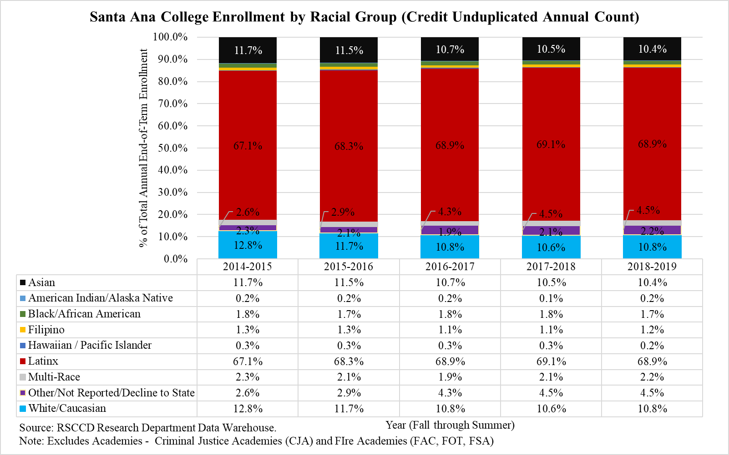

## Table 9 – Santa Ana College Annual Enrollments by Course Instructional Method

The significant decrease in enrollments for in-person courses mirrors an almost equally significant decrease in enrollments for online courses



## Table 10 – Measures of Student Satisfaction

Students rate Santa Ana College “good” on these six measures of satisfaction with a trend towards an average rating nearer to “excellent.”

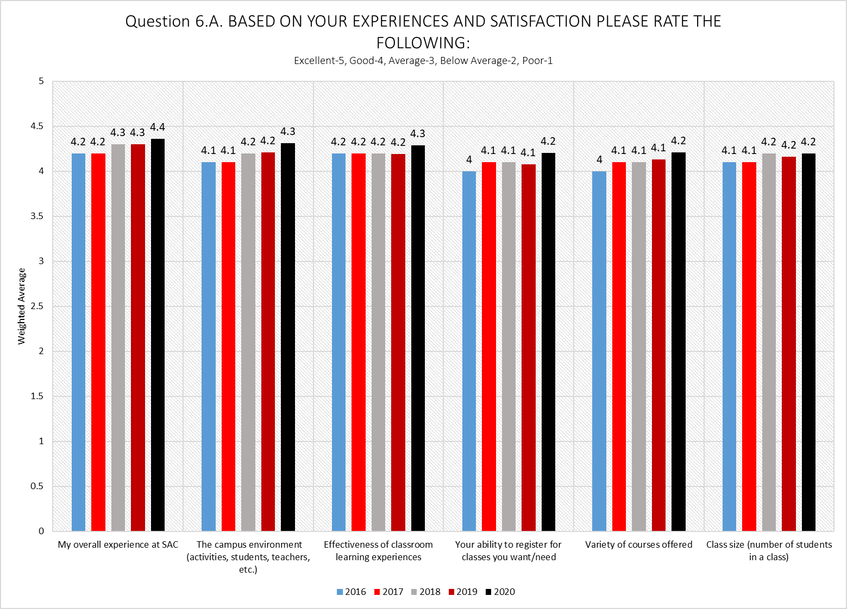

## Table 11 – Employment Status of Santa Ana College Credit Students (Excluding Criminal Justice/Fire Academy Students)

More than 25% of students want a job but are not employed The College needs to increase its capacity to assist students with career preparation

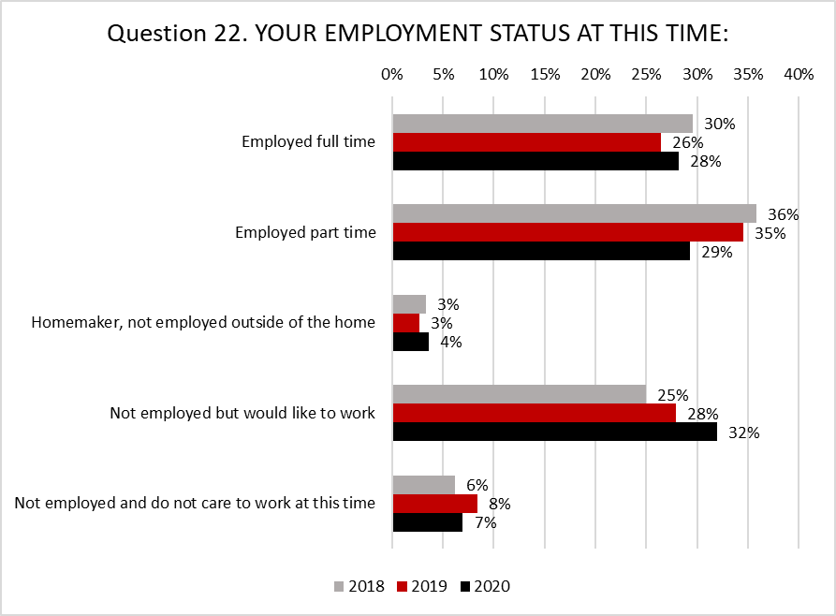

## Table 12 – Degrees and Certificates Awarded (Credit)

Santa Ana College awarded its first Bachelors of Science degrees in 2018-2019 Increasing the number of Associate Degrees and Certificates awarded is one of the primary goals of the college



## Table 13 – Transfers to Four-Year (Credit)

Increasing the number of transfers to four-year institutions is one of the primary goals of the college

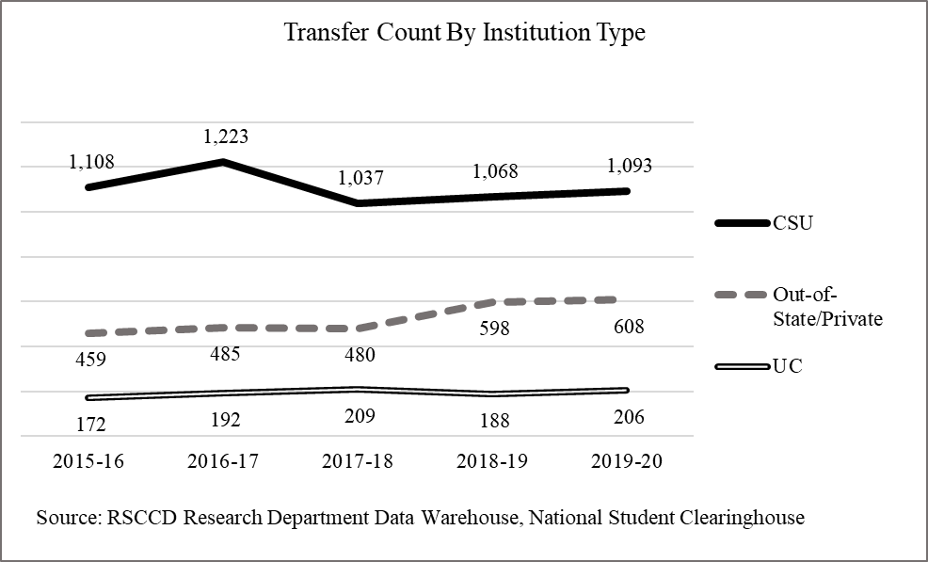

## Table 14 – Employee Voice: Sense of Connection/Engagement

Improvement is needed in the areas encouragment of “teamwork between departments” and creating an environment where employees “feel comfortable and safe bring forward a complaint” Employees indicated the most agreement with the statements: “I understand and support the mission of the college” and “I am proud to be part of this intitution”

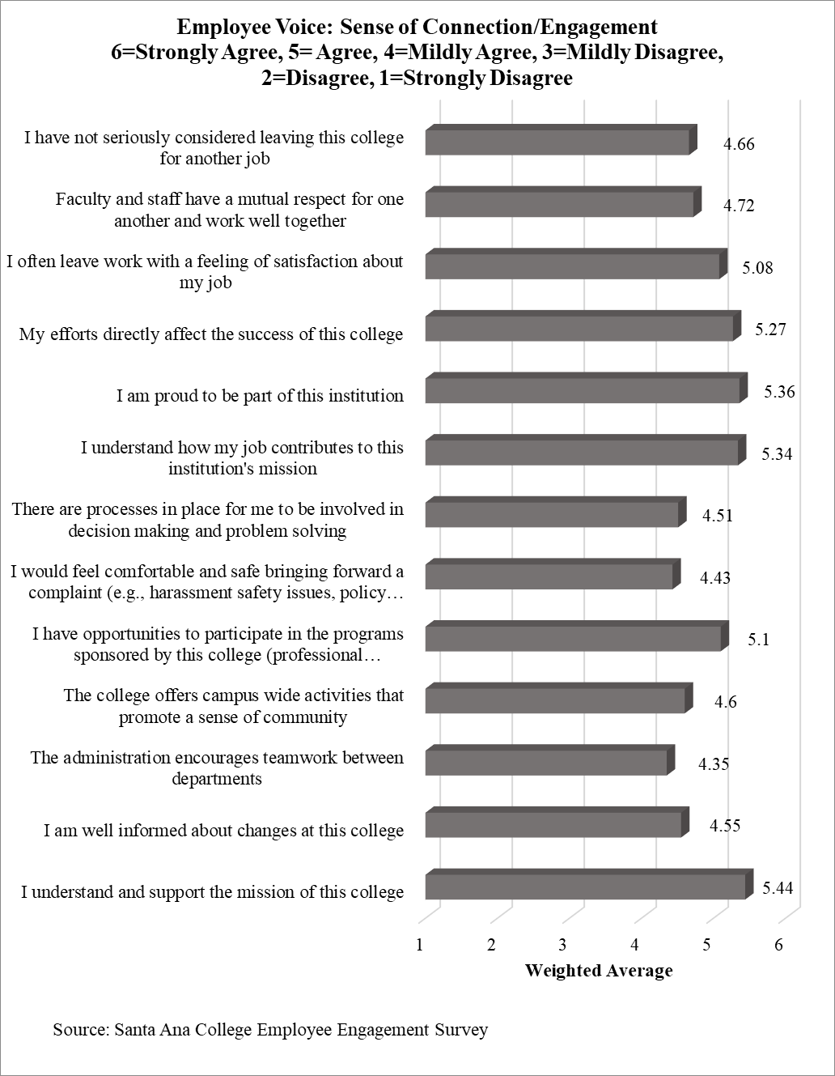

## Table 14 – Student Survey Spring 2020 (COVID-10 Check-in)

The College surveyed students often after the Coronavirus (COVID-19) outbreak. The collected data were evaluated to determine the technological, instructional, financial and personal needs of students and the College responded with new and enhanced programs.



## ADDITIONAL RESOURCES

**Santa Ana College Research Office,** https://sac.edu/research

Santa Ana College Fact Book

Santa Ana College FACTS Sheet

Santa Ana College SEAT (Student Equity Action Tool) Dashboard

Santa Ana College NEAT (Noncredit Equity Action Tool) Dashboard

Santa Ana College Persistence Tool

Santa Ana College Student Satisfaction Survey

Santa Ana College Survey of Student Engagement (SENSE) Results

Santa Ana College School of Continuing Education Quick Facts

The Economic Value of Santa Ana College

**Santa Ana College Accreditation,** https://sac.edu/Accreditation/Pages/default.aspx

**Santa Ana College Guided Pathways,** https://www.sac.edu/FacultyStaff/GuidedPathways/Pages/default.aspx

**Rancho Santiago Community College District Research Office,** https://www.rsccd.edu/Departments/Research/

FACTS N STATS Dashboards

Enrollment Management Dashboards

Rancho Santiago Community College District Credit Program Facts and Stats Dashboard

An Environmental Scan of Rancho Santiago Community College District

Rancho Santiago Community College District Quick Facts

**Rancho Santiago Community College District Continuing Education Research,** https://www.rsccd.edu/Departments/Research/SCE/Pages/School-of-Continuing-Education-Research-Home-Page.aspx

FACTS N STATS

External Environmental Scans

**California Community Colleges Chancellor’s Office,** https://www.cccco.edu/

California Community Colleges Guided Pathways, h<ttps://www.cccco.edu/College-P>rofessionals/Guided-Pathways

California Community Colleges Chancellor’s Office Management Information Systems Data Mart, https://datamart.cccco.edu/datamart.aspx

California Community Colleges Launchboard, https://www.calpassplus.org/LaunchBoard/Home.aspx

California Community Colleges Vision for Success, h<ttps://www.cccco.edu/About-U>s/Vision-for-Success