- Upcoming Online Equity Conference - April 29th – May 1st. Registration is free All the individual sessions are available remotely. Online Equity Conference Schedule

- New/Updated Faculty Canvas Training is live. The DE staff and faculty from the DE advisory workgroup spent months updating and modernizing the faculty canvas training. Big thank you to Instructional Designer, Maggie Manzano!
  - We’ve utilized articulate storyline to create interactive and engaging lessons
  - Accessibility was a significant factor when updating
  - We simplified the badging process (it was confusing for us too!) It is now:
    - Foundational Canvas
    - Advanced Canvas
    - And Applied Canvas (only necessary for OTC (Online Teaching Certificate)
  - If you have already completed a faculty canvas training in the past, you do not need to take it again (and your badge/certificate is still valid). However, if you do decide to take this updated training you can receive PD credit for it. There have been a few emails sent out to ya’ll about this, if you’re having trouble finding it please reach out to me (king_jaki@sac.edu) and I’ll get you the information.

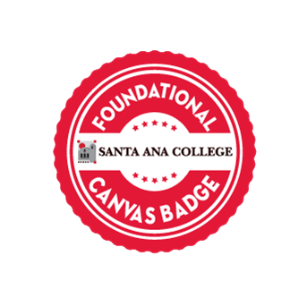
Description
The earner of this badge is a faculty member who has completed the Foundational Canvas level training in the Santa Ana College Faculty Canvas Training. They have learned the technical skills required to execute basic tasks in the Canvas LMS, including navigating the various pages and managing their features. They have also learned mid-level tasks in Canvas, including creating content and assessments, managing communications, creating rubrics, and grading.
Earning Criteria
Earners have completed the Foundational Canvas level training in the Santa Ana College Faculty Canvas Training; and passed the course assessment with a score of 80% or higher.
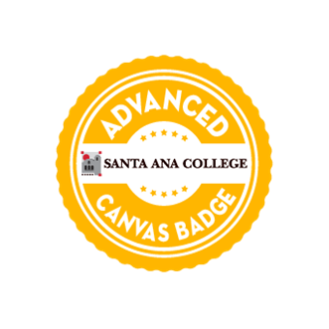

Description
The earner of this badge is a faculty member who has completed the Advanced Canvas level training in the Santa Ana College Faculty Canvas Training. They have learned the technical skills required to execute advanced technical skills in the Canvas LMS, including use of groups, peer review, external tools, surveys, and advanced tools.
Earning Criteria
Earners have completed the Advanced Canvas level training in the Santa Ana College Faculty Canvas Training; and passed the course assessment with a score of 80% or higher.

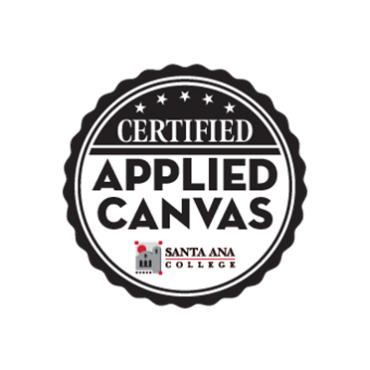
Description
The earner of this badge is a faculty member who has demonstrated the required Canvas skills in a course, providing mastery of the technical skills necessary to create and facilitate a course using the Canvas LMS. Competencies include creating Canvas pages in modules. Demonstrated skills include creating pages, uploading accessible files and documents while using the recommended structure.
Earning Criteria
Earners have demonstrated basic Canvas knowledge and technical skills through the submission and review of a sample Canvas course that uses the SAC Course Template and aligns with the CVC-OEI Rubric.

