DE Advisory Group Agenda
Time: 2:00pm to 3pm, February 6th, 2024
Welcome and Introductions
Faculty Canvas Training update – self-enroll link
Updates:
- Canvas Impact is active
- PopeTech Accessibility Dashboard
- Quality Reviewed Courses and Funding
  - 106 quality reviewed courses
  - Funding based on grants and we need to be stricter on timelines
- Equity Rubric (Online Equity Rubric.xlsx)
- Chief Information Systems Officers Association (CISOA) Nomination:
  - Email and Nomination Blurb
From Marina Aminy at the CVC: I hope all is well, and happy new year! I wanted to let you know that we nominated RSCCD for a recognition/award at the next CISOA conference. The CO asked us and a couple of other grantees to submit our nominations to them for consideration; note that whether the CO ultimately selects the district is not in our hands and the outcome may be different. However, I thought you should know that the CVC consensus was that Santa Ana and Santiago Canyon are stellar colleges with district, IT and college teams with whom we love to work.
And here is how they nominated us:
After conferring with the CVC team, we'd like to nominate the Rancho Santiago CCD for a recognition. Specifically, they've done a great job with the following:
- They are responsive to internal process changes to make etranscripts more student-centered. Meaning, during the process of implementations when they encountered problematic business processes that were not student-friendly, they did the work to update and change those.
- They are very supportive of post-implementation updates, pilots and other needs.
- They champion the use of the CVC Exchange throughout their district, and have also made concerted efforts to add more online STEM courses, particularly in math. They also did a board presentation on the Exchange and are good about informing their stakeholders about their engagement.
- They are a good system-wide leader in that they created a slidedeck for us about their "lessons learned" during implementations and have even offered to answer questions from other colleges who may have similar ERPs/structures.
- The two colleges do an excellent job of intentionally using the Exchange for strategic enrollment management and enrollment recovery, and as a result have been a top "earner" in terms of their presence and enrollments through the Exchange.

- Email from CVC about RSCCD
  - Rancho Santiago CCD has the most enrollments of any district, despite only launching in fall 2022. As of summer 2023, RSCCD had 1,177 cross enrollments. Foothill - De Anza CCD, which went live a year prior, comes in second with 1,006 cross-enrollments.
  - The single college with the most cross-enrollments to date is Chaffey College with 889. Chaffey went live in fall 2021.
  - Since fall 2020, the CVC Exchange has had more than 100,000 online class sections available for enrollment in the CVC Exchange during the start of each term. More than 75% of these online classes are badged for course quality, online tutoring, and/or Zero Textbook Cost.
  - During the 2022-23 academic year, the most searched course by keyword was calculus, followed by physics and statistics. More than 24,250 students searched for online sections of calculus, while 16,565 searched for physics and 11,426 for statistics.
  - The only non-GE subject to make the top 20 was real estate with 5,729 searches.
  - The most searched general education requirement is ethnic studies, with more than 1,300 students searching for it since summer 2022.
  - The single term with the most cross-enrollments is summer 2023 with 2,506. This is compared to only five cross-enrollments when the Exchange debuted in fall 2020
- Goals for Spring 2024
Follow up:
- Underage Identifier in Canvas (from San Bernadino CCD email):
  - I hope the start of the semester is going well for everyone. We received a request to add an underage identifier in Canvas, and I am reaching out to see if anyone has had a similar request and, if so, what was your workflow or process. For context, the campuses are requesting this feature on Canvas so faculty can identify minors. Faculty are mandated reporters, and without this feature, students in 9th and 10th grade must get special permission from the instructor before they enroll in a course so faculty can identify them. However, 11th and 12th grade students do not complete the special form, so faculty cannot identify them.
- Hyflex in Classrooms
- College Buys Contract:
  - Link to Slides from January DECO meeting where College Buys representative gave a presentation
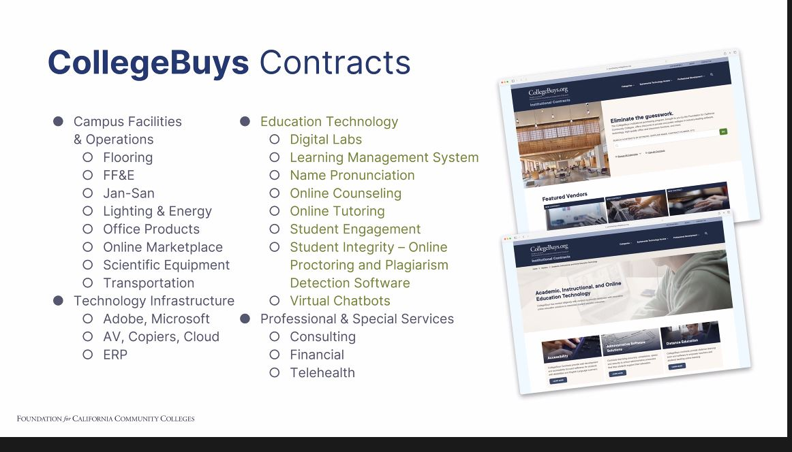
- Class maximums: Collected Articles, Research, and Examples so far
  - Review collected survey responses
    - Summary with charts
    - All the data
  - Begin construction of DE Advisory Class Size Maximum Recommendation
- Discussion/Brainstorm: Recertification/Maintenance.
  - Recertification – please use the brainstorm document
  - Based on last week's discussion we would like to continue filling out and brainstorming ideas, methods, and language.
  - Brainstorm Document – please feel free to begin adding to this.
- Proctorio – begin reviewing other options (consider Respondus webinars)
- Mt. SAC paying more for online class instruction (Heather Arazi, brought this to my attention)
  - Perhaps this can be a start to the Faculty Evaluations conversation
- Intersession and Spring Template updates
- Discussion: At last week’s DE Coordinators meeting (with the state’s coordinators), an ASCCC Paper was presented which was drafted by the ASCCC Online Education Committee. I have linked it below along with the resolution. There have been many updates, additions, and changes with state language (contact and accessibility) as well as recommendations regarding:
  - Student Basic Needs
  - Mental Health
  - Inclusion, Diversity, Equity, Anti-Racism, and Accessibility
  - The roles of different committees in online education
  - Evaluation and Design
ASCCC Effective and Equitable Online Education: A Faculty Perspective
Spring 2022: Faculty Responsibility for Equitable, Accessible Learning Environments
  - OER Project Estimated Time Completion / ZTC Form
Other/Announcements

